SAE TECHNICAL
PAPER SERIES

University of Windsor SAE Mini-Baja
Design Report

Vehicle #38

Curtis Calwell, John Dejan, William Lo, Robert McKinlay, Janelle Meszaros, Jason Petruniak, Steven Reis,
Matt Reynolds, and Lucas Romeo
Mechanical, Automotive, and Materials Engineering
Drs. Bruce Minaker and Greg Rohrauer
Faculty Advisors


SAE Midwest Mini-Baja
Troy, Ohio
June 16-19, 2005

University of Windsor SAE Mini-Baja Design Report
Curtis Calwell, John Dejan, William Lo, Robert McKinlay, Janelle Meszaros, Jason Petruniak, Steven Reis, Matt Reynolds, and Lucas Romeo
Mechanical, Automotive, and Materials Engineering
Drs. Bruce Minaker and Greg Rohrauer
Faculty Advisors
Copyright © 2005 SAE International

ABSTRACT
The objectives of the mini-baja competition are to design and manufacture a “fun to drive”, versatile, safe, durable, and high performance off road vehicle. Team members must ensure that the vehicle satisfies the limits of set rules, while also to generating financial support for the project, and managing their educational responsibilities. This vehicle must be capable of negotiating the most extreme terrain with confidence and ease. The 2005 University of Windsor Mini-Baja Team met these objectives by dividing the vehicle into its major component subsystems. Each team member was responsible for a specific system that was designed according to the objectives and given rules. By examining the 2004 entry, the team was able improve on many design features to better meet the stated requirements.

INTRODUCTION
Mini-Baja is an international collegiate design competition sponsored by the Society of Automotive Engineers (SAE) that attracts engineering student teams from all over the world. Each team’s goal is to design, build, test, promote, and compete with a prototype of a single seat off-road vehicle intended for production and eventual sale to the non-professional weekend racer. The main objective of the competition is to subject students to real-world engineering design projects and their associated challenges.
The University of Windsor’s 2005 Mini-Baja team consists of nine undergraduate students in Automotive Mechanical Engineering. This year, it was decided to create an entirely new vehicle to compete in the Midwest competition held in Troy, Ohio.
For 2005, the team’s design objectives were structured around not only designing a competitive vehicle for the competition in Ohio, but also producing a practical vehicle targeting diverse customer markets. The car should appeal to the off-road weekend racer, outdoor sports enthusiasts, adventurers, cottagers, and drivers of every skill level. The team employed engineering design and judgment to refine many of the successful design features of the 2004 entry, as well as develop several new subsystems that further improve the vehicle and meet the objectives. These core systems include:
- Continuously variable transmission (CVT), in series with a ‘two speed with reverse’ manual transmission
- Open differential with locking mechanism
- Four wheel disk brakes and hand actuated steering brake
- Rack and pinion steering
- Rigid and lightweight chassis
- Four wheel independent double wishbone suspension with rising rate spring setup and variable damping rates
- Vacuum molded body panels and mud guards

The design of each of these components is further detailed in the following report.

originality and innovation
Suspension system – The suspension system design process implemented by the University of Windsor’s Midwest Mini-Baja Team will undoubtedly set a new competition standard in full vehicle ride and handling simulation. The innovative approach to suspension subsystem development using the vehicle dynamics modeling and simulation capabilities of ADAMS/Car resulted in not only well tuned suspension kinematics but well-founded initial estimates for spring and damping rates. Furthermore, these dynamic simulations were used to estimate peak service load requirements as input loading conditions for finite element (FE) models of the suspension, steering, and frame subsystems.
The front suspension and steering and rear suspension subsystems were initially modeled independently. Once the baseline geometry was designed, a full vehicle assembly was constructed to conduct an assortment of pertinent full vehicle simulations.
Both the front and rear suspensions were subjected to parallel wheel travel, opposite wheel travel, roll with vertical force, and static load simulations. The results of these preliminary simulations were used in designing initial hard-point locations for the control arms, drive shafts, tie rods, and wheels. Additionally, these simulation results led to obtaining first order estimates of the loading cases at the shock mounts, ball joints, control arm mounting points, tie-rod ends, spindles, etc. The initial steering geometry layout was determined through a basic lock to lock steering simulation.
Subsequently, the full vehicle model was assembled to include the following subsystems: front suspension, steering, rear suspension, brakes, tires (Paijeka 89 tire model with baseline coefficients), power train (standard mini-baja template power train), and frame. The four primary simulations required for the development and assessment of the full vehicle model were: obstacle avoidance (single lane change) simulation; rollover resistance (ramp steer) simulation; four-poster ride simulation; and jumping performance simulation.
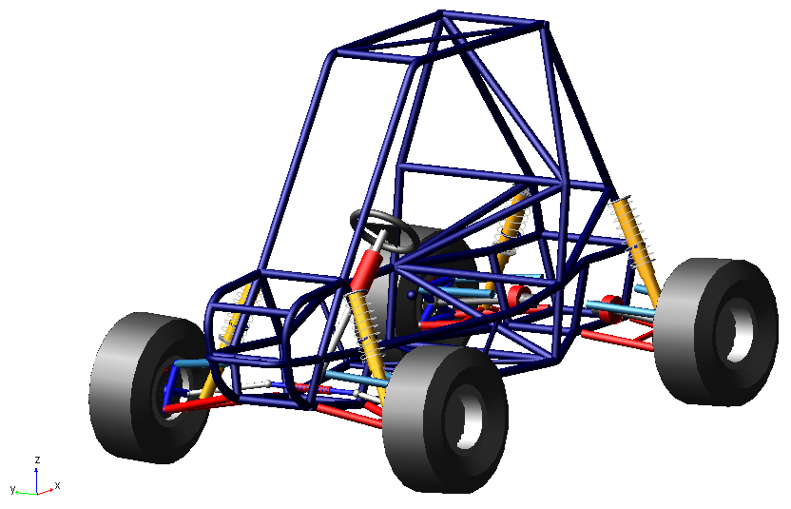
Screen captures from each of the following ADAMS/Car simulations, as well as the baseline suspension simulations, are located in Appendix A
Obstacle Avoidance Simulation – Used to make improvements to baseline suspension geometry for improved steering response, and to tune lateral load transfer distribution to influence lateral handling dynamics, i.e., oversteer, understeer, and neutral steer. A sinusoidal steering input was sent through the driving machine, forcing the vehicle to perform a lane change maneuver over a range of velocities and steering amplitudes/frequencies.
Rollover Resistance Simulation – Used to determine the level of lateral acceleration required to roll the vehicle at different ride heights, with various suspension geometries, and different spring and damping rate settings. A ramp steering input was sent through the driving machine, forcing the vehicle to experience high levels of lateral acceleration to the point of rollover.
Four-Poster Ride Simulation – Used to tune spring and jounce/rebound damping rates to achieve flat ride over rough terrain, i.e., minimize body pitch displacement, and achieve an acceptable level of body acceleration with controlled unsprung mass motion. Low and high frequency sinusoids of varying amplitude were used to actuate the wheels of the vehicle through movement at the wheel pads.
Jumping Performance Simulation – Used to obtain estimates for peak dynamic loads at the previously mentioned joint locations, and to compliment the four-poster ride simulation as a tool for tuning jumping dynamics. The vehicle was sent over a ramped road profile at variable ramp angles and speeds.
The rising rate, coil over spring/damper assemblies were custom built based on simulation results to suit the vehicle and driver weight, front to rear weight distribution, control arm geometry, and desired wheel travel. Externally adjustable damping rates and quad rate springs add practical versatility to the suspension system, resulting in improved ride and handling.
The quad rate spring setup includes four chrome silicon steel springs, ranging in both stiffness and travel. By stacking the springs in various configurations, the operator can control the rate at which the suspension stiffness rises; resulting in progressive impact absorption and improved road holding, while maintaining firm, responsive handling.
The jounce and rebound damping rates are adjusted independently by means of cockpit mounted remote reservoirs (compression) and damper mounted dials (rebound). Damping rates control the energy absorption and release of the suspension, and greatly influence the performance of an off road vehicle
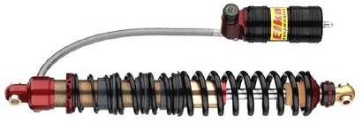
Brake system – To make efficient use of limited cockpit space, and increase leg room, a reverse actuated master cylinder pedal assembly with custom aluminum pedals and compact remote reservoirs was chosen for this year’s vehicle. This assembly allows the pedals to be mounted as close to the front of the frame as possible, while protecting the master cylinders, and utilizing virtually the entire length of the cockpit. The compact master cylinders with remote reservoirs keep the pedals as low as possible for improved foot space.
To increase maneuverability, a steering cut-brake was incorporated into the rear braking system. The cut-brake allows the driver to independently lock the inside rear tire during cornering, leading to rapid increases in yaw rate and body slip angle, and resulting in controlled oversteer. The cut-brake enables the vehicle to negotiate much tighter corners resulting in better maneuverability and a vehicle that is more “fun to drive”.
For ease of serviceability, maintenance, and long term cost savings, the rear inboard brake system was designed as a three-piece rotor assembly. Users can remove one piece of the rotor at a time, with only two bolts, giving access to the brake pads or replacing individual rotor pieces without the hassle of pulling a single piece rotor system off of the drive shaft.

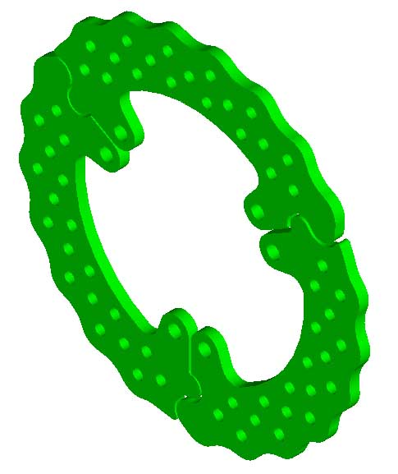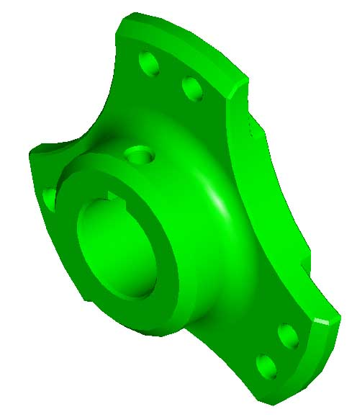
Powertrain – To utilize the full power output of the Briggs and Stratton 10 HP Intek Model engine, a two speed transmission with reverse, coupled with a CVT, was designed to provide a low and high gear range. With the cockpit mounted shift lever in low gear, the driver has the torque available for towing heavy loads, climbing steep gradients, and driving through mud and loose sand. The high gear is designed for top speed and acceleration.
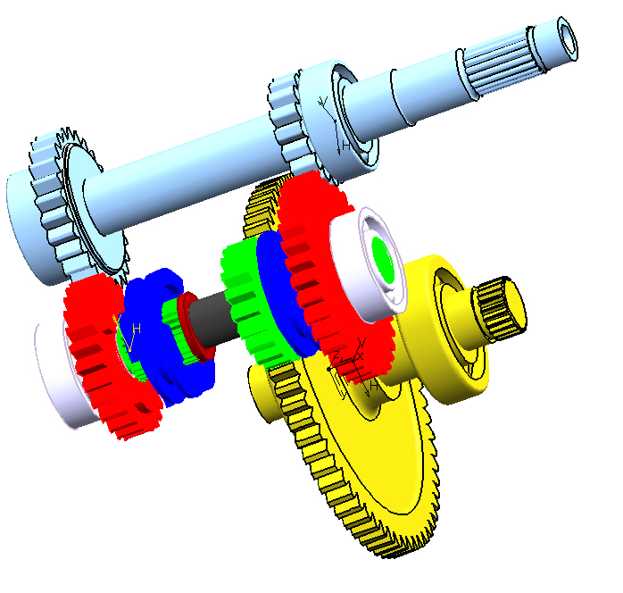
Figure X: Gear Assembly
These characteristics are achieved without continuous shifting by coupling a continuously variable transmission (CVT) to the two speed transmission. The CVT allows any driver, of any skill level, to focus on the obstacles ahead without concentrating on proper gear selection. The CVT eliminates the burden of a manual clutch and is far more simplistic than an automatic transmission.
Further gains in versatility and performance for 2005 are realized by means of a differential locking mechanism. A cockpit mounted lever gives the driver the option of switching from an open differential to a locked differential, resulting in improved tire grip for low traction situations. Furthermore, the locking differential leads to noticeable gains in towing performance, gradability, and straight line acceleration.
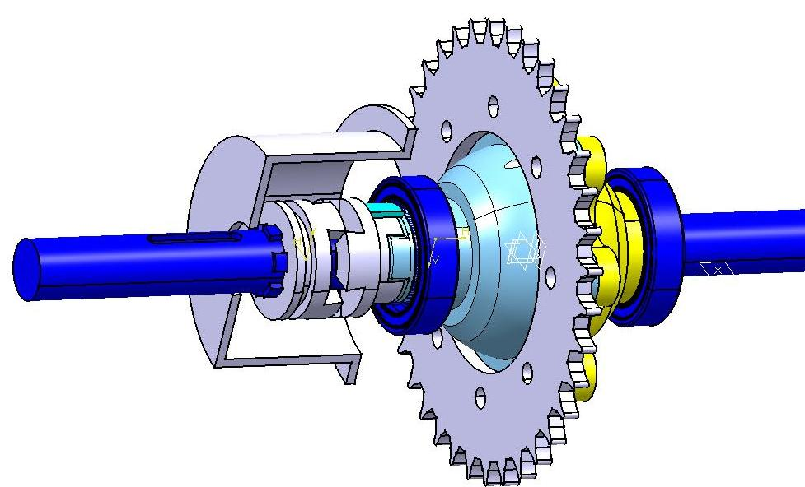
Figure X: Differential Lock Assembly
Structural design – To increase cockpit volume and shorten the wheelbase, bowed side impact members and a protected foot cage were designed. The bowed side impact members create space for the shock absorber remote reservoirs, the cut-brake lever, the gear selector lever, and the differential locking lever. Additionally, the bowed side impact members increase elbow room while protecting the driver in the event of a side impact collision. The protected foot cage was designed to increase leg room, while shortening the wheelbase, and provided the space required under the driver’s feet for the reverse actuated master cylinder pedal assembly.
For utility and versatility, the 2005 entry features a multi-position rear tow hitch, allowing the operator to adjust the tow hitch location based on the trailer hitch position, payload and road surface conditions. By proper adjustment of toe hitch height, the normal load on the rear tires can be doubled, or even tripled, to increase available tire traction.
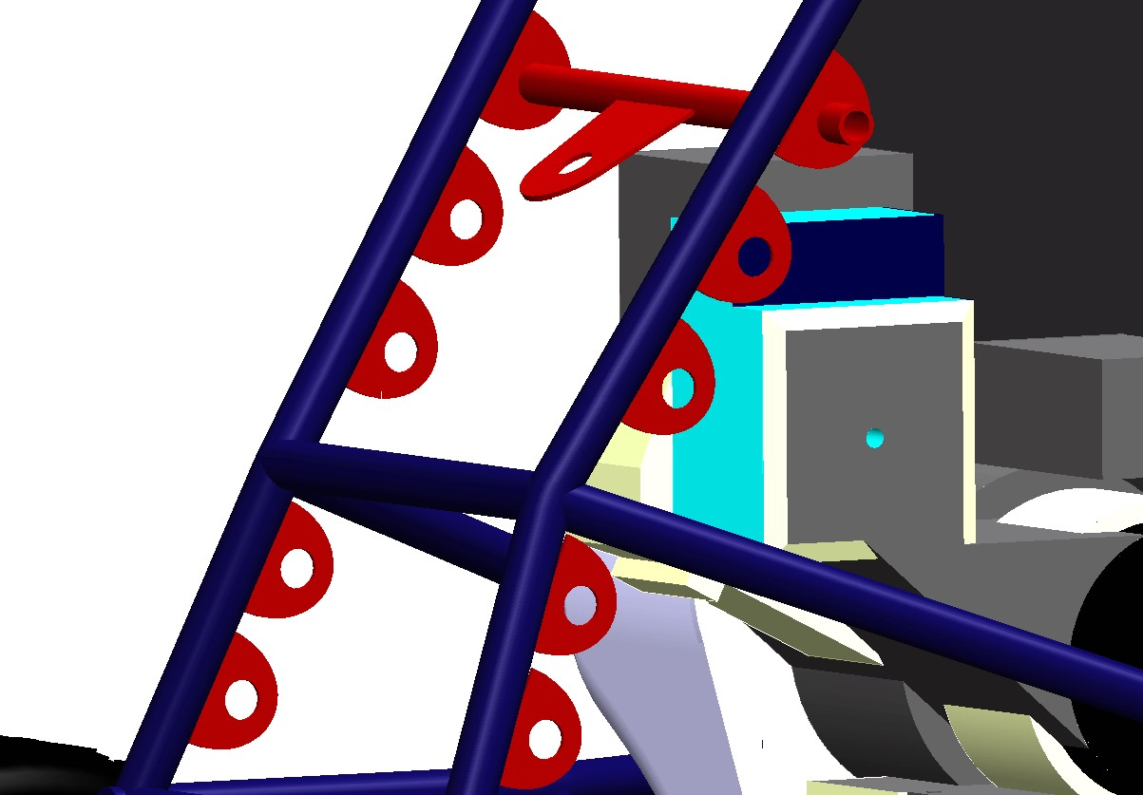
The material for the front body panel and mud guards is ABS thermoplastic. This material was chosen for its durability and ease of formability. The vacuum formed body panel and mud guards provide an aggressive look for the 2005 vehicle; shield the driver from projected debris; and are lightweight, durable, and crack resistant.

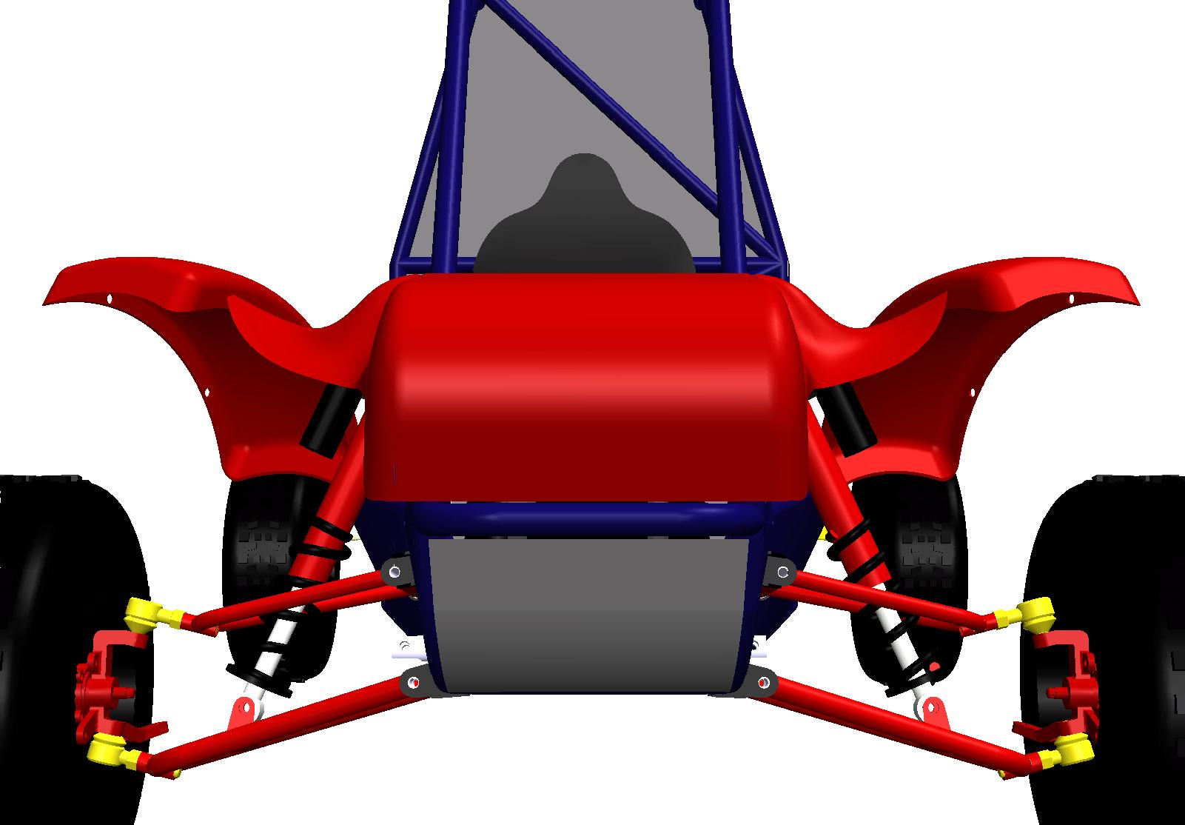

Suspension and brake systems
Suspension
A Mini-Baja suspension system must satisfy the following design requirements:
- Control movement at the wheels during vertical suspension travel and steering, both of which influence handling and stability
- Provide sufficient sprung mass vibration isolation to maintain satisfactory ride quality, while maintaining high tire-ground contact rate and low tire vertical load fluctuation rate to improve road holding and handling
- Improve jumping performance by limiting sprung mass pitch displacement while the vehicle is airborne
- Limit chassis roll during cornering to prevent roll-over, decrease roll camber, and therefore, decrease steering reaction time and slip angle induced drag forces
- Prevent excessively high jacking forces by managing static roll center location and roll center migration
- Limit lateral tire scrub to maintain straight line stability and minimize horsepower losses at the rear suspension
- Control lateral load transfer distribution to influence both steady state and limit of adhesion oversteer/understeer handling characteristics

The non-professional weekend off road enthusiast requires a vehicle which exhibits both safe, stable, responsive handling; and a soft, comfortable ride.

The tire must support the vertical load, while cushioning against road shocks [Gillespie]. In general, tires with low aspect ratios have high cornering stiffness, low rolling resistance coefficients, and improved traction capabilities; the first being important for quick, precise cornering behavior, the second and third for acceleration, grading, and hauling performance. Proper tread pattern is essential to maintaining traction on loose dirt and mud. The lightweight, 12x7-10 Titan Fast Trekker tires were used at all four corners of the vehicle. These tires have an aspect ratio of only 0.636, a weight only 10lbs, a wide contact patch, and an ‘s’ shaped tread for improved clean out.
Independent double wishbone suspension linkage configurations were used at both ends of the vehicle. Independent suspensions are preferable in the case of rough terrain because they provide better resistance to steering vibrations and reduce unsprung mass. Further advantages of the double wishbone setup include easy control of the roll centers by choice of the geometry of the control arms, the ability to control track and camber change with jounce and rebound, larger suspension deflections, and greater roll stiffness for a given suspension vertical rate [Gillespie].
An independent trailing arm setup was evaluated for use in the rear suspension as it would eliminate lateral tire scrub at the driven wheels, allow the rear wheels to trail over bumps, and possibly provide a passive four wheel steering system with tuning of the bushing stiffness; however, simulations proved that, due to the ground level roll center, the rear suspension roll stiffness would have to be increased substantially, which would require the complications of incorporating an anti-roll bar. Furthermore, the trailing arm setup does not allow for the incorporation of kinematic camber compensation.
The 12” long-travel 2005 suspension linkage configurations remained similar to those of 2004, with only minor adjustments to relative arm lengths and orientations—resulting in reduction of lateral tire scrub, and thus, kinematic camber compensation at the front suspension, and increased arm lengths at the rear suspension. All linkage design improvements were based on ADAMS/Car simulation results. Camber, track width, and roll center height vs vertical wheel travel curves can be found in appendix B
The shock mount locations on the rear suspension were switched from a centered location on the upper control arm (UCA) to a laterally offset position on the lower control arm (LCA). This resulted a lessening of the UCA tube size from 1”OD x 0.065”W to ¾”OD x 0.065”W, and resulted in a 12% weight reduction in rear unsprung mass. On the posterior half of the rear LCA, beside the shock mount, 1”OD x 0.083”W tubing and “0.030 stainless steel gusset plates were used to decrease bending stress and increase torsional rigidity.
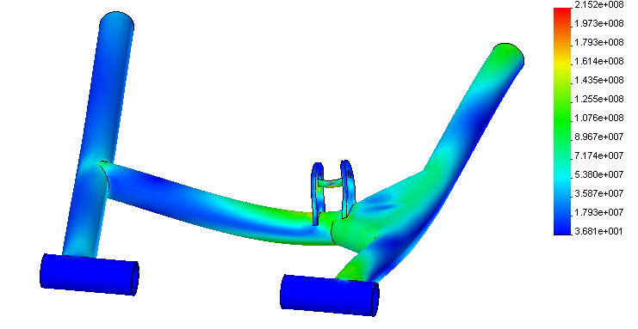
The front suspension UCA inboard mounted heim joints used in 2004 were replaced with a single, bushed pivot joint/anti-penetration bar setup. Two inboard mounted pivot joints were used to mount each LCA to the chassis. Pivot joints are stronger than rod end bearings, and thus, are more reliable in high impact bending load situations, as experienced by the front suspension of a mini-baja vehicle. Threaded ball joints were used at the uprights to facilitate static camber adjustment and increase strength. The 1”OD x 0.065” 4130 UCA tubing of 2004 was replaced with ¾”OD x 0.058” 4130 tubing for 2005.
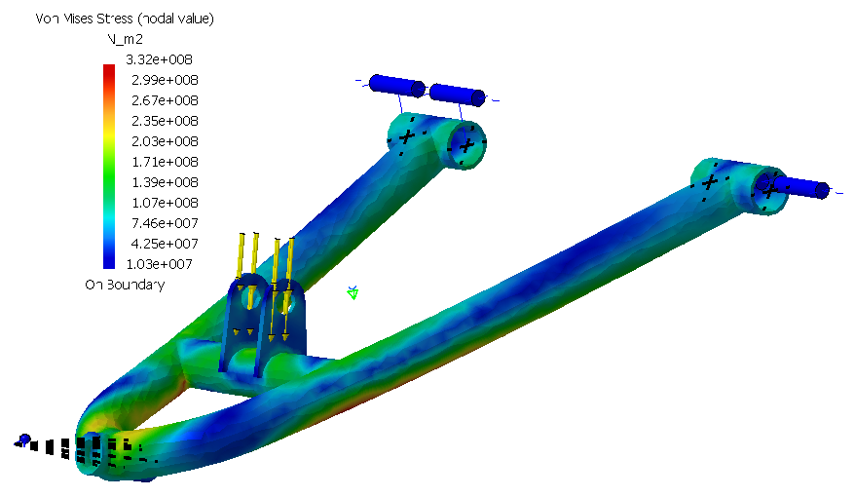
The rear uprights were redesigned for weight reduction and improved manufacturability. The improved, symmetrical upright design realized a 5% weight reduction, allowed for 1” increase in rear control arm length, and maintained a safety factor greater than 3. The upright material was chosen as 6061 T6 grade aluminum for its high strength to weight ratio and high modulus of toughness. A double row split inner ring, angular contact wheel bearing was press fit into each upright.
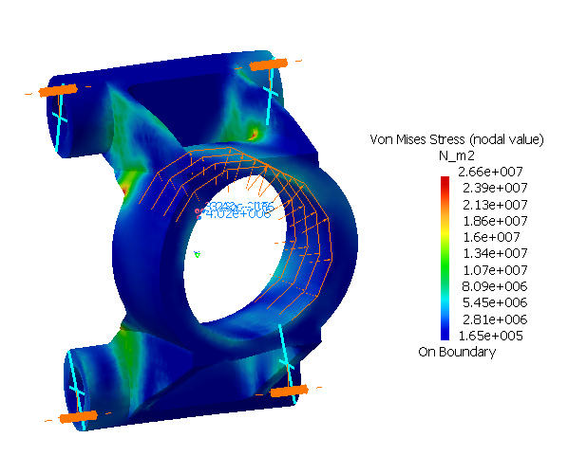
The rear cast aluminum hubs were designed as a direct replacement for the OEM Polaris hubs.
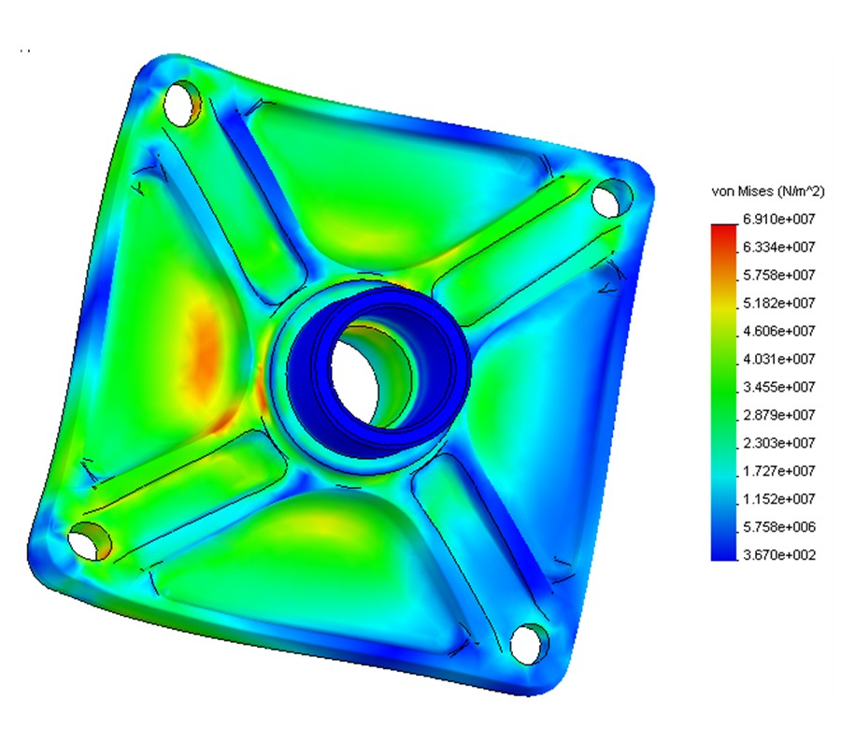
The 8” travel Bilstein shocks used in 2004 were replaced with 6” travel, quad rate, Elka Sports & Racing Series shocks. These performance shocks boast independently adjustable damping rates in jounce and rebound with remotely mounted reservoirs. Damping rate adjustability is essential for proper tuning of jumping performance, ride comfort, and handling.
The equation governing spring rate for the multi-rate spring setup in series is:
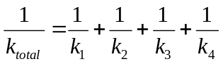
The total combined spring rates for the front and rear suspensions are:
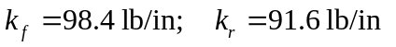
These spring rates, once modified by the motion ratios of the suspensions, resulted in the following front and rear bounce natural frequencies:
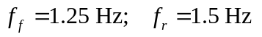
The rear natural frequency was designed to be 20% higher than the front natural frequency to maintain flat ride over rough terrain by allowing the rear suspension to catch up to the front subsequent to encountering a bump in the terrain.
The ‘full soft’ setting damping force vs. velocity dynamometer curves, as tested by Elka Suspension, are depicted in figure X. Note that the blue and red data sets are for the front and rear shocks, respectively.
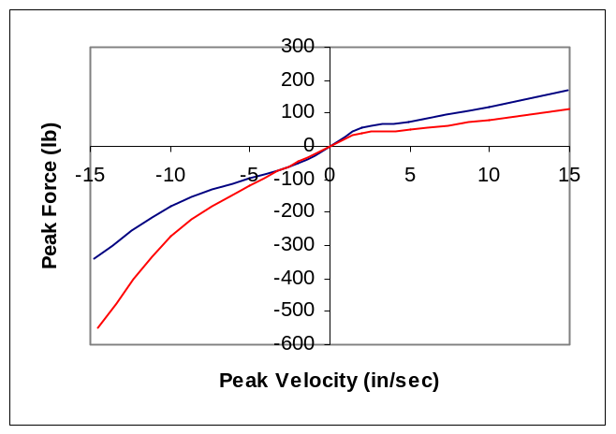 Figure x - Force vs. Velocity Elka Shock Dynamometer Curves
The shocks were designed to, at the baseline ‘full soft’ setting, provide damping ratios of 0.4 and 0.3 in compression and 1.0 and 2.0 in rebound for the front and rear suspensions, respectively. This setup results in equivalent front and rear sprung mass transmissibilities of 1.03 in rebound under an excitation frequency of 1.63 Hz (corresponds to “whoop-de-doo” excitation with vehicle traveling at 20 mph) resulting in minimal body pitch motion over wavy terrain. Rebound damping rates are used in the sprung mass transmissibility calculation because rebound damping controls the release of energy, or “kick-back”, of the spring after it encounters a bump. This setup was based largely on the results of the Four Poster Ride simulation. Further damping rate adjustments can be made via the independent externally adjustable jounce and rebound damping knobs to suit any application.
The front upright was designed to improve suspension and steering geometry; increase strength; and use OEM wheel hubs and brake calipers. The new design resulted in a more ergonomic steering rack location along with a 5 degree increase in inner wheel angle at full lock. Separating the upright into a spindle made of 4140 and upright body made of 4140 resulted in a stronger and more machinable part.
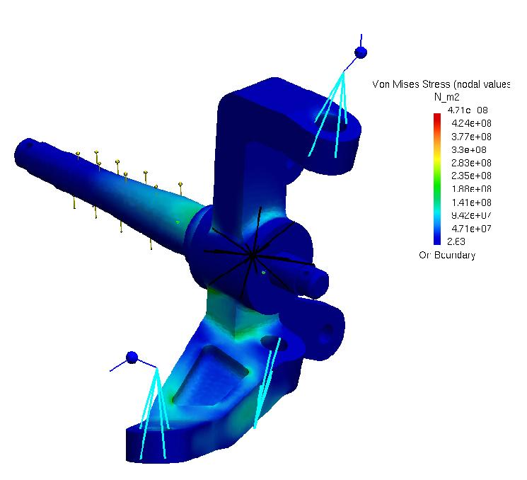
A rack and pinion system was incorporated for its low weight and durability; this allows for the inner tie rod mounting location to be relatively close to the inner suspension mounts. The inner tie rod location was chosen to keep the steering rack as low and far back as possible, preventing the rack from interfering with the driver’s feet.
If the tire steers when it encounters a bump, the car will travel on a path that the driver did not select [Milikan]; thus, to remain stable on rough terrain, bump steer must be reduced to a minimum. The outer tie rod location was chosen to compliment both the inner tie rod location and the control arm geometry. The designed layout achieved nearly 100% Ackerman geometry; a maximum inner wheel angle of 46 degrees at full lock; and a mere 0.175 degrees of bump steer at full jounce/rebound.
An aggressive 8 degrees of inner wheel camber and -6.5 degrees of outer wheel camber at full lock provide improved lateral grip during cornering, keeping tire slip angles low to improve steering response time. The curvature of the camber vs. wheel angle profile can be attributed to approximately 13 degrees of static steering axis inclination (SAI), and a static caster angle of approximately 10.3 degrees. Caster and SAI result in a self-centering torque at the undriven wheels, which provide feedback to the driver.
Along with the geometric steering accomplishments, the vulnerable outer tie rod ends were mounted on top of the upright steering arm, as opposed to below the arm, as was done in the 2004. The tie rod closely follows the inside of the rear member of lower control arm, which keeps it protected from direct collisions.
The steering wheel is a 13.5 inch outer diameter wheel to provide enough torque to easily steer the wheels in all conditions without fatiguing the driver. The steering column is adjustable in length, using a quick release pin, to suit various sized drivers. The column is supported by two needle pin roller bearings, and split with a low friction sealed u-joint to provide smooth steering motion and minimize frictional losses.
One of the foremost design objectives relating to the 2005 brake system was that of increased driver compartment leg room; however, extension of the wheelbase was undesirable and could not be permitted. In previous vehicle entries, the mounting location for the brake master cylinders was located aft of the brake pedal, and was actuated by means of a second class lever. This resulted in a cramped driver compartment, causing discomfort and limited space for leg extension. The solution to this problem was a reverse actuated (third class lever) brake pedal assembly. In this configuration, the operator’s feet rest above the master cylinders and the entire assembly is pushed forward by over 7”. A removable cover was designed to house the cylinders and reservoirs, protecting them from damage, and to act as a footrest for the rider.
The entire pedal assembly is made from 6061-T6 aluminum. The changes in design removed 5 pounds of weight from the entire pedal assembly, as well as removing 2 inches from the wheelbase by means of advancing the location of the pedal assembly.
The 2005 mini-baja vehicle incorporates a four wheel disc brake setup with martensitic 410 stainless steel wave rotors. Custom aluminum hubs were designed and manufactured to mount the three piece rear rotors to the halfshafts. For improved cornering maneuverability, a hand actuated steering brake sends maximum braking torque to the inner tire and maximum driving torque to the outer tire, resulting in rapid changes in vehicle attitude angle and yaw velocity, without significant longitudinal deceleration.
Proven OEM Yamaha Warrior brake calipers were selected for the front brakes, with laser cut, cross drilled wave rotors. The rear brake design features an inboard braking system that uses Jr. Dragster brake calipers. A unique, self retracting and adjusting piston system has been incorporated into this caliper which enables the piston to retract as the brake line pressure is reduced. Weighing a meager 1.2 pounds, the caliper's lightweight billet design includes high performance, high friction brake pads including deep cup stainless steel pistons for reduced heat transfer. The rear braking system consists of a three piece wave rotor bolted to a custom hub that is keyed to the rear driveshaft. Oftentimes, both the rear wheel hub and wheel/tire assembly must be removed in order to replace the rear rotors; a three piece rotor design allows the rotor to be removed radially, piece by piece, without the aggravation of removing additional components. Figure X below displays the three piece rotor, hub, and rotor hub assembly.
Powertrain
The objectives of the Powertrain subsystem are to:
- Increase function by incorporating a differential lock and two speed gearbox with reverse
- Increase torque by providing a lower ratio for low range
- Improve efficiency by providing an oil bath for lubrication, decreasing rotating mass, and ensuring bearing fits maintain alignment
- Create a rugged and durable system

The primary objective of the power train subsystem was to develop a versatile vehicle that is both robust and serviceable. This was achieved through the successful design and manufacture of a complete powertrain assembly that is capable of powering the vehicle through a broad range of operating conditions. The main focus of the powertrain is to maximize the following: transmission efficiency, reliability, and function.
The marketing goal of the project was to develop a vehicle suitable for the weekend off-road enthusiast. This broad requirement can be examined as number of sub requirements applying specifically to the powertrain system, which include: vehicle safety; reasonably high top speed; maneuverability over a broad range of terrain; reasonably high towing capability for the size of vehicle; maximum serviceability; and finally, maximum operator experience.
The continuously variable transmission (CVT) system, coupled with a ‘two-speed plus reverse’ gearbox helps to meet a number of the above requirements. By employing the CVT, it enables the operator to drive through many obstacles without needing to consider shifting a manual gearbox. The transmission ratio of the CVT varies from 4.25:1 at low rpm, and 0.76:1 at maximum rpm, under optimal conditions. Due to the sensitivity of the CVT to engine speed, it functions well coupled with an engine with a narrow rpm range, much like the Briggs and Stratton engine used in this application. The operator can focus on driving rather than transmission control, which contributes to the safety of the operation of the vehicle. The custom built two-speed gear box enables the vehicle to achieve both high torque and high speed. The system is designed to accommodate general operation in high range, and increased towing capacity and gradeability using the low range. The transmission ratios of the gear box are 6.64:1 for low range, and 3.29:1 for high range coupled with a 2.57:1 final drive ratio. Figure X displays the gear assembly of the 2005 vehicle.
Another feature that contributes to the versatility and function of the vehicle is the newly designed differential lock. A simple locking mechanism allows for increased torque capacity of the rear wheels when operating over loose, wet, or icy terrain. The differential lock also allows for more confident towing and gradability. A layout of the locking mechanism can be seen below in Figure X

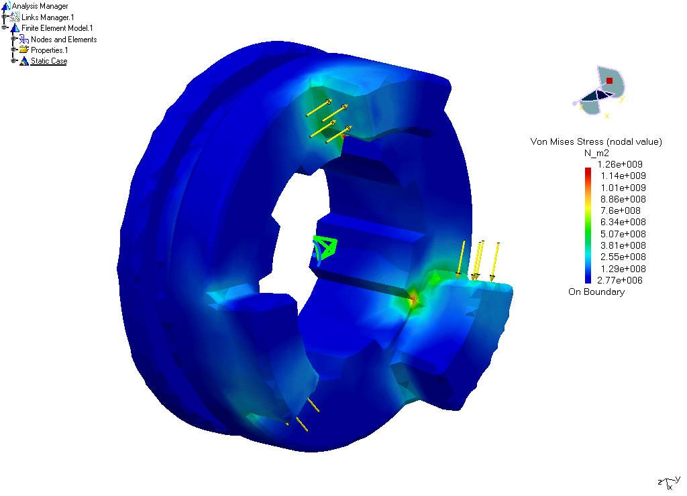
A second driveline option was considered in the preliminary stages of design. The first option for shaft speed reduction was a 6-speed manual transmission from a proven design. After comparison analysis and evaluation of customer requirements, a number of potential problems arose. The gearboxes that were analyzed typically carried gear ratios much higher than those required in a mini-baja application. Packaging and operation was also considered to be too cumbersome. Issues including clutch location and transmission operation while cornering were avoided with the use of the CVT.
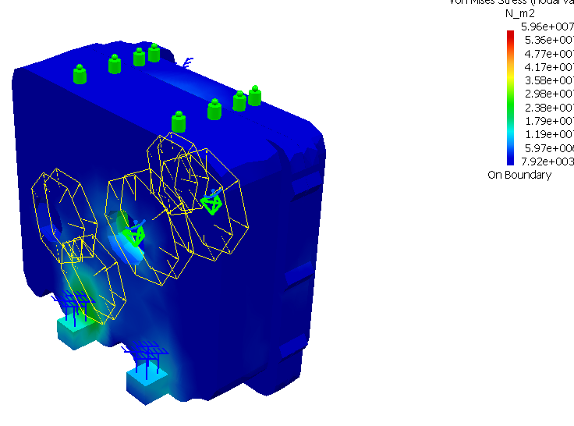
Constant velocity (CV) joints were considered for the half shafts because of their ability to transmit torque through a higher range of suspension articulation. However, CV joints are inherently heavy; and therefore, lightweight universal joints provided a feasible alternative. After analysis, it was found that the operating range of u-joints was sufficient to meet the suspension requirements. Significant weight savings was realized through this design choice.
Improvements in the powertrain system over the 2004 University of Windsor entry are numerous. The 2004 entry employed a two speed chain and sprocket transaxle. The two speed gearbox utilized for 2005 provides a more reliable and compact alternative. The ratios selected for the 2005 entry are spread wider than that of the 2004 car to achieve both an increased top speed in high range, and greater torque in low range. Transmission efficiency is increased by the reduced inertia of the spur gears compared to sprockets. Both the gear box and the differential gear carrier are lubricated using an oil bath, which fosters an efficient operating environment for the mechanical elements. In addition to lubrication, the oil provides cooling and cleansing to the transmission elements.
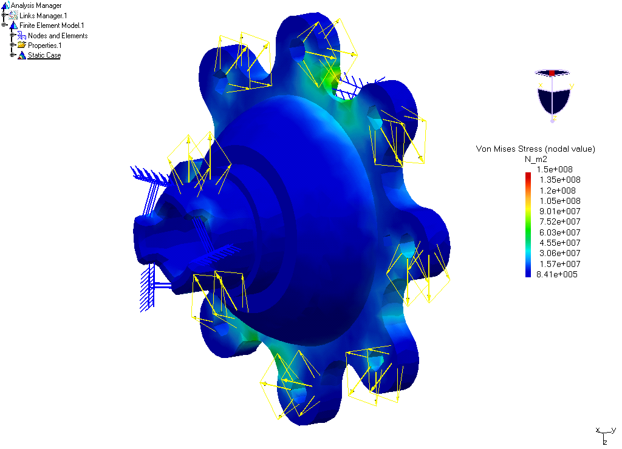
Increased function of the system over the 2004 entry is achieved through the introduction of a reverse gear. A reverse gear enables much more maneuverability and less chance of being trapped in a “bottleneck” situation which can frequently occur in a race setting.
The entire design of the 2005 powertrain provides a very robust alternative to the 2004 entry. The custom gearbox is sufficiently strong to both support the engine and transmit the torque. The rear support, rigidly fixed to the frame provides a very stable setup.
structural design
The following is list of design requirements the mini-baja chassis must satisfy while meeting or exceeding SAE specifications:
- Provide full protection of the driver, by obtaining required strength and torsional rigidity, while reducing weight through diligent tubing selection
- Utilization of nodal geometry to minimize internal bending moments in frame members
- Design for manufacturability, as well as cost reduction, to ensure both material and manufacturing costs are competitive with other SAE vehicles
- Shorten the wheelbase by up to 2 inches over the 2004 vehicle to further improve maneuverability
- Improve driver comfort by providing more lateral space and leg room in the driver compartment
- Maintain ease of serviceability by ensuring that frame members do not interfere with other subsystems

The customer requires a lightweight chassis capable of surviving the rigorous punishment of off road terrain. The frame must have a high torsional stiffness to effectively control the lateral load transfer distribution, and should provide a comfortable ride with ease of serviceability.

One major decision in the frame design in 2005 resulted from the simulated and physical testing of the 2004 vehicle. A finite element analysis of the 2004 vehicle was completed to locate areas that experience the highest loads under a variety of loading conditions. Using ADAMS/Car, an appropriate ramp height was determined through a full vehicle jumping performance simulation of a 2004 car model. Eighteen half bridge strain gages were installed at areas under high loading. The ramp was built and the 2004 vehicle jumped the ramp several times with the strain data collected using wireless transmitters. Both the simulated and actual testing of the 2004 vehicle can be seen in Figure X.
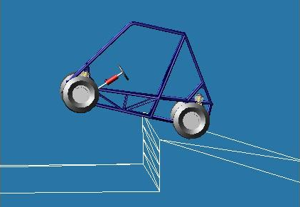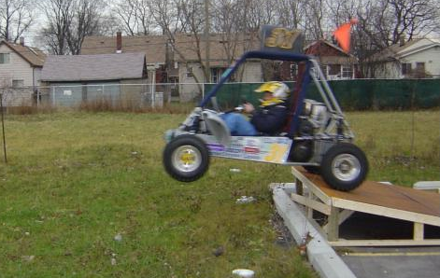

Figure X: ADAMS/Car ramp simulation and actual ramp testing of the 2004 vehicle with use of strain gages
From the strain data obtained, it was determined that it is safe to reduce the 4130 frame tubing from 0.058” wall thickness to 0.049” thickness. This switch resulted in weight savings of approximately 7% over the 2004 chassis.
To provide the desired strength, as well as minimize cost and weight, a combination of roll cage materials was utilized in the frame construction. The frame incorporated both 4130 and 1020 oversized 1.25” steel tubing. The outer roll cage was made of 0.049” wall 4130 Cold Drawn Steel (CDS) tubing that is 32% stiffer and 38% stronger than SAE Mini-Baja specifications to help protect the driver and stiffen areas of the vehicle that may experience impact in a roll over accident (mainly the overhead members). The bracing members were made using 0.049” wall 1020 Drawn Over Mandrel (DOM), Stress Relief Annealed (SRA) tubing that is 32% stiffer and 8% stronger than SAE specifications. Since under SAE costing, mild steel is cost at half that of alloy steel, a cost savings of nearly 30% is obtained over the continued use of the 4130 tubing for the entire structure.
All non-required bracing has been made of 0.75” x 0.058” 1020 DOM SRA tubing, compared to the 0.065” thick tubing used on the 2004 vehicle. This lighter tubing reduces weight while still providing the required load lines through the frame. The overall design and tubing selection for the 2005 chassis can be seen in Figure X.

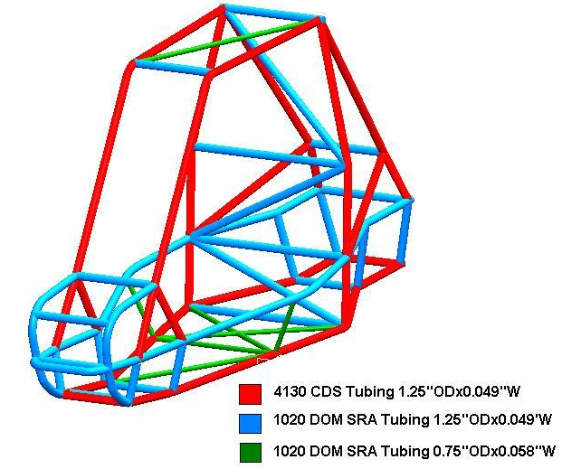

Figure X: 2005 Mini Baja Chassis displaying tubing selection

Before the chassis design was finalized, a mock up of the frame was built out of PVC piping. The mock up allowed the team to see the frame in 3D, as well as mock up the powertrain, steering, and brake systems to ensure that there is adequate space.
For further weight reduction, thinner firewall and skid plate materials were used. The firewall material was chosen to be 0.025” utility grade aluminum. The skid plate was optimized for weight reduction by using a combination of sheet metals. On the front nose 0.06” stainless steel was used where additional strength is required to protect the driver in the event of a front impact. The rest of the skid plate is made of much lighter 0.032” utility grade aluminum where strength is not such a necessity. These materials resulted in a weight savings of 20% over the 2004 vehicle’s shielding materials.
The improved brake and frame design in the front allowed for further wheelbase reduction. One inch was taken off of the driver compartment, and one from the rear due to the shorter driveline configuration. This meets the goal of the further 2” wheelbase reduction over the 2004 vehicle.
Tubing selection was based on not only strength, but also on manufacturability. For example, the newly designed bowed side impact members and front nose were made of 1020 because they are easier to form into the required bends.
In Ideas software, the frame was built out of beam elements, and a torsional load was applied at the front shock mounts. Through this configuration, the torsional stiffness of the frame was calculated to be 2175 ft-lbs/deg. The graphical results in Ideas for torsional stiffness can be seen in Figure X.
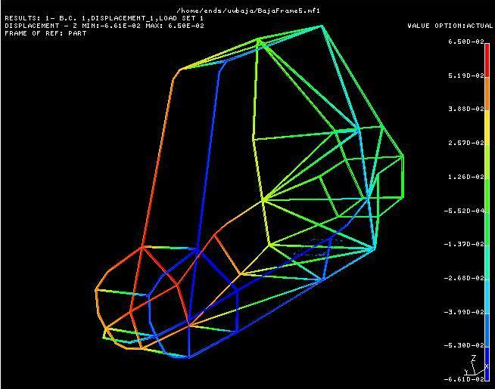
Figure X: Torsional Stiffness results in Ideas software, red is max positive displacement, blue is max negative displacement
The 2005 chassis is TIG welded as compared to the MIG welded 2004 frame. TIG welds produces a very strong, tight, and clean weld which further improves the aesthetics of the 2005 vehicle.
A tubular, front bumper type, front tow hitch was chosen due to its functionality and low cost. By welding a 1 inch tube bent across the front of the vehicle, the front tow hitch can act as both a front bumper to protect the front body panel; and as a hitch point by which the vehicle can be pulled, pushed, or lifted.
For towing of heavy loads the 2005 vehicle employs a newly designed multi-position rear tow hitch. Calculations were performed to determine a range of rear tow hitch locations depending on the length of pulling chain, height hitch on trailer, and road surface conditions. Out of this range, 5 locations were selected to provide maximum traction at the wheel without causing the vehicle to overturn while pulling.
craftsmanship
Suspension and Brake Systems – Meticulous care was taken in fabrication of the suspension control arms. Each tube was manually notched, according to the required geometry, in order to maintain tight fittings and minimize the requirement for filler weld metal. The 4130 control arm tubing was joined by means of a TIG welding process, resulting in clean, high strength fillet welds with small heat affected zones. The front suspension control arm tubing was bent using a ratcheting tube bender; care was taken to ensure smooth, wrinkle free, high quality bends.
Threaded end caps for the rear suspension inboard mounting heim joints, along with the threaded bosses for the front suspension ball joints, were end faced, turned down, drilled, tapped, and polished on a lathe. All mounting brackets were laser cut, and the delrin bushings were turned down on a lathe.
The front and rear uprights were fabricated using a CNC milling machine; the spindles for the front uprights required additional lathe work.
The tie-rods consist of a left hand male threaded bosses and a right hand male threaded boss welded on the inner end and outer end respectively, of the tie-rod tube. Female threaded heim joints are used as the inner tie-rod ends and female threaded ball joints are used as the outer tie rod ends.
The similarly designed profiles of the gas and brake pedals were water jet cut from aluminum plate, and the pedal plate weldments were TIG welded to the CNC machined profiles. Furthermore, the wave rotors were laser cut and surface ground to size. The aluminum rear 3 piece rotor hubs required both lathe and mill work, and the shaft and hub keyseats were cut to positively lock the hub to the driveshaft.
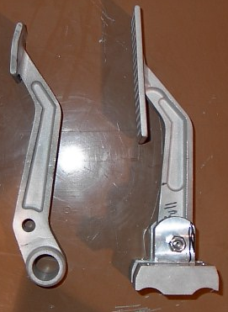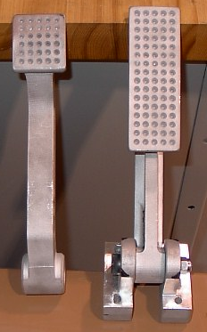
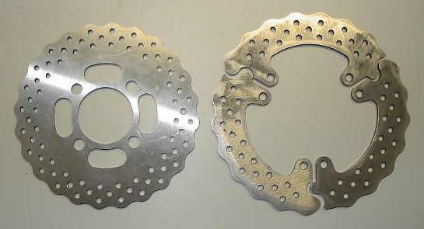
The rear hubs were custom cast of 319 aluminum alloy in order to reduce weight and increase strength. They are a direct replacement for a Polaris OEM part, so that they will mate properly with the half-shafts. The FEA and cast part can be seen in Figure X.
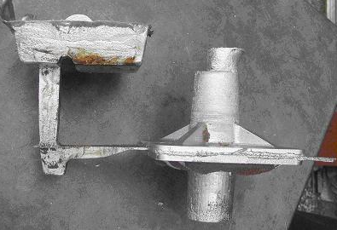
Figure X: FEA and cast part with runner and sprue, respectively
Chassis - Frame construction was a time consuming process, requiring patience and attention to detail. All tube end radiusing was done by hand, ensuring tight notches and minimizing filler weld metal to maximize weld zone strength. A ratcheting tube bender with several die sizes and radii was required to create the complex frame geometry. The chassis was TIG welded to ensure strong, clean weld beads, and all exposed tube ends were capped.
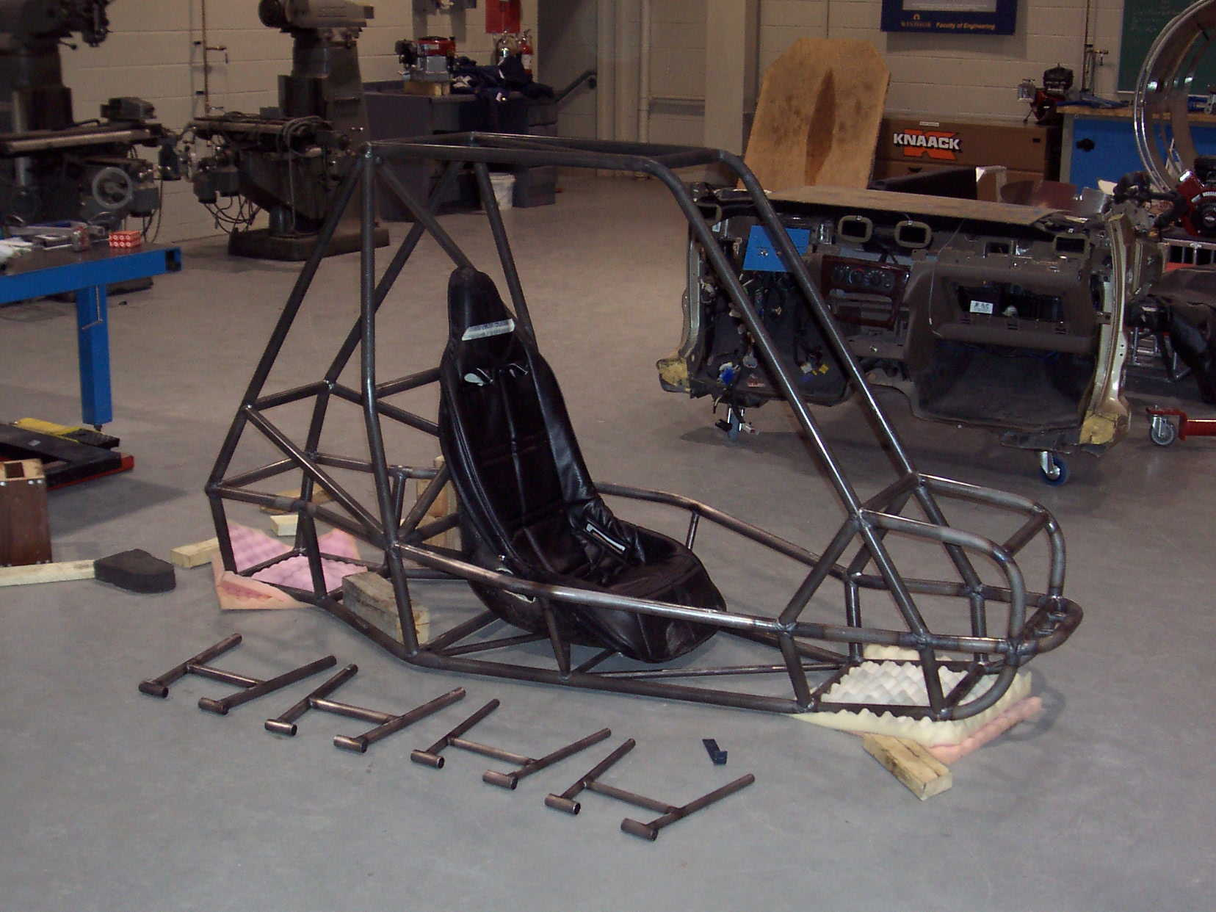
POWERTRAIN - The manufacturing of the powertrain components required close co-ordination of material vendors, along with contracted machine shops. The custom built gear case was machined on a CNC milling machine, along with the differential support. The differential gear carrier was machined on a CNC lathe to ensure that the bearing surfaces of the differential gears were accurate. Material was selected to minimize component weight without compromising function. The gear case, differential carrier, and differential support were manufactured from 6061 T6 aluminum. The differential lock mechanism, including the lock hat, lock collar, and lock slider were manufactured from 4340 chrome-moly steel. The custom lock mechanism maximizes design simplicity without compromising function. The lock hat is a steel component mated to the aluminum carrier and fixed with an interference fit collar to support the junction. The lock slider was manufactured with a slide fit SAE spline to the drive axle. The face meshing dog teeth mate with the lock hat to close the differential. Specific to the drivetrain system, one must ensure that the support bearings are carefully installed to prevent damage to the race way surfaces. Also, one must ensure that the drive axle, sprocket, and rotor hubs are installed with an indicator dial to reduce misalignments, and improve function.
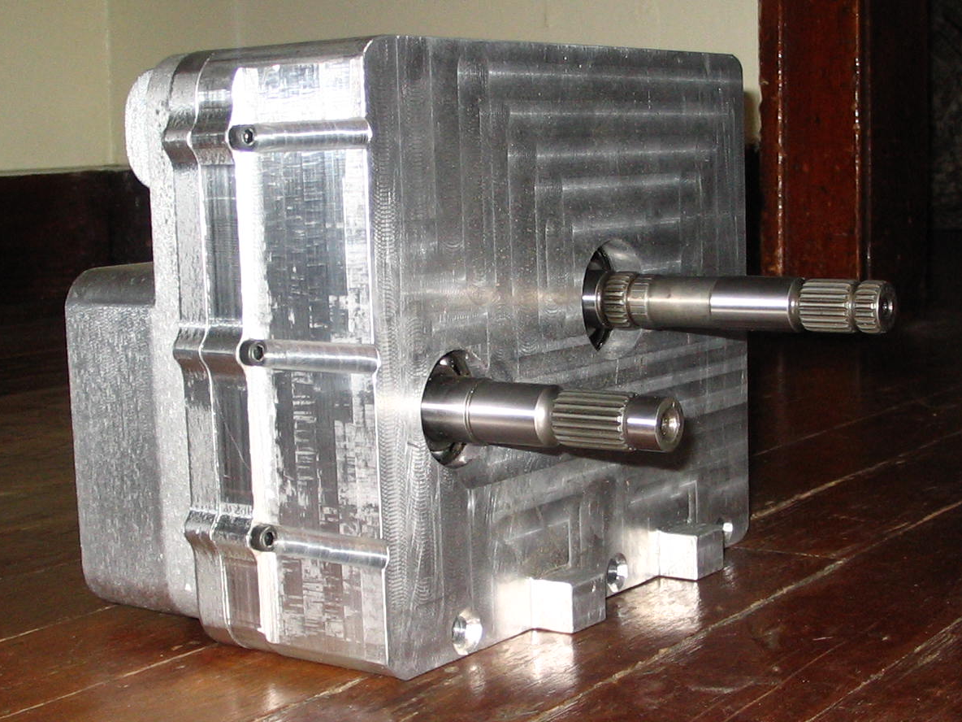
Miscellaneous - The seat is constructed of fiberglass, which was laid to cure on a mold. The glass fibers provide a rigid, lightweight seat, at minimum cost. For a vehicle to be successful, it must not only perform well, but must also be attractive to consumers. The 2005 entry has smooth, aggressive, vacuum formed ABS thermoplastic fenders and front body panel. A vacuum forming manufacturing process was used over composite processes to lower cost and reduce production time. The side body panels are made of flexible plastic sheet, which is shaped around the body and simply fastened using clips. The side body panel provides an aesthetically pleasing look while adding minimal weight.
Operator comfort
To improve driver comfort, the side impact members were bowed to provide additional hip clearance. This provides more room to mount the steering brake, differential lock lever, and the shock reservoirs.
In order to create more room in the nose of the vehicle, the brakes were mounted further away from the driver, which required a re-design of the nose of the vehicle. The nose size was increased, preventing the driver’s toes from touching the front panels of the vehicle, which resulted in an ergonomically improved driving experience over the 2004 vehicle.
Independently adjustable damping rates in both jounce an rebound, coupled with the versatility of spacer configurations on the quad rate springs, provide the operator with precise control over not only how the vehicle handles, but also how it rides. The ride can be tuned soft for leisure riding, improving operator comfort, with the option of harder settings for the driver who wishes to operate the vehicle in MX or cross country racing situations. Furthermore, the compression damping is adjustable from within the cockpit, so the rider has the ability to adjust ride quality on the fly.
feasibility for mass production
Manufacturability was a central feature to the design of each subsystem. Moreover, feasibility for mass production played an important roll in the research, design and development of each component within its respective subassembly.
Combined, chassis and control arm fabrication is limited to the following manufacturing processes: tube cutting/radiusing, tube bending, drilling, tapping, fixturing, and welding. All of which are feasible in mass production. The suspension bushings require simple lathe operations, which could be automated.
The frame requires tube cutting, bending, notching, and welding, similar in process to the control arms.
The rear uprights, gear case, differential carrier, differential supports, gas and brake pedals, all of which have been CNC machined for the purpose of this prototype, will be cast for a mass production run, similar to the rear hubs. All casting processes require post process machining to produce required bearing surface roughness.
The drive axles were turned on a lathe and mounted on a mill to cut the brake rotor hub keyways and differential lock spline. In a production situation the shafts would need to be turned and milled to size. The gearbox, motor, CVT and rear axle would be sequentially assembled onto the chassis on a production line.
serviceability
Suspenison – All suspension components are easily accessible, and designed to be serviceable. The front suspension ball joints are greaseless, as are all of the Delrin bushing mounts used in the control arms. However, the rear suspension heim joints require greasing. The custom built Elka shocks can be completely rebuilt.
Brakes – The 3 piece rotor allows for simple brake jobs; the hard lines allow for inexpensive repair; and the standard automotive flares, fittings, and brake pads are readily available Brake pads can be replaced without difficulty when required, and the master cylinders are easily accessed beneath their protective covering.
Powertrain - The final drive ratio can be tuned to maximize performance by changing the easily accessible output sprocket of the gearbox. The open chassis at the rear of the vehicle allows easy access to any power train component. The modular design of the system increases the ease of component swapping. The drive axles are hub retained; compression rings have been used at the axle end gears to increase ease of axle disassembly. Furthermore, assembly and disassembly tools for the axle and wheel bearings are available as custom tools to aid in maintenance. By locating the fill/drain holes of the gearbox and differential carrier in obvious and accessible locations make routine maintenance problem free.
COCKPIT - Dirt and mud inside the driver compartment are an unavoidable consequence of off-road driving. Thus, quick releasing body panel clips were incorporated to allow for easy access to those hard to clean places in the cockpit. Furthermore, easy cleanup is facilitated by the fully water resistant driver compartment, which can be quickly hosed down and drained.
Conclusion
Designing a “fun to drive”, versatile, practical and attractive vehicle that targets diverse customer markets is the goal of every design team. The University of Windsor’s 2005 Midwest Mini-Baja entry has been successfully designed and built according to the stated objectives.

The SAE Midwest Mini-Baja competition in Troy, Ohio will compare the vehicle’s design, performance, durability and engineered solutions against that of similar vehicles from other schools. This will determine if the University of Windsor’s 2005 entry is truly competitive.

Since the design process is never ending, the design and modification will continue well beyond the competition. Experience gained from the competition and testing will highlight areas that require design improvements.

The design of each of these components is further detailed in the following report.Acknowledgments
The team would like to thank the following individuals for their continued support and knowledge throughout the past year:
Dr. Greg Rohrauer – SAE Faculty Advisor
Dr. Bruce Minaker – Faculty Advisor
Mr. Bruce Durfy – M.A.M.E. Technician
Mr. Mike Charron – M.A.M.E. Technician
Mr. Bob Tattersol – M.A.M.E. Technician
Mr. Andy Zuccato, Mr. Darryl Danelon,
and Mr. Ed Oh – Graduate Assistants
Special thanks also go out to all of our generous sponsors that enabled this project to come to life.
References
- Inclusion of this section is mandatory.
- Type references over these paragraphs.

CONTACT
Steven Reis – Technical Head
University of Windsor Mini-Baja Team
Fourth Year Mechanical Engineering Student with Automotive Option
reis3@uwindsor.ca

Matt Reynolds – Team Coordinator
University of Windsor Mini-Baja Team
Fourth Year Mechanical Engineering Student with Automotive Option
reynol3@uwindsor.ca
Additional Sources
Here are any additional sources. This is an optional section.
Definitions, Acronyms, Abbreviations
Here is the Definitions section. This is an optional section.
Term: Definition for the term
APPENDIX

HELPFUL HINTS:
- Tables — When creating tables, do so by using the “Insert Table” command under the Table menu.
- Greek Fonts — When using Greek fonts in your paper, please apply the “Symbol” style to the characters by using the “Style” command under the Format menu.
- Bold, Underline, Italic — When applying these styles in your paper, please apply the appropriate style to the character by using the “Style” command under the Format menu.
- Figures — Please number figures consecutively.
- To FTP files to the SAE site from either Netscape Navigator or Microsoft Internet Explorer, type:
ftp://papers:papers@www.sae.org/papers/incoming
Authors who are connected to the Internet can click on the above link to transfer their electronic Technical Paper file. Please note that, for security reasons, authors will not see the document placed in this directory, but will receive confirmation in the form of a reply web page.

To obtain the latest SAE Technical Paper templates, they can be downloaded from the download area of the SAE web site:
ftp://papers:papers@www.sae.org/papers/outgoing
There, authors will be able to select one of several templates, and download by double clicking on the desired version.

Authors wanting to use a different FTP client should use the following information to logon:
Site: www.sae.org
Username: papers
Password: papers
Directories: for incoming papers: /papers/incoming
for outgoing templates: /papers/outgo



