Title: Scientific Diagrams as Argument: The Example of Darwin
Author: A. Gross
Commentary by: F. van Eemeren

© 2003 A. Gross

As we gathered data for our book, Communicating Science, my collaborators and I discovered the increasing centrality of figures to scientific communication and thought, an increase especially evident as the 19th century unfolded. Simultaneously, these figures altered in character; more and more, they depicted, not things, but theories. Now I would like to correct for this omission for our book, concentrating especially on the single diagram in Darwin's Origin of Species. Although of course well-known, it is little commented upon. I think this is an error, one perhaps due to the relentless focus of philosophers of science on sentences and their underlying propositions. But when we look at this diagram along with its text, when we look at the Origin as a whole as a semiotic system, its verbal and visual codes combining to create meaning, we see this diagram as a component that is part of the “one long argument” that is Darwin’s book. To see the diagram this way is legitimately to stretch the meaning of argument, to insist that there are visual arguments and that no argument theory that omits such arguments can be called complete.
In the case of the single diagram in Origin, lines and curves depict aspects of the world only insofar as those aspects serve evolutionary theory. The diagram’s vertical dimension is time; its horizontal dimension, organic diversity. The further up you go, the nearer you get to the present; the further apart species are, the more they have differentiated themselves from their parent species through evolutionary processes. Reading the diagram vertically, we trace descent. We see that a¹ and m¹, and a¹⁰ and m¹⁰ have the same remote ancestor A. Reading horizontally, we see that far greater evolutionary divergence exists between the latter pair than between the former.
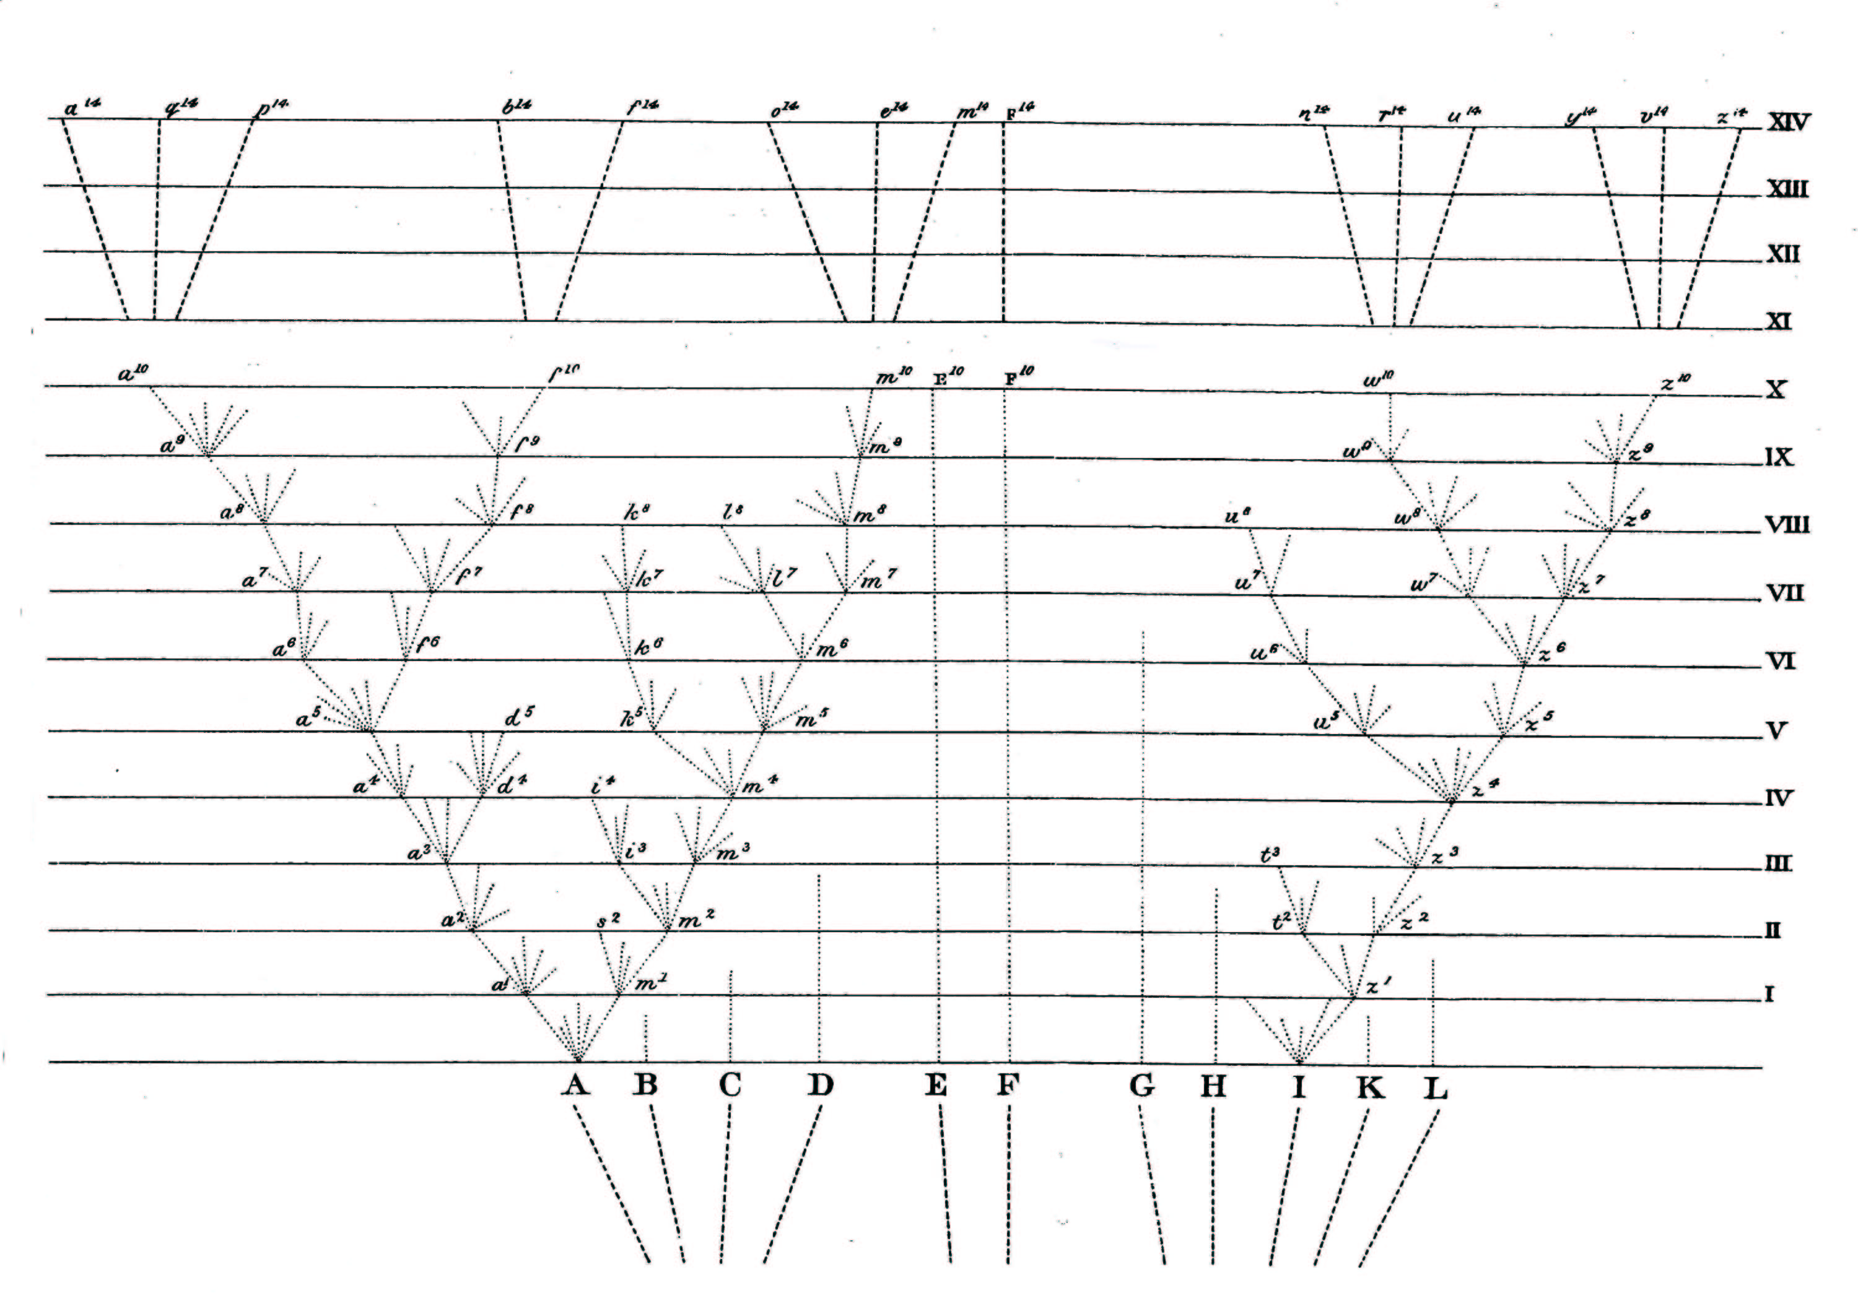
Extinction is also represented in the diagram, literally, by the end of a line. Species s², the descendent of A, becomes extinct in Era II; species u⁸, a descendant of z⁴, which is, in turn, a descendant of I, becomes extinct in Era VIII. The diagram also embodies the cause of extinction, the struggle for existence. It is no accident that A, F, and I, whose ancestors are still living, were originally nearly the most divergent from each other, for the nearer species are along the horizontal dimension, the more likely they are to compete for the same territories and resources in the battle for survival; the more likely they are to become extinct. In many cases, B, C, and H, for instance, there is no evolutionary change over time, but only in the case of F do we still have a living species, a living fossil. In other cases, the branches of evolutionary trees eventually crowd out these lines of descent.
Finally, Darwin makes a theoretical point about the significance of the numbered letters: “In our diagram the line of succession is broken at regular intervals by small numbered letters marking the successive forms that have become sufficiently distinct to be recorded as varieties. But these breaks are imaginary, and might have been inserted anywhere, after intervals long enough to have allowed the accumulation of a considerable amount of divergent variation” (119). Despite their individuation as points, species a¹, a², a³, etc., are not real; even the lines of divergence are conjectural; they are dotted lines. Only the processes that create divergence are real. Evolution embodies an ontology of process, rather than product.
Moreover, as the time scale of the process is open, the amount of evolutionary change each incremental coordinate represents may legitimately vary. Darwin says: “If we suppose the amount of change between each horizontal line in our diagram to be excessively small, these three forms may still be only well-marked varieties ... but we have only to suppose the steps in the process of modification to be more numerous or great in amount, to convert these three forms [a¹⁰, f¹⁰, and m¹⁰] into well-defined species” (120). But the time scale can also change enormously. Darwin asks us to imagine the vertical increment represents “a million or hundred million generations” (124). This variation in time scale and, consequently, in the span of evolutionary change blurs distinctions between species and variety, genus and species. In effect, Darwin turns the diagram into an argument for these intellectual leaps.
Thus far we have seen Darwin’s diagram as a representation of evolution; but it is equally a representation of the geological record, “a succession of the successive strata of the earth’s crust including extinct remains” (124), a record of evolution. In the first case, the vertical dimension is metaphoric: space represents time. In the second case, the vertical dimension is denotative: space represents only space—the geological column. But the geological column is, as it were, time made visible; therefore the vertical dimension also represents time. Really, it is time: looking at the fossil embeddings in the geological column, we are, in a very real sense, looking at the past. It is a past, moreover, that the first reading of the diagram allows us to understand. Looking at the geological record, Darwin says, “we find . . . such evidence of the slow and scarcely sensible mutation of specific forms, as we have a just right to expect to find” (336). The location of these forms and their fossil remains, it should be noted, is not their physical but their evolutionary location, not where they are found, but where, once found, they belong in the evolutionary sequence.
It is crucial that the diagram has gone half-way to meet theory, divesting itself in the process of those features that facilitate pattern recognition in the case of middle-sized objects such as real trees and real geological columns. It is precisely this divestment that permits the diagram to mediate between the world and its explanation.
We can see the argumentative value of graphic presentation when we compare Darwin’s diagram with its verbal ‘equivalent’; Darwin ends the chapter in which the diagram appears with an extended simile based on the analogy between evolutionary development and the growth of a tree. Up to a point, the comparison holds: “The green and budding twigs may represent existing species; and those produced during each former year may represent the long succession of extinct species. At each period of growth all the growing twigs have tried to branch out on all sides, and to overtop and kill the surrounding twigs and branches, in the same manner as species and groups of species have tried to overmaster other species in the great battle of life.” But the argument from analogy soon outwears its theoretical and expository welcome. In the verbal expansion, disanalogy undermines Darwin’s theoretical purpose: In the case of the real tree that must be the vehicle of Darwin’s extended simile, the lower branches, trunk, and roots must be alive or there can be no top branches. The minimalism of his diagram permits Darwin to evade this fatal implication: The diagram represents only those characteristics of a tree that serve his theoretical purpose.
Darwin’s strategy is to not to rely solely on verbal argument or graphic presentation or metaphorical representation, but to avail himself of every available modality of persuasion. As a consequence of this rhetorical assault, the visual-textual compound that is the single diagram in Darwin’s Origin becomes more than a depiction of evolutionary theory; it also becomes an argument in favor of that theory. The geological column is evidence for the theory of descent; the theory of descent explains the geological column.
But the analysis thus far does not exhaust the diagram’s argumentative possibilities. The diagram also presents us with a paradox, a visual figure of speech: death is life. Death and life are dramatically juxtaposed, the living beings of the tree with the fossils of the geological column, revealing that continuing life depends upon continued death. In addition, the diagram functions as a conceptual oxymoron. It juxtaposes actual continuity, the tree of life, with apparent discontinuity, the fossils in the geological column; it demonstrates that the discontinuity evidenced in the column is really evidence of continuity, revealing that seeing must not be believing. We know from the work of Jeanne Fahnestock that the figure “is a verbal summary that epitomizes a line of reasoning. It is a condensed or even diagram-like rendering of the relationship among a set of terms, a relationship that constitutes the argument and could be expressed at greater length” (24).
We may say with some justice that, so interpreted, Darwin’s diagram is his theory, his argument. On this view, once we understand the diagram, we understand Darwin. On this construal, our view of the Origin as a book with one diagram is mistaken; it is really a diagram so complex that it takes a whole book to unfold its meaning. Such a view, however, misrepresents the division of labor that Darwin’s work so elegantly exemplifies. Necessarily, Darwin’s diagram falls short of depicting the complexity of the processes involved. It altogether omits sexual selection, the effects of inbreeding that would retard change, and the environment that is change’s motor: “The diagram illustrates how natural selection, the principle of divergence, and the evidence for the extinction of many species in time [can be conceived and grasped as a single picture]. It goes far in exemplifying the complexity Darwin needs, but cannot do it all. Darwin needs the rest of the book, not [only] to explain the diagram, but to explain to his readers the complexity of the process that is missing from the diagram” (Reidy, personal correspondence). In short, Darwin’s diagram and Darwin’s texts function together, two semiotic codes that fuse synergistically to create the meaning and enhance the significance of the Origin of Species.

References

Darwin, Charles. 1964. On The Origin of Species. 1st. edn. Cambridge: Harvard University Press.

Darwin, Charles. 1987. Charles Darwin’s Notebooks: 1836-1844. Ed. Paul H. Barrett and others. Ithaca: Cornell University Press.

Fahnestock, Jeanne. 1999. Rhetorical Figures in Science. New York: Oxford University Press.

Gross, Alan G., Joseph E. Harmon, and Michael Reidy. 2002. Communicating Science: The Scientific Article from the 17th Century to the Present. New York: Oxford University Press.

Reidy, Michael. October 2, 2002. Personal correspondence.

Notes

Paraphrased from a letter of Michael Reidy, October 2, 2002.
Perhaps Darwin would have been better off with an alternative comparison, mentioned in the Notebooks: “the tree of life should perhaps be called the coral of life, base of branches dead” (177). But for his 19th century audience coral would have lacked the cultural resonance possessed by the tree.
Fahnestock makes the additional point that only if it were in three dimensions, as in a computer graphic, could the diagram do full justice to branching (121).

