60-592. Project II

Study Tools: Analyzer

Instructor: Dr. Aggarwal

By: | Zhongwei Hu
 | Xinyu Gan
 | Haitao Zheng

Table of Contents

Chapter 1. Preamble --------------------------------------------------------------------------------------------------------------------------- 1

Chapter 2. Introduction of Analyzer ------------------------------------------------------------------------------------------------ 3
2.1. Analyzer Structure
2.2. Description of the Main Components
2.3. Configurations Files
2.4. Data Captures

Chapter 3. Case Study ------------------------------------------------------------------------------------------------------------------------ 12
3.1. Data Captures Samples
3.2. Statistics Graphs
Appendix. Reference --------------------------------------------------------------------------------------------------------------------------- 16

In our second project, three members in our team have spent lot of our time together, and contributed almost the same time and work. Also, we would like to take this chance to thank Dr. Aggarwal for giving us such a good opportunity to learn some new & useful tools with all of our classmates in this course.
Chapter 1. Preamble

1.1. Objective

To study a new domain network analysis tool – Analyzer, we can have better knowledge and understanding about Network Traffic. This brings us tons of benefits in providing a domain network security during our current and future work and study.
1.2. Contents
Analyzer is a full configurable network analyze program for Win32 environment. Analyzer is able to capture packets on all platforms (and link-layer technologies) supported by WinPcap (except for Windows 95), and it displays them through a graphical interface. With Analyzer, we can choose the network adapter (used for the capturing and monitoring process), specify an appropriate filter, select, copy and paste packets.
1.3. Supported Platforms
The WinPcap drivers support most of the Windows platforms. Basically, Analyzer supports Windows 98/ME and NT/2000. However, analyzer does not work with Windows 95.
1.4. Network compatibility
Ethernet is well supported. Token Ring and FDDI should be supported as well. However, dial-up adapters are usually unsupported.
1.5. Pre-Installation
1. Uninstall all the preview version of the capture drivers (WinPcap) prior of release 2.1.
2. Reboot the machine
3. Make sure that there is not any packet.dll and packet.vxd (on Win98) or packet.sys (on
Win NT/2000) in the system. If they are still present, please delete them manually.
4. Install the latest version of WinPcap (recommend Version 2.2)
1.6. Analyzer Installation
1. Download the latest Analyzer (2.2) released in a compress executable form
2. Decompress the program into the destination folder on the hard disk
3. Analyzer does not need any installation. Analyzer can be launched by double-clinking on the Analyzer.exe file.

Chapter 2. Introduction of Analyzer
Analyzer is a packet-capture tool. It captures packets from network and displays them via a graphical interface. The user can choose the network adapter, specify an appropriate filter, select, copy and paste packets. Advanced features concern both the possibility to make some advanced statistics on the packets and to plot statistics in real time (number of packets flowing through the network and so on).
2.1. Analyzer Structure
Analyzer is made up of several components:
① A graphical interface, used for a user-friendly interaction.
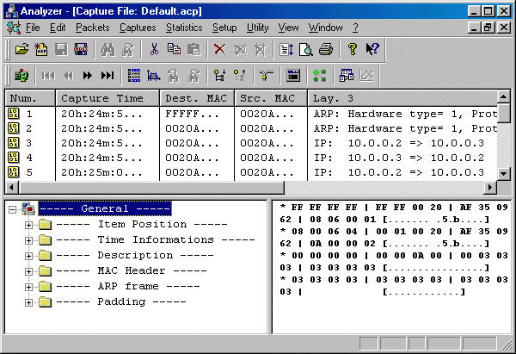
② A low-level packet capture library, used to capture packets, monitor network traffic. Analyzer uses the WinPcap library to capture packets from the network and to create the capture file.
What is WinPcap? WinPcap is an architecture for packet capture and network analysis for the Win32 platforms. It includes a kernel-level packet filter, a low-level dynamic link library (packet.dll), and a high-level and system-independent library (wpcap.dll, based on libpcap version 0.5). Please see [2] http://netgroup-serv.polito.it/WinPcap/ for more detail information about WinPcap.
③ Query is remained from the older versions of Analyzer. Query is a standard application, which receives command lines and produces text lines as output. Query aims at:
I. Read capture files created by Analyzer. These files are interpreted by a special code (dynamically created) to decode packets, display protocols in the graphical interface. For instance, when the graphical interface asks Query for the packet number 34, then Query looks for the required packet in its packets list and returns the dump of the packet. Then it will interpret the packet and all the protocols contained in there, then the interface will format the text output properly in order to make it looking good.
II. Provide off-line statistics on the capture files.
④ Parsers: these are external programs that take text files as input and they generate pseudo-code used to interpret and display packets.
⑤ Graphical Plug-ins: they are standard Windows DLLs that aim at displaying graphics coming from the statistical and monitoring output.
The following figure shows a general schema about the interactions among the components of Analyzer.

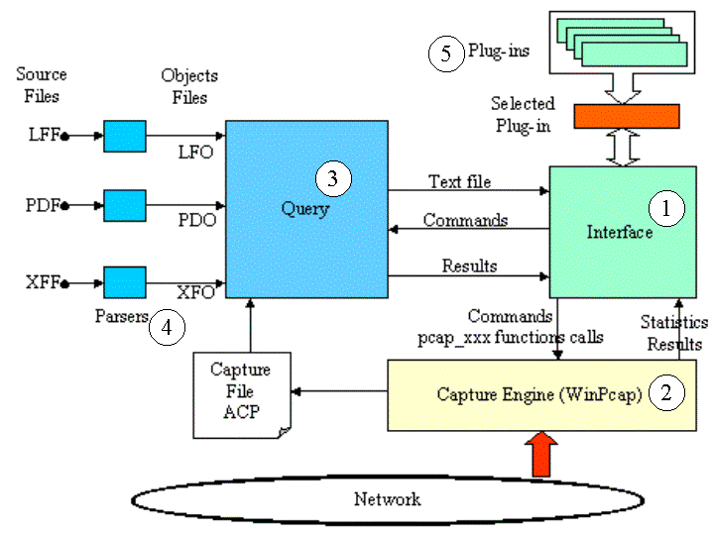
From the above figure, Query ③ is the analysis engine, it reads the capture file created by the Capture Engine ② (based on the WinPcap library); Query ③ needs some configuration files (indicated in the figure with their abbreviations which are also their extensions) to read the capture file. These files include: the format of the capture file (LFF - Log File Format), the protocols structure (PDF - Protocol Definition Format), which kind of information have to appear in the index of the first panel in the Analyzer window (IFF - Index File Format), the structure of the packet description which appears in the second panel (the tree view panel) (DFF - Definition File Format). These files are ordinary text file; an advanced user can modify these files in order to add a new protocol to the supported list or to enable a new capture file format recognition created for instance by an other network sniffer. Query ③ does not directly receive the configuration files; it receives their object files created by three parsers ④ which are applications separated from Analyzer. So Query ③ has all the information to read the capture file and to create the output which is composed by text lines; these text lines contain all the information which are shown by the three panes of the graphical interface: the packets index, the packets description and the hexadecimal packets structure.
The Capture Engine ② is implemented calling the functions defined by the WinPcap library which
is included in the Interface ① project. Through these function the Interface ① sets the capture parameters (Adapter, file name where the capture is stored, capture filter, number of packets which have to be captured ...) and launches the capture. The capture file, which is created using the ACP format, is passed to the Analysis engine which reads it. Besides the Interface ① uses the WinPcap to show the network traffic situation in real time. Through the Interface ① the user can set which type of traffic has to be monitored, then the chosen parameters are sent to WinPcap through the pcap_xxx functions calls. The results of the network monitoring are directly returned to the Interface ① which shows them through the graphic engine.
The graphic engine is implemented through a group of DLL files - the plug-ins ⑤. Each plug-in ⑤represents a graph (pie, column, line,...); it receives from the interface the data which have to be represented.
2.2. Description of the main components

(1) Protocol parsers (PDF, DFF, IFF)
Analyzer uses three external parsers that are used to make the protocol parsing/decoding working. To edit these three protocol parser files, go to “Setup” → “Protocol Def.”.
- PDF file (Protocol Definition Format) defines protocols supported by analysis engine and it is a normal text file.
- DFF file (Description File Format) defines the complete description of the protocol
- IFF (Index File Format) describes a brief description of the protocol
Analyzer executes these parsers automatically when
- User changes the source files (for example the protocol definition, in menu' s Setup/Protocol Definition)
- At launch time (Analyzer automatically controls the coherence of object files with the corresponding source file)

(2) Other parsers (LFF, STT, MAC)
There are other parsers used by Analyzer. Most of the ways they work are shared with the protocol parsers (interaction with Query and so on). Below is a brief description of these components.
- Definition of the dumpfile format (LFF: Log File Format)
There are several programs for network analysis and capture, each one with its proprietary dumpfile. LFF files are used to describe the format of each dumpfile in order to allow analyzer to import files created with different programs. Even if LFF is a generic description format that can be used to import and export files, Analyzer does not allow exporting files with different formats; only importing is permitted. This parser can be launched either by Analyzer or manually:
fdreader INPUT.LFF OUTPUTFILE.LFO

Statistics files (STT: STaTistics files)
The statistics files are used by the analysis engine to evaluate statistics on capture files. They usually have the extension STT (STaTistics). They describe the statistics which have to be evaluated. These files, which are text files, need empty row in order to separate the different sections. STT is case sensitive except for the part involving protocols fields / protocol names.

Macro files
These files allow launching by one only command the execution of an analysis engine functions series. The functions series has to be written in the MAC file, then this file has to be compiled in order to create the relative object file (the MO file); then this file is interpreted and executed by the Analysis engine. The MAC file is a normal text file, it does not need end row characters and its parser is not case sensitive.

(3) Query: the Analysis engine
The analysis engine, Query.exe, is a standard console application and it can be used "stand-alone". Analyzer uses this program and it redirects its input/output to the graphical interface.
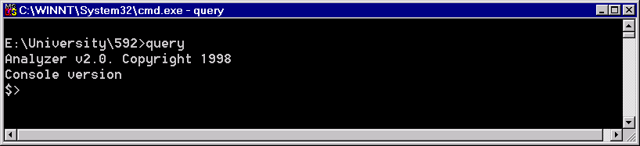
Query supports two kinds of commands:
- Off-context commands: they are commands that can be given at any time
- On-context commands: they are commands that can be given only when there is a capture file open.

(4) Graphical Plug-ins
Analyzer relies on external applications for all graphical-related jobs. So, for example, Analyzer himself is not able to create a pie graph representing the protocol distribution during a certain time interval. Analyzer is able to calculate the raw data using its built-in monitoring and statistics functions but it is not able to display the result. Analyzer uses a set of external applications that are able to accept raw data (for example a CSV table) and print graphically the result.
These applications are dynamic link libraries (DLL) with Microsoft Foundation Classes (MFC) support. In few words: they receive the data that has to be printed and the device context where the graph has to be drawn. This implementation offers the following advantage: the user can create a new plug-in which draws his prefer graph and, after inserting it in the plug-ins directory, Analyzer will automatically be able to display data according to the new graph. These files have the extension APG (Analyzer PluG-in).
2.3. Configurations files

2.3.1. Analyzer interface uses a list of DAT files, which are stored in the folder “Data” as below:
  - Cap_fltr.dat: the filter list which is presented by the dialog used to set the capture filter.
  - Exts.dat: the LFF files presented by the dialog 'Capture definition and file association' (menu: Setup/Captures/Captures Association).
  - Filters.dat: the filter list presented by the dialog which sets the filter used to select the packets.
  - metering.dat: the filters list presented by the dialogs “Monitoring Settings” and “Statistics Settings”.
  - Tables.dat: “Tables.dat” is not directly used by Analyzer interface. It includes several constants used by the parsers; these include a list of Ethertype, protocol type, and others.

2.3.2. Some .INI files (Analyzer.ini, Query.ini, Plug-ins INI files)

(1) Analyzer.ini
Analyzer.ini is a normal Windows .INI file. It defines all of the Analyzer settings, page setup, capture settings, DAT. Files, and windows settings, etc…
Following is some samples:
[Settings]
AppPath=C:\WINDOWS\DESKTOP\592\ANALYZER\
PDF=Conf\Protocols\default.pdf
IFF=Conf\Protocols\default.iff
DFF=Conf\Protocols\default.dff
LFO=Conf\Objects\default.lfo
PDO=Conf\Objects\default.pdo
IFO=Conf\Objects\default.ifo
DFO=Conf\Objects\default.dfo
TmpDat=conf\Data\TmpDat.dat
HTMLdir=conf\html\
PreviewPages=1
FontList=Arial
……

(2) Query.ini
This file stores the configuration settings for Query. It is located in the same directory which query.exe belongs to. Paths are relative to the Query.exe folder.
[Settings]
rows=25
cols=80
MaxItemSize=65535
Tables=conf\data\tables.dat
lfoName=objects\default.lfo
pfoName=objects\default.pdo
dfoName=objects\default.dfo
ifoName=objects\default.ifo
CsvSep=20
[PRINT]
v=VENDOR_CODE
m=MULTICAST_ADDRESS
p=PROTOCOL_TYPE
l=LLC_SAP
i=IP_PROTOCOL_TYPE
a=ARP_HARDWARE_TYPE
r=XEROX_PACKET_TYPE
n=NETWARE_PORTS
t=TCP_PORTS
w=UDP_PORTS
[Cap]
1=mac
11=llc_atm

(3) Plug-ins INI files

Each plug-ins has its own configuration file whose name coincides to the plug-in name. These files contain the settings specific to the plug-ins (such as the font size, etc.). They are saved in the folder iniplugin contained in the plug-in folder indicated by Analyzer.ini.
2.4. Data Captures
In our sample study, we will concentrate on some real data captures by Analyzer displayed via the graphical interface. The Query is a command lines console remained from the earlier version of Analyzer. We won’t spend too much time on Query in this project. All of the functions in Query have been covered in the current Graphical Interface Analyzer.
In the current Analyzer version, we can select filters from four different layers:
- Mac layer
- Network layer
- Transport layer
- Application layer
First, we need to select network adapter (if there are more than one adapter in the computer).
Second, we can edit capture settings, such as “Capture buffer size”, “Number of packets to
capture” (or the capture can be stopped by user), “Section of the packet to capture” (Whole packet or packet header only), and “Time to start the capture”.
Third, we can edit filter list. By editing “rt_filters.DAT” file, we can modify or define new filters at different layers.
Following is the default settings for the four layers:
[Mac layer]
All traffic,
Broadcast traffic, ether broadcast
Multicast traffic, ether multicast
Traffic of packets <= 64 bytes, less 64
Traffic of packets >= 65 < 128 bytes, greater 64 and less 128
Traffic of packets >= 128 < 256 bytes, greater 127 and less 256
Traffic of packets >= 256 < 512 bytes, greater 255 and less 512
Traffic of packets >= 512 < 1024 bytes, greater 511 and less 1024
Traffic of packets >= 1024 < 1518 bytes, greater 1023 and less 1519
Arp Requests, arp
Rarp Requests, rarp
Host 00:80:c7:cb:43:9a, ether host 00:80:c7:cb:43:9a
Source Host 130.192.16.81, src host 130.192.16.81
[Network layer]
IP traffic, ip
IPv6 traffic, ip6
Tunnelled IPv6 in IP traffic, ip and ip[9]==41
IP Broadcast traffic, ip broadcast
IP Multicast traffic, ip multicast
[Transport layer]
TCP traffic, tcp
New TCP sessions, tcp[13]&2=2
udp traffic, udp
ICMP traffic, icmp
[Application layer]
Web traffic, port 80
New Web sessions, dst port 80 and tcp[13]&2=2
FTP traffic, port 21 or port 20
New FTP sessions, dst port 21 and tcp[13]&2=2
Mail (POP and SMTP) traffic, port 25 or port 110
Telnet traffic, port 23
New Telnet sessions, dst port 23 and tcp[13]&2=2
NETBIOS traffic, port 137 or port 138 or port 139
SNMP traffic, port 161 or port 162
Another advantages for this new version Analyzer is: it could display all the data traffic as various graphic interfaces. The graphic interface can be used to track in two ways:
- Statistics Summary (Cumulative)
- Real-Time Monitoring
We will show these in detail at the next chapter.

Chapter 3. Case Study
In this chapter we will capture some data using different filters. Analyzer is a fully configured tool. Advanced users may specify to capture the kind of traffic they want. The other main function for Analyzer is statistics. It can show the real time monitoring and cumulative result in different format. In this way, the user may have the vivid impression of what the current network status are.
3.1. Data Captures Samples
3.1.1. All Traffic
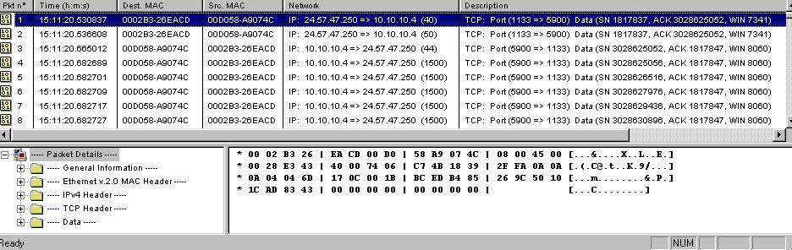
The above screen shot shows the result of all traffic in an organization’s private network within a period of time. It captured 150 packets. Every single packet has the exact bit flow represented in hexadecimal format. The analyzer also interpreted them into readable form. For example we can tell from the upper part of the screen the time each packet was captured, source and destination IP address and port number, serial number and ACK, etc. The lower part of the screen shows the detailed information of a particular packet, as per user’s request, the analyzer may highlight the exact part of data that represents the general information, Ethernet header, IPv4 header, TCP header and user data. In this way Analyzer user may have a clear idea of what the packet’s components are.
3.1.2. IP traffic
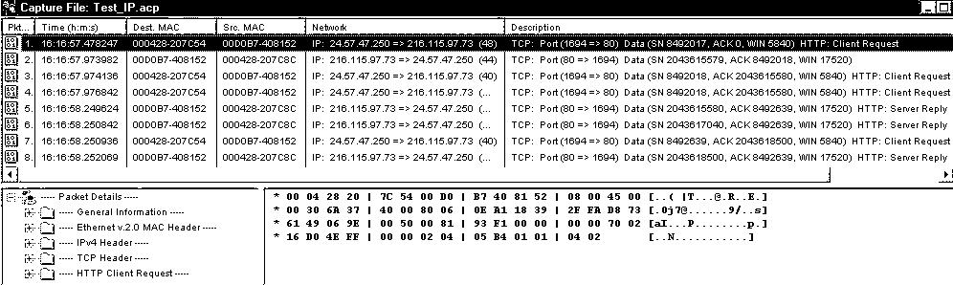
The above screen shot captures all the IP packets during a certain period. The information includes the operation time, source/destination Mac address, IP addresses between the transfer, and TCP port numbers involved. In the advanced capture settings dialog, the user may define the capture buffer size, the number of packets to capture or only capture the header etc.

    - TCP traffic
The following screen shot captures another sample of the TCP packets. The information also includes the operation time, source/destination Mac address, IP addresses between the transfer, and TCP port numbers involved. 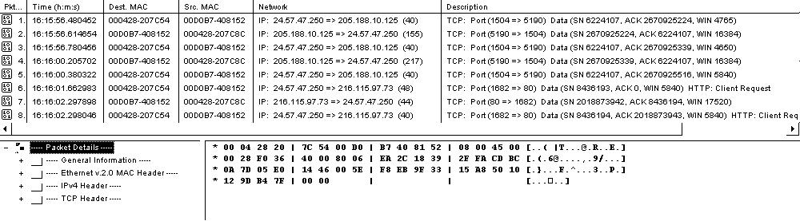
3.1.4. Traffic of packets less than 64 Bytes

The user can edit the configuration file to define what kind of packets to be captured, for example the amount of data within a specific size in a certain period. The screen shot below shows the result of captured packets less than 64 Bytes.
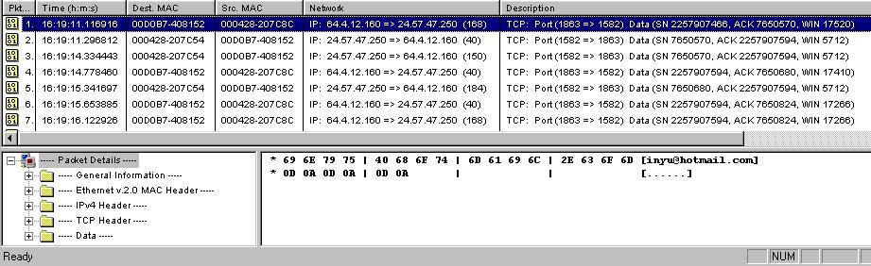
3.1.5. Telnet Data Capture
Analyzer may also capture traffic under the same service. Below is the traffic contributes to Telnet connection.
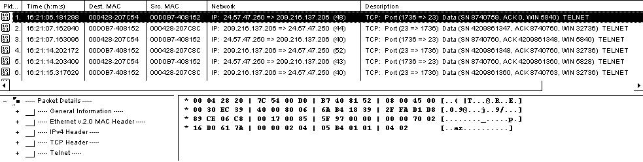

3.1.6. WWW Data Capture

The following shot shows the WWW data traffic captures in a certain period.
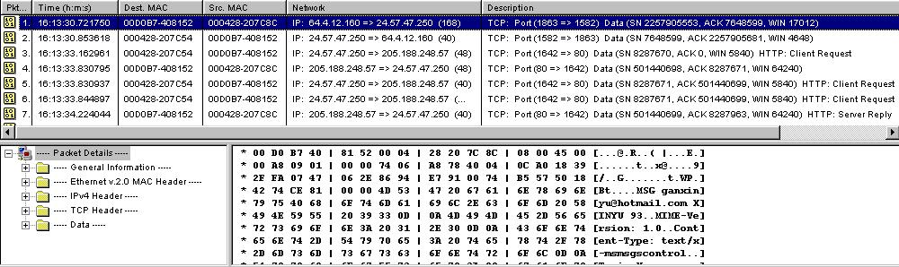

3.2. Statistics Graphs
Analyzer may also capture the real-time data or calculate the cumulative report and present them in line, 2D or pie graphs. Here are some examples in general cases.
3.2.1 Real Time

In this figure below, Analyzer captures four different traffics (IP, TCP, WWW, Telnet) and displays the output in a real-time base. In each small pie, it shows the data traffic amount percentage at that certain period.
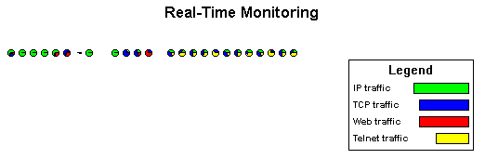

3.2.2 Cumulative Report

In this figure below, Analyzer captures the four same traffics (IP, TCP, WWW, Telnet) and displays the output as the cumulative amount base. During this certain longer period, the pie shows the data traffic percentage for all these four traffics.
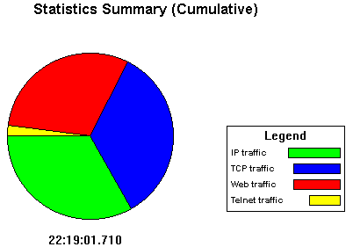

Appendix. Reference

[1] “Analyzer: a public domain protocol analyzer”, http://netgroup-serv.polito.it/analyzer/
[2] “WinPcap: the Free Packet Capture Architecture for Windows”, see
http://netgroup-serv.polito.it/WinPcap/

