60-564 : Report on Paper Review

A survey on
Secure Protocols for
Wireless Sensor Networks



Instructor : Dr. A. K. Aggarwal

Prepared by :
Md. Shamsul Wazed & Rahman Quazi

April 05, 2006
School of Computer Science

List of 4 Selected Survey Papers

[1] N. Aboudagga, M.T. Refaei, M. Eltoweissy, L. DaSilva and J. Quisquater, “Authentication Protocols for Ad Hoc Networks : Taxonomy and Research Issues,” In Proceedings of the 1st ACM international workshop on Quality of service & security in wireless and mobile networks, Quebec, Canada, 2005, pp. 96-104.
[2] W. Du, R. Wang and P. Ning, “An Efficient Scheme for Authentication Public Keys in Sensor Networks,” In Proceeding of 6th ACM International Symposium on Mobile Ad Hoc Networking and Computing (MobiHoc), IL, USA, 2005, pp. 58-67.
[3] H. Cam, S. Ozdemir, D. Muthuavinashiappan and P. Nair, “Energy Efficient Security Protocol for Wireless Sensor Networks,” Vehicular Technology Conference, 2003, vol. 5, pp. 2981-2984.
[4] C. Karlof and D. Wagner, “Secure Routing in Wireless Sensor Networks: Attacks and Countermeasures”, In Proceedings of the 1st IEEE International Workshop on Sensor Network Protocols and Applications, Anchorage, AK, 2003.

Abstract

As wireless sensor networks are growing fast so they need for effective security mechanisms as well. Sensor networks interact with sensitive data and operate in a hostile unattended environment, hence security concerns be addressed from the beginning of the network design. Due to resource and computing constraints, the biggest challenge in sensor network is to provide security in routing protocols. Many sensor network routing protocol have been proposed, but a very few have been designed with security as a goal. Asymmetric cryptographic algorithms are not suitable for sensor network providing security, as sensor nodes has limited computation, power and storage resources. On the other hand, it is not feasible to replace the batteries of thousands of sensor nodes, hence sensing, computing and communication protocols must be made as energy efficient as possible. There is currently enormous research potential in the field of wireless sensor network security. Thus, we need to be familiar with the current research in this field. We survey on the major topics in secure protocol and routing for wireless sensor network and focus on four recent papers published which also deal with data integrity, authentication, classify different types of attacks and their corresponding countermeasures.

Table of Contents
Article
Page

- Introduction 5
  - Obstacles of Sensor Security 6
  - Security Requirements 8
  - Sensor Network vs. Ad-hoc network 9
  - Related Works 9
- Authentication Protocols 10
2.1 Components of the Authentication Process 11
2.2 Classification Based on Authentication Function 12
2.3 Classification Based on type of Credentials 13
2.4 Classification Based on Establishment of Credentials 15
- Authenticating Public Keys 15
3.1 System Schema 16
3.2 A Memory Efficient Scheme 17
3.3 Improved Authentication Scheme 18
- Energy Efficient Security Protocol 21
  - System Model 21
  - Secure Data Transmission Algorithm 22
  - NOVSF Code Hoping Technique 23
  - Implementation 23
- Attacks and Countermeasures 24
  - Problem Statement 25
  - Attacks on Sensor Network Routing 27
  - Countermeasures 29
- Testing Methodology 31
- Conclusion 40
- References 41

1. Introduction

A Wireless Sensor Network (WSN) consists of a mass of inexpensive, lightweight, battery-operated multifunctional sensor nodes. The feasibility of these sensor networks is accelerated by the advances in MEMS (Micro ElectroMechanical Systems) technology, combines with low power, low cost Digital Signal Processors (DSPs) and Radio Frequency (RF) circuits. Sensor networks are deployed in military or citizen field for collecting information or monitoring environment. Sensors nodes are severely energy constrained and expected to last until their energy drains out. Since it is not practical to replace the batteries of thousands of sensor nodes, the key challenge in sensor networks becomes to maximizing the lifetime of sensor nodes. Therefore sensing, computing and communication protocols must be made as energy efficient as possible. Another key issue in wireless sensor networks is to have secure communication between sensor nodes and base station. A very few research has been reported in the literature so far on sensor network security.

Wireless sensor networks can be deployed in both indoors and outdoors. Sensor nodes can be deployed on a very large scale, possibly even mixed into concrete and paint, woven in fabric, or scattered from airplanes. It can also be used in habitat monitoring, energy management, inventory control, and military warfare. Thus many sensor networks will likely to be deployed in open, physically insecure, or even hostile environments where node compromise is a distinct possibility. Depending on the deployment platform, there are a variety of applications for such sensor networks.

To provide security, communication in sensor network should be encrypted and authenticated. Researchers therefore began focusing on building a sensor trust model to solve the problems beyond the capability of cryptographic security. It is important to prevent unauthorized users from eavesdropping, obstructing and tampering with sensor data, and launching denial-of-service (DOS) attacks against entire network. A secure routing protocol should be such to handle any attack in a way so that network continues to function properly.

  - Obstacles of Sensor Security
A wireless sensor network is a special network which has many constraints comparing to the other networks. These constraints make difficult to directly employ the existing security to the wireless sensor networks. The followings are the brief discussion on these constraints of a sensor network [5].

1.1.1 Limited Resources: Security approach requires a certain amount of resources for the implementation, including data memory, code space, and energy to power the sensor. However, currently these resources are very limited in a tiny wireless sensor.
- Limited Memory and Storage Space - A sensor is a tiny device with only a small amount of memory and storage space for the code. In order to build an effective security mechanism, it is necessary to limit the code size of the security algorithm. For example, one common sensor type has an 8-bit, 4MHz CPU only with only 4.5K available disk space (Table I). Due to such limitation, the security related code must also be quite small.
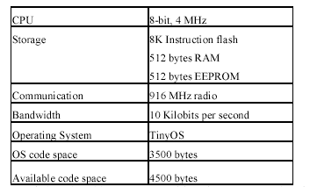
Table I: Characteristics of prototype SmartDust Nodes [6]

- Limitation Power Energy – Limited power is the biggest constraint of the wireless sensor networks. It is not feasible to replace or recharge the thousand of high cost of sensors. Therefore, the battery charge taken with them to the field must be conserved to extend the life of the individual sensor node as well as the entire sensor network. The processing of security related functions (e.g., encryption, decryption, signing data, verifying signatures) consume extra battery power.
1.1.2 Unreliable Communication: Unreliable communication is another key challenge to sensor security. The network security depends on network protocol, which in turn depends on communication.
- Unreliable Transfer - The packet-based routing of the sensor network is normally connectionless and thus inherently unreliable. Packets may get damaged due to channel errors or dropped at highly congested nodes. The result is lost or missing packets. If the protocol lacks of appropriate error handling, it is possible to lose critical security packets. This may include, for example, a cryptographic key.

- Conflicts - In a high-density sensor network if packets meet in the middle of transfer, conflicts will occur and the transfer itself will fail which can be a major problem in providing security.

- Latency - The multi-hop routing, network congestion, and node processing can lead to the latency of the network, thus make it difficult to achieve the synchronization among sensor nodes. The synchronization issues can be critical to sensor security.

1.1.3 Unattended Operation: The sensor nodes may be left unattended for long periods of time for a particular sensor network. There are three main caveats to unattended sensor nodes as describe follow.
- Exposure to Physical Attacks - The sensor may be deployed in an environment open to adversaries, bad weather, and so on. These sensors may suffer a physical attack in such an environment.
- Managed Remotely - Remote management of a sensor network makes it virtually impossible to detect physical tampering and physical maintenance issues. The longer that a sensor is left unattended the more likely that an adversary has compromised the node.

  - Security Requirements
A sensor network also poses unique requirements of its own as well as shares some commonalities with a typical computer network. The factors related to the security of a sensor network are described below [5]:

- Data Confidentiality - A sensor network should not leak it data to its neighbors. In many applications nodes communicate highly sensitive data, e.g., key distribution. It is very important to build a secure channel in a wireless sensor network. The standard approach for keeping sensitive data secret is to encrypt the data with a secret key.

- Data Integrity - The adversary may modify the transmitting data, e.g. add some fragments or decrees the data within a packet. This new packet can then be sent to the original receiver. Data integrity ensures that any received data has not been modified in transit.

- Data Freshness - Data freshness suggests that the data is recent, and it ensures that no old data is re-transmitted. This requirement is especially important when there are shared-key strategies employed in the design. It is also disrupt the normal work of the sensor. To solve this problem a time-related counter can be added into the packet to make ensure data freshness.

- Authentication - An adversary can change the whole packet stream by injecting additional packets. So the receiver needs to ensure that the data is sent by the original sender. On the other hand, when constructing the sensor network, authentication is necessary for many administrative tasks (e.g. network reprogramming or controlling sensor nodes etc.).

- Availability - Adjusting the traditional encryption algorithms to fitting in the wireless sensor network is not free, and will introduce some extra costs. Moreover, additional computation consumes additional energy. If no more energy exists, the data will no longer be available. The requirement of security is highly important in maintaining the availability of the whole network.

  - Sensor Networks vs. Ad-hoc Wireless Networks
Wireless sensor networks may appear similar to ad-hoc wireless networks, but several important distinctions can be drawn between the two [4].
- Ad-hoc networks typically support routing between any pair of nodes, whereas sensor networks have a more specialized communication pattern, like many-to-one, one-to-many and local communication.

- In most of the sensor networks nodes are not mobile, possibly embedded in walls or dispersed from an airplane in a filed.

- Sensor networks are more resource constrained in respect of ad-hoc networks. Nodes in an ad-hoc network may have a 32-bit processor, megabytes of RAM, a 2 Mbps radio, and a large battery, whereas a typical sensor node have an 8-bit processor, kilobytes of RAM, a 40 Kbps radio, and a tiny battery.

- There may exists a significant amount of redundancy in sensor network traffic as an event in the environment may cause several neighboring nodes to send data to the sink at correlated times. This redundancy is almost absent in case of ad-hoc network

  - Related Works
Many researchers have proposed many different techniques to provide security in ad-hoc wireless networks. The application of these techniques to sensor networks is promising, however the possibility of malicious nodes blackmailing good nodes and the difficulty in distinguishing between node misbehavior and poor network conditions must be handled with care. In the paper [7] the authors Perrig et al. presented two security protocols optimized for use in sensor networks, SNEP and μTESLA. SNEP provides confidentiality, authentication, and freshness between nodes and the sink, and μTESLA provides authenticated broadcast. Both are useful building blocks for securing routing protocols in sensor networks. To achieve efficient key management, several symmetric key based techniques were proposed in the past. To the studies on symmetric key cryptography, recently, there are a number of studies investigating the implementation of PKC (Public Key Cryptography) in sensor networks.

We have surveyed on 4 papers [1, 2, 3, 4] regarding security in sensor networks protocol. Our survey report has focused on various aspects of deploying secure protocols by the recent researchers. The rest of the survey is organized as follows, section 2 described the taxonomy for authentication protocols as in paper [1], section 3 stated the optimization of an essential operation in public key cryptography as in paper [2], section 4 described the security protocol proposed by authors in paper [3] and section 5 discussed about different attacks and their countermeasures as presented by the authors in paper [4]. Section 7 concluded the survey with some discussion.

2. Authentication Protocols [Nidal Aboudagga et al, 2005]

The authors in the paper [1] presented a new taxonomy for the classification of authentication protocols in ad hoc networks. Ad hoc networks can be classified into static and mobile networks. Sensor networks (SensNets) typically are static ad hoc networks. On the other hand, mobile ad hoc networks (MANETs) are autonomous systems of mobile nodes that are free to move at will. A hybrid network may also exist.

From a security standpoint, ad hoc networks face a number of challenges. Attacks may come from anywhere and from all directions [8]. Additionally, the lack of a clear line of defense and traffic concentration points poses a challenge to deploying security solutions in ad hoc networks. The broadcast nature of the transmission medium and the dynamically changing topology add even more complications. Furthermore, the reliance on node collaboration as a key factor of network connectivity presents another obstacle.

In order to provide network security, support for authentication, confidentiality, integrity, non-repudiation, and access control should be provided. The authors believe that authentication is the cornerstone service, since other services depend on the authentication of communication entities [9]. Authentication supports privacy protection by ensuring that entities verify and validate one another before disclosing any secret information. In addition, it supports confidentiality and access control, by allowing access to services and infrastructure to authorized entities only, while denying unauthorized entities access to sensitive data.
In this paper the authors presents taxonomy for the classification of authentication protocols in ad hoc networks. They identify three major criteria for classification, based on a node’s role in the authentication process, the type of credentials used for authentication, and the phase during which the establishment of credentials takes place.

2.1 Components of the Authentication Process

Authentication is a process that involves an authenticator communicating with a supplicant using an authentication protocol to verify credentials presented by the supplicant in order to determine the supplicant’s access privileges. A Trusted Third Party (TTP) may be involved as part of the authentication protocol.

A generic authentication process has six major phases as shown in figure 1. Bootstrapping is the first phase, where a supplicant is securely provided, either offline or online, with something that it should have (a key) or something that it should know (a password) that authenticators would trust as a proof of the supplicant’s eligibility to access protected resources or offer service.

Once the bootstrapping phase is completed, the supplicant is ready to participate in the network. The pre-authentication process is where a supplicant presents its credentials to an authenticator in an attempt to prove its eligibility to access protected resources or offer services.

Once the supplicant’s credentials are verified, a credential establishment process is invoked to establish the supplicant’s new credentials, which it will use as a proof of its identity and as a verification of its authorized state thereafter.

Upon success of all of the steps above, a supplicant is considered authenticated, which means that it is authorized to access resources protected by the authenticator. Within the authentication state, all communication between the supplicant and the authenticator is authenticated by the source and validated at the destination using the established credentials. While authenticated, a supplicant’s behavior is monitored for fear of its being compromised or misbehaving. A compromised supplicant may get its credentials revoked (as in [10]) or its re-establishment of credentials request denied when its credentials expire. In both cases, the supplicant is isolated from the network.
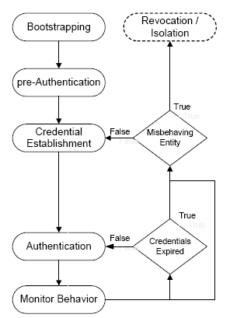

Figure 1 : Functions in a Generic Authentication Process in Ad hoc Networks

2.2 Classification Based on Authentication Function

- Homogeneous : Homogeneity indicates that all nodes in the network have the same role with respect to the authentication operation. This class of authentication protocols assumes that nodes in the network either make authentication decisions autonomously or they depend on information contributed by other nodes in the network to make such decisions. In general, trust based mechanisms fall under the homogeneous class of authentication protocols.

Under the dependent homogeneous class of authentication protocols, authenticators rely on information from their trusted peers to make authentication decisions.

On the other hand, in the autonomous homogeneous class, authenticators make authentication decisions autonomously without relying on their peers or any overlaying infrastructure

- Heterogeneous : The heterogeneous class of protocols indicates that nodes in the network have different roles with respect to the authentication operation. This suggests that there is an underlying service in the network that is meant to aid other nodes in making authentication decisions (e.g., a trusted third party). Authentication protocols that are based on PKI or symmetric key fall under the heterogeneous authentication class.

The underlying service could be centralized, where one specialized node is responsible for providing that service, distributed, where service nodes are deployed anywhere in the network responding to service requests from any node, or clustered, where nodes are clustered and each cluster has a unique provider of the authentication service.

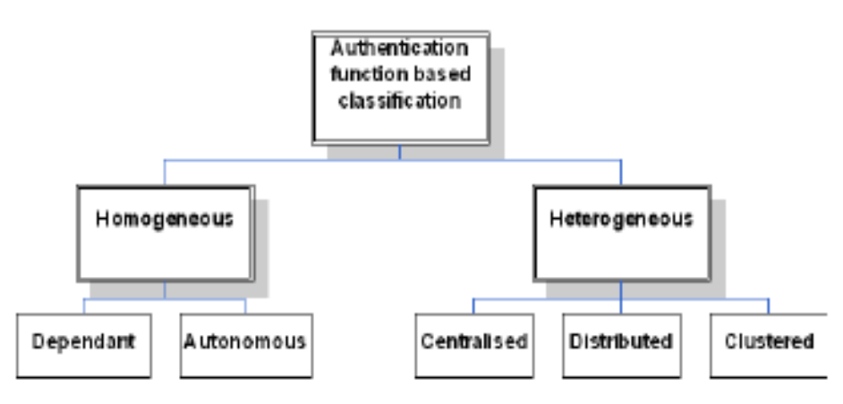
Figure 2 : Classification based on node role

2.3 Classification Based on type of Credentials

2.3.1 Identity-based credentials
This category recognizes a unique possession owned by the supplicant that could be used to identify it with high confidence. Usually, this is in the form of a key that is known to be unique to the supplicant. Identity based credentials can be further classified into encryption based and non-encryption based. An encryption based identity credential is a piece of information produced and cryptographically signed using the key possessed by the supplicant in order to verify its possession of the key, and hence prove its identity.

One form of non-encryption based identity credential is information that is hashed using a one-way key-based hash function and the key possessed by the supplicant. In order to verify the supplicant’s identity, the authenticator must possess the same key (symmetric key) and the hashed information as the supplicant in order to re-generate the hash value and verify the claimed identity of the supplicant

2.3.2 Context Based Credentials
This category recognizes a unique contextual attribute of the supplicant that can be used to identify it with high confidence. Contextual based credentials can be behavioral or physical.
Behavioral-based contextual credentials attempt to identify and authenticate a supplicant based on its pattern of behavior.

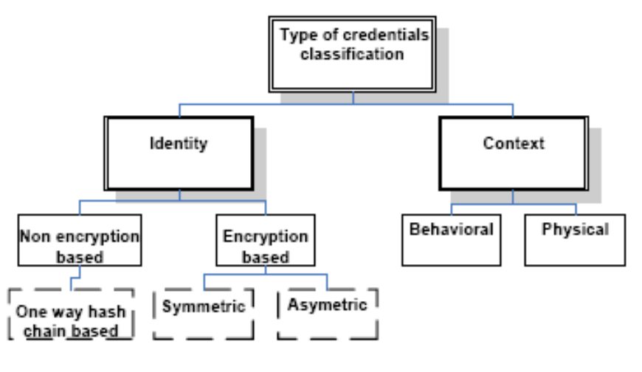
On the other hand, physical characteristics based contextual credentials attempt to identify and authenticate a supplicant based on a physical characteristic that uniquely identifies it, such as its GPS location, RSSI (Received Signal Strength Indication), or SNR (Signal to Noise Ratio).

Figure 3 : Classification based on type of credentials
2.4 Classification Based on Establishment of Credentials

The first category of authentication protocols under this classification assumes a pre-distribution offline phase (before deployment) where credentials are established. The second category of authentication protocols assumes that credentials are established post-deployment, such as protocols that rely on contextual information. The third category, like the first one, assumes pre-distribution of initial credentials. However, the actual credentials used for authentication are derived from the initial credentials post deployment.
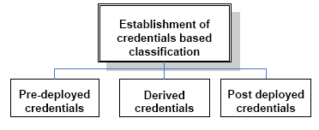
Figure 4 : Classification based on establishment of credentials

The authors have presented a generic authentication process and developed taxonomy of authentication protocols. They have also shown in this paper, through simulations, such as the counterintuitive increase in delay as the number of authentication severs increases for a high number of flows, indicate that an authentication model needs

The authors’ work focuses on developing a formal model for reasoning about the properties of authentication protocols, a unified framework for the quantitative analysis of authentication protocols, and a generic architecture for authentication management.

- Authenticating Public Keys [Wenliang Du et al, 2004]
The authors in the paper [2] investigated how to replace one of the important PKC operations–the public key authentication–with symmetric key operations that are much more efficient. Sensor networks are being deployed for a wide variety of applications. Depending upon the environment of the deployment of sensor network, the security of communication between the nodes of the network might become extremely important. To provide security, communication should be encrypted and authenticated. Symmetric key techniques are attractive for this task due to their energy efficiency.

However, due to the limitation on memory, these techniques are not able to achieve both a perfect connectivity (i.e., high percentage of the neighbouring sensors should be able to establish secure communications between them) and a perfect resilience (i.e., the capture of some sensors by an adversary should not jeopardize the security of other sensors) for large-scale sensor networks.

The use of Public-Key Cryptography (PKC) would eliminate the above problem. Because of its asymmetry property, sensors do not need to carry the pre-distributed keys. Any two sensors can establish a secure channel between themselves, and the capture of some sensors will not affect the security of others.

The main problem of using PKC in sensor networks is its computational complexity and communication overhead. Compared to the symmetric key cryptography, the cost of PKC is always much more expensive.

Studies are being carried out [e.g. 16] to find out the ways for reducing the complexity of PKC protocol. In this paper [2] the authors have proposed the optimization of an essential operation in PKC: the public key authentication, by exploring network properties.

3.1. A Naive Scheme
The authors have assumed that since the sensor networks are under the control of a certain administration, nodes of the network can carry the public key of all the other nods with them. This might eliminate the public key authentication problem without any certification.
However, since the size of public keys can be large, sensor might not have enough memory to save all the public keys. We can improve the memory-usage situation by letting each node carry a one-way hash value of those public keys. When two nodes exchange their public keys, they just need to compute the one-way hash value of the received public keys and check whether the results match the values stored in their memory. Therefore, public key authentication is reduced to a one-way hash function evaluation, which consumes two to three orders of magnitude less energy than a public-key operation.
The above solution still has the memory-usage problem. For a sensor network of size N, each sensor needs to devote (N −1) L memory to those hashes, where L is the length of each hash value (e.g. L = 160 bits for SHA1 [11]). For example, when N = 10000, 195K bytes of memory are needed for SHA1. Sensors usually do not have that much of data memory.

3.2 A Memory Efficient Scheme
As mentioned by the authors, Merkle trees [12] can be used to solve the memory-usage problem. To build a Merkle tree for this problem, the authors construct N leaves L₁, . . . ,L_{n}, with each leaf corresponding to a sensor node. Each leaf contains the bindings between the identity of its corresponding node and the public key of the node. Then a complete binary tree with these leaves is being built [Fig.1]. The ϕ value of each node is defined as the following (the authors use V to denote an internal tree node, and V_{left} and V_{right} to denote V ’s two children; we use id_{i} to represent node i’s identity, and we use pk_{i} to represent node i’s public key):
ϕ(L_{i}) = hash(id_{i}, pk_{i}), for i = 1, . . . ,N
ϕ(V) = hash(ϕ (V_{left}) || ϕ ( V_{right})),

where “||” represents the concatenation of two strings, and the function hash is a one-way hash function such as MD5 or SHA1. Each sensor only needs to store ϕ(R), where R is the root of the Merkle tree. The memory usage is the length of one hash value.

B: ϕ(B) = hash(ϕ (L₃) || ϕ (L₄)) R: ϕ(R) = hash(ϕ(E) || ϕ(F))
C:ϕ(C) = hash(ϕ (A) || ϕ ( B)) ϕ(R) is used as the commitment of all public keys

E:ϕ(E) = hash(ϕ (C) || ϕ ( D)) F
C D

A B

L₁ L₂ L₃ L₄ ……. …….. L_{n} _{Alice’s Index}
Fig. 5: Using Merkle tree To Authenticate Public Keys.

The communication cost for authenticating public key in this scheme has been calculated as follow :
Let pk be Alice’s public key, and L be Alice’s corresponding leaf node in the tree. Let λ denote the path from L to the root (not including the root), and let H represent the length of the path. For each tree node v ∈ λ, Alice sends ϕ(v’s sibling) to Bob, along with the public key pk. Use λ₁, . . . , λ_{H} to represent these ϕ values, and call these ϕ values the proofs.
To verify the authenticity of Alice’s public key pk (assume Alice’s identity is id), Bob computes hash (id, pk); he then uses the results and λ₁, . . . , λ_{H} to reconstruct the root of the Merkle tree R′ with ϕ(R′). Bob will trust that the binding between id and pk is authentic only if ϕ(R′) = ϕ(R).

Because the Merkle tree is a complete binary tree with N leaves, its height is logN (the base of the logarithm is assumed to be 2). Therefore, the communication costs is L.logN, with L being the length of a hash value.

3.3 Improved Authentication Scheme

The grid pattern illustrated here just serves to provide a convenient model for analysis, whose approach can also be applied to other group-based deployed patterns. Classify each pair of deployment groups as horizontal/vertical neighbors, diagonal neighbors, and non-neighbors, based on their spatial relationship. To fully take advantage of Merkle trees, let the number of sensors in each group be S = 2^{t}.
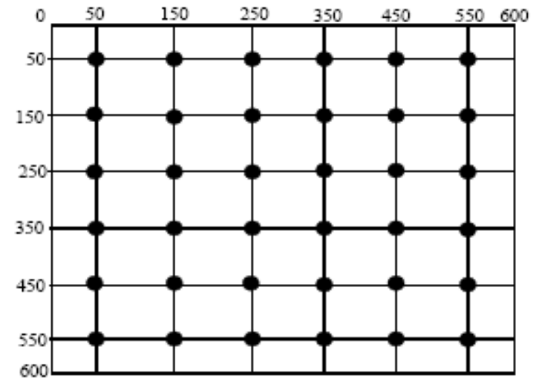
Figure 6: An Example of Group-based Deployment (each dot represents a deployment point).
The idea is that, if two nodes are from horizontal or vertical neighbor groups, they are more likely to be neighbors after the deployment than those from diagonal neighbor groups or from non-neighbor groups. Therefore, the height of the Merkle trees that these two nodes belong to should be different (preferably smaller) than nodes from other types of neighbor groups. Here is how our improved scheme works: First, build the same single Merkle tree as the one in the basic scheme. Then, for each node A, use the following strategy to trim down the original Merkle tree into a set of Merkle sub-trees. Note, the strategy is node dependent; therefore, different nodes will end up having different Merkle forests [Fig: 8].

- The sub-tree that corresponds to A’s own group is trimmed down to Merkle sub-trees of height a (a ≤ t).
- The sub-trees that correspond to A’s horizontal or vertical neighbor groups are trimmed down to Merkle sub-trees of height b (b ≤ t).
- The sub-trees that correspond to A’s diagonal neighbor groups are trimmed down to Merkle sub-trees of height c (c ≤ t).
- The original Merkle tree is trimmed down to Merkle subtrees of height d. Note these sub-trees also contain the above three types of sub-trees. Such redundancy is inevitable when d is larger than t, the height of sub-trees for each group.
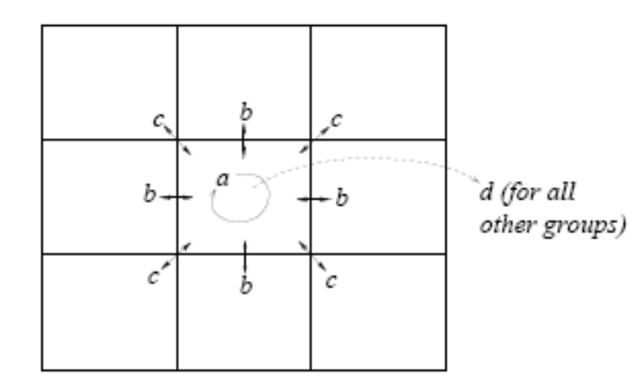
Figure 7 : Height of Merkle Tree for nodes from different neighbor groups.

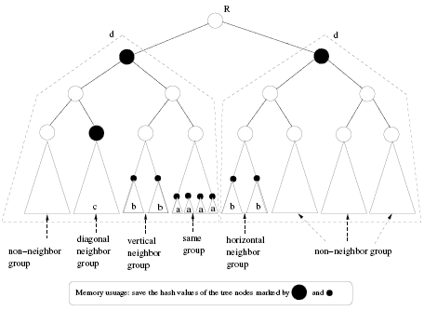
Figure 8: An example of Merkle Forrest.

Assume that the number of sensors in the network is N, and the number of sensors in each deployment group is S. Since the height of a Merkle tree for the nodes in the same group is a, and such a tree can accommodate 2ª nodes, the number of Merkle trees required for this group is ⎡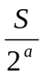⎤. This is also the number of hash values that need to be stored for this group. Similarly, we can compute the number of hash values for other neighbor groups. In total, the amount of hash values each node needs to carry in its memory is the following:
m = ⎡⎤ + ⎡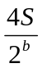⎤ + ⎡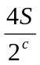⎤ + ⎡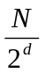⎤
If we consider the probability of two nodes to in the same group, in the vertical/horizontal neighbor group, diagonal neighbor group or non-neighbor as w0, w1, w2 and w3 respectively, the authors suggests that we can calculate the communication cost C can be given as:
C = w0.a + w1.b + w2.c + w3.d
Now for a given memory size of a node, m_{max} we can choose the values of a, b, c and d, such that C becomes minimum, which will enable us to minimize the communication cost.
The authors have shown in this paper that due to a unique property of sensor networks, public keys do not need to be authenticated in the same way as it is done in the Internet environment (i.e., using certificates); instead, public keys can be authenticated using one-way hash functions, which are much more efficient than signature verification on certificates. They have conducted extensive evaluation on their scheme. They have claimed that the results show significant savings on power consumption.

- Energy Efficient Security Protocol [Cam et al., 2003]
Wireless sensor network consists of thousands of wireless nodes, each having sensing capability. These sensors are operated by extremely low powered battery for their sensing, computation and communication purpose. As the sensors are energy constraints, asymmetric cryptographic algorithms are not suitable for providing security. Therefore symmetric cryptographic algorithm is used to support the sensor network security [7]. Again, these algorithms also compromise security due to limited key length and memory available on the sensors. In the paper [3], the authors proposed an “energy efficient security protocol” by using non-blocking OVSF (Orthogonal Variable Spreading Factor) [13] technique in addition to changing session keys dynamically. The rest of the part of this section will discuss the authors proposed security protocol.

  - System Model
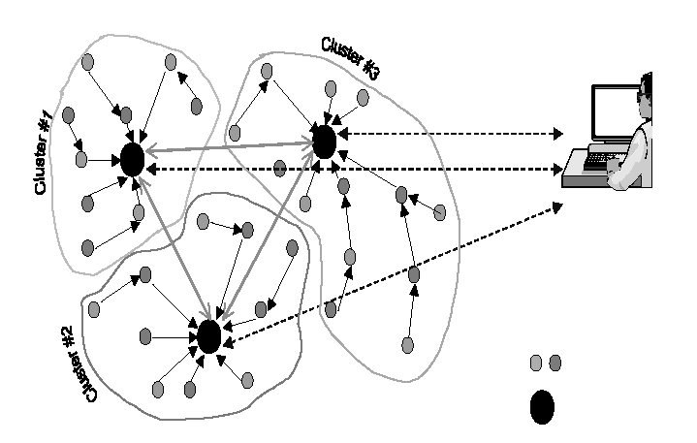
The authors in [3] considered a cluster-based sensor network where each cluster contains a cluster-head. These cluster-heads are responsible to gather data from their corresponding clusters aggregate and transmit to the base station (sink) as shown in Fig 9.
Sensor Nodes
Cluster-Heads
Base Station

Figure 9 : A typical cluster-based sensor network
Sensor nodes are assumed to be immobile and cluster-heads are chosen dynamically from each cluster based on remaining battery power. Base station is assumed to have sufficient power and memory for secure communication with the cluster-heads, other higher cluster heads or external network if necessary.

Each sensor nodes are assigned a secret key (K_{i}) and a unique ID number during the manufacturing phase. Before the network deployment, the base station is given all the ID numbers and K_{i} of the nodes belongs to it. Base station also generates a session key (K_{b}) at a certain time intervals and broadcasts to all the sensor nodes. After receiving the session key (K_{b}), each sensor re-generates their new secret session key (K_{i}, _{b}) by XORing K_{i} with K_{b}. These secret session keys provide a substantial security in sensor networks.

  - Secure Data Transmission Algorithm
The authors proposed two different algorithms to be implemented in the sensor nodes and in the base station respectively. The followings are the steps applied to achieve secure data transmission to the model system –

- The base station will generate the session key K_{b} at a certain time intervals to maintain data freshness and broadcast to all sensor nodes when it is needed.
- The cluster-head will send the current session key K_{b} to its sensor node i when it is requested from the node i.
- After receiving the current session key, sensor node i will XOR the session key (K_{b}) with its built-in key K_{i} to compute the secret encrypted key session key K_{i}, _{b}.
- Sensor node i will encrypt the sensed data with K_{i}, _{b} and append its ID number as well as the time stamp and then will send to the cluster head using NOVSF code-hopping technique.
- After receiving the encrypted data from sensor nodes, cluster head will append its own ID number and will send them to higher cluster-head or the base station. Appending ID numbers will help the base station in location the origin of the data.
- When the base station receives the encrypted data, it will decrypt the data by using the secret key K_{i}, _{b} and perform the authentication with the time stamp and the ID number.
- If the current encryption key K_{i},_{b} decrypt the data perfectly after a successful authentication, the transmitted message will be obtained for further process, otherwise the data will be discarded.

  - NOVSF Code Hoping Technique
To provide the complete security, the authors introduce the NOVFS code hoping technique to the sensor network without utilizing additional power for implementation. Each OVSF code has 64 time slots such that any number of these timeslots can be assigned to a channel and it can be accomplished by adding a multiplexer to the system. In each session, the data block will be assigned to different permutation of the timeslots (Fig 10), which provide more security in transmission of encrypted data.
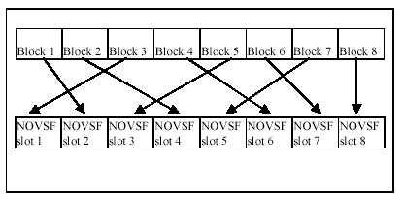
Figure 10: Mapping data blocks to NOVSF time slots,
where eight blocks are available in a buffer [3]

  - Implementation
The authors used prototype sensor nodes of SmartDust project [6] to implement the proposed algorithms. The characteristics of the SmartDust sensors are shown in Table I. Several cryptographic algorithms are evaluated as shown in Table II to be used for the encryption and decryption.

The authors considered AES (Advanced Encryption Standard) algorithm Rijndael [14] is very fast, but requires at least 800-byte memory space for lookup tables whereas the prototype node has only 4,500 available code space. TES is small algorithm, but it is not as secured as Rijndael. DES also used large lookup tables. Finally, mini version of Blowfish [15] is considered for implementation on 8-bit processor with minimum of 24 bytes of RAM and 1000 byte of ROM.

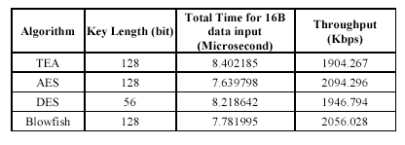
Table II : Performance analysis results for cryptographic algorithms [3]

The cryptographic algorithm, Blowfish, necessitate 1KB memory; in addition to that 400-Byte is needed for key setup. CBC-MAC also requires 580-Byte in the smallest case [7]. The total memory space cryptographic primitives thus become around 2KB which is acceptable for SmartDust sensor nodes.

The authors claimed that by using symmetric key cryptography and NOVSF code-hoping technique, the proposed protocol is more secured and energy efficient. By appending ID number and time stamp to the message provides data freshness for the protocol. Changing encryption keys time-to-time helps to maintain confidentiality of the transmitting data. The authors also claimed that using the same cryptographic algorithm for encryption and decryption, it saves memory space of the sensor nodes.

- Attacks and Countermeasures [Karlof et al., 2003]
It is very difficult to incorporate security mechanism into sensor routing protocols after the design has completed. Therefore, sensor network routing protocols must be designed with security considerations for an effective solution to achieve secure routing. The authors in the paper [4], proposed security goals for routing in sensor networks. The authors also presented general classes of attacks, and discussed the countermeasures and design considerations for secure routing in sensor networks. The Sinkhole attacks and HELLO floods are the two new classes of attacks were introduced by the authors. The detail security analysis of some major existing routing protocols was also presented in this paper. The rest of the part of this section will discuss the authors’ problem statement, different attacks and countermeasures for the sensor networks.
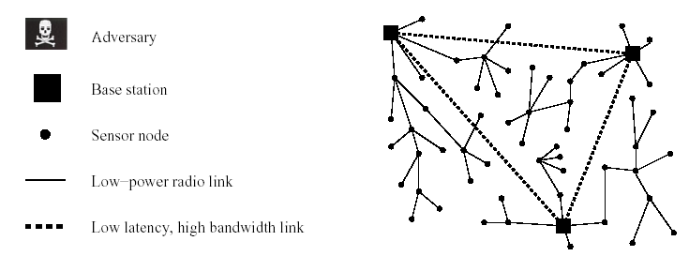
Figure 11 : A representative sensor network architecture

In the paper [7] the authors Perrig et al. presented two security protocols optimized for use in sensor networks, SNEP and μTESLA. SNEP provides confidentiality, authentication, and freshness between nodes and the sink, and μTESLA provides authenticated broadcast. Both are useful building blocks for securing routing protocols in sensor networks.

5.1 Problem Statement

The following sections are the outline of the authors’ assumptions in this setting about the underlying network, models for different classes of adversaries and considered security goals.

    - Network Assumptions: Due to wireless communications, the radio links are insecure. Attackers can eavesdrop on our radio transmissions, inject bits in the channel, and replay previously heard packets. The attackers may capturing the packets and physically overwrite into their memory. It is not assumed sensor nodes are tamper resistant. If an adversary compromises a node, she can extract all key material, data, and code stored on that node. Extremely effective tamper resistance tends to add significant per-unit cost, and sensor nodes are intended to be very inexpensive.

    - Trust Requirement: Base stations are assumed to be trustworthy to behave correctly since they act as gateway nodes to the outside world. Aggregation points which are often regular nodes are trusted in certain protocols to accurately combine with other messages and forwarded to a base station. It is possible that adversaries may try to deploy malicious aggregation points or turn malicious nodes into aggregation points; therefore, aggregation points may not necessarily be trustworthy.

    - Threat Models : The mote attackers can be defined as the attackers who has get access to a few sensor nodes with similar capabilities to motes and nothing more. In contrast, a laptop-class attacker may have access to more powerful devices in which case, malicious nodes have an advantage over legitimate nodes as they may have greater battery power, they may have a more capable CPU, they might have a high-power radio transmitter or a sensitive antenna for eavesdropping, and so on. A laptop-class attacker might be able to jam the entire sensor network using its stronger transmitter.

An outsider attacker who has no special access to the sensor network. On the other hand, an insider attacker is an authorized participant in the sensor network who may have either compromised sensor nodes running malicious code or adversaries who have stolen the key material, code, and data from legitimate nodes.

Security Goals: Secure sensor network routing protocols should have the traditional security goals of integrity, authenticity and availability of message delivery in presence of adversaries. Confidentiality should be provided through end-to-end or link layer encryption.

5.2 Attacks on Sensor Network Routing

Many sensor network routing protocols are quite simple, and therefore facing multiple types of attacks as described bellow :

5.2.1 Spoofed, Altered, or Replayed Routing Information : This is the most direct attack against a routing protocol. Adversaries may be able to create routing loops, extend or shorten source routes, generate false error messages, partition the network, or increase end-to-end delay latency

5.2.2 Selective Forwarding : Malicious nodes may refuse to forward certain messages, drop them, ensuring that they are not propagated any further. A simple form of this attack is when a malicious node behaves like a black hole refuses to forward every packet she sees. It is most effective when the attacker is explicitly included on the path of a data flow.

5.2.3 Sinkhole Attacks : Adversary tries to take control of all the traffic from a particular area through a compromised node, creating a metaphorical sinkhole with the adversary at the center. Due to either real or imagine high quality route through compromised node, each neighboring node of the adversary will forward packets destined for a base station through the adversary. Since all packets share the same destination (the only base station), a compromised node needs only to provide a single high quality route to the base station to influence a large number of nodes (Fig 12).

5.2.4 The Sybil Attack : In a Sybil attack, a single node presents multiple identities to other nodes in the network. This type of attack can reduce the effectiveness of fault-tolerant schemes and pose a threat to geographic routing protocols. Adversary can be in more than one place at once by using this attack (Fig 13).

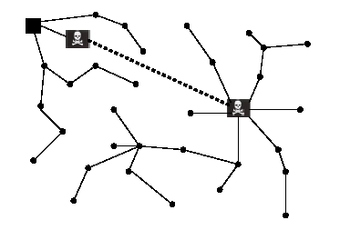
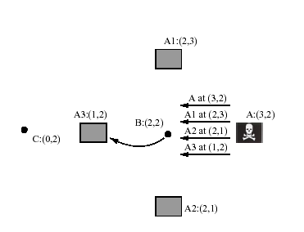

Figure 12 : A laptop-class adversary using Figure 13 : Adversary A contains multiple a wormhole to create a sinkhole attack identities (A1, A2, A3) to capture data
sending from B to C through A3

5.2.5 Wormholes : In the Wormhole attack, an adversary tunnels messages received one part of the network over a low latency link and replays them in a different part. Wormholes can be used to convince two distant nodes that they are neighbors by relaying packets between the two of them. These attacks can be combined with selective forwarding or eavesdropping.

5.2.6 HELLO Flood Attacks : A laptop-class attacker broadcasting routing or other information with large enough transmission power could convince every node in the network that the adversary is its neighbor. An adversary can re-broadcast overhead packets with enough power to be received by every node. HELLO floods can be considered as one-way broadcast wormholes and uses a single hop broadcast to transmit a message to a large number of nodes unlike the traditional definition of flooding denoting epidemic-like propagation of a message to every node in the network

5.2.7 Acknowledgement Spoofing : An adversary can spoof link layer acknowledgements for overheard packets addressed to the neighboring nodes. A sender can be convinced that a weak link is strong or a dead or disabled node is alive. Since packets sent along weak or dead links are lost, an adversary can effectively mount a selective forwarding attack using acknowledgment spoofing by encouraging the target node to transmit more packets on those weak links.

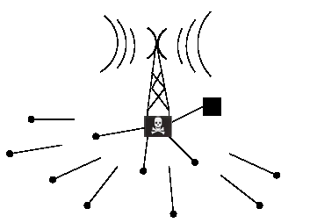
Figure 14 : HELLO flood attacks in WSNs [4]

5.3 Countermeasures

The authors have not simulated or provided any platform to show that the countermeasures actually work, but provided some countermeasures as follows -

5.3.1 Outsider Attacks and Link Layer Security : The majority of outsider attacks against sensor network routing protocols can be prevented by simple link layer encryption and authentication mechanisms using a globally shared key. Replay can easily be detected by maintaining a monotonically increasing counter for each link and including the next value of the counter with each packet. Each node simply remembers the most recently received counter value from each of its neighbors and discards packets containing older values. These mechanisms are enough to counter most of the discussed attacks when mounted by outsiders.

5.3.2 The Sybil Attacks : By maintaining a monotonically increasing counter for each link and including the next value of the counter with each packet, the Sybil attack will no longer relevant because nodes are unwilling to accept even a single identity of the adversary. Identities must be verified and a globally shared key should be used to prevent such attacks. Every node should share a unique symmetric key with a trusted base station. Nodes will be restricted to collect data from any node except their verified neighbors.

5.3.3 HELLO flood Attacks : HELLO flood attacks are not countered by link layer encryption and authentication mechanisms. The simplest defense against HELLO flood attacks is to verify the bidirectionality of a link before taking meaningful action based on a message received over that link. The identity verification protocol described in Section 5.3.2 is also sufficient to prevent HELLO flood attacks.

5.3.4 Wormhole and Sinkhole Attacks : Wormhole and sinkhole attacks are very difficult to defend against, especially when the two are used in combination. A technique for detecting wormhole attacks is presented in some papers, but it requires extremely tight time synchronization and is thus infeasible for most sensor networks. The protocols that construct a topology not initiated by a base station have less possibility to wormhole and sinkhole attacks, like Geographic protocols. A Geographic protocol constructs a topology on demand using only localized interactions and information and without initiation from the base station.

The authors also presented the drawbacks of some of existing sensor network protocols, like TinyOS. Directed diffusion and Geographic routing are to overcome these threats. The authors did not carry out any simulation to show that the proposed countermeasures actually work. The problems were left as open problem in designing a secure sensor network protocol that satisfies the proposed security goal.

- Testing Methodology
  - Authentication Protocols [N. Aboudagga et al, 2005]
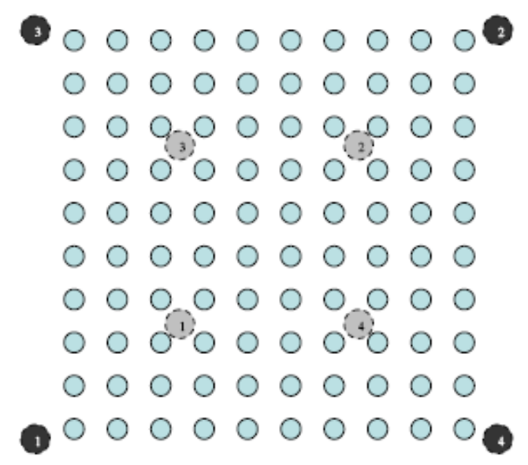
In this paper [1] the authors have justified the authentication management with a demonstrative simulation for a flat authentic server deployment model. In figure 15, they have shown a topology that we use to study the effect of these factors on the performance of the authentication operation. The network is a 10X10 grid of nodes in 500x500 topography. To study the effect of load over the network, they randomly generate sets of 20, 40, 60, 80, 100, 150, and 200 UDP flow. Before a flow starts, the source and destination nodes should authenticate one another through an authentication server as shown in figure 16. Moreover, to study the effect of increasing the number of deployed servers, the author deployed 1, 2, 3, and 4 authentication servers. Furthermore, to study the effect of placement of authentication servers, they experimented with two placement models. The first model places authentication servers in the middle of quadrants as shown in figure 15. The second model places servers at the edges of the network as seen in figure 15. Finally, they compare the flat deployment model used in the above simulations to a hierarchical deployment model, where the authentication status of each node is known to single authentication server.

Fig. 15: 10X10 Grid Topology. (First authentication server placement model is shown in gray. Second AS placement model is shown in black.)

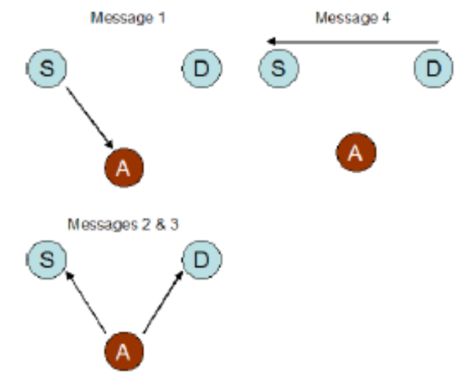
Fig. 16: Flat Authentication Model. “S” denotes a source node, “D” denotes a destination node, and “A” denotes an authentication server.

The performance of the authentication operation is measured in terms of the delay caused by node authentication, while that of the network is measured in terms of packet loss. The simulation results (shown in figures 17 & 18) indicate that the authentication delay increases as the load over the network increases. The results are consistent for both placement models and regardless of the number of authentication servers deployed.
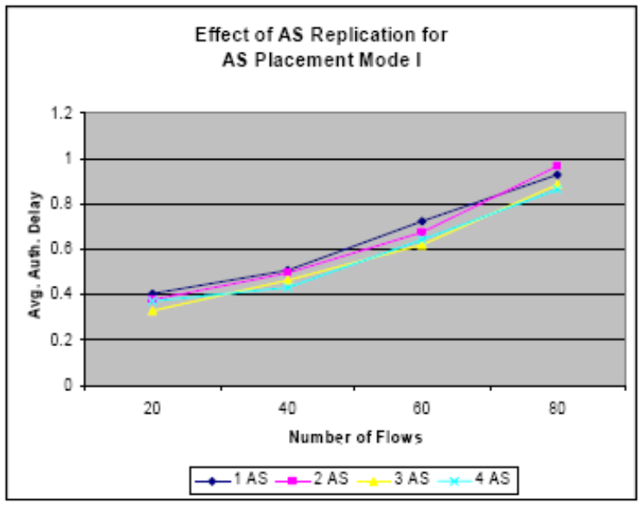
Fig.17: Simulation results showing authentication delay as the number of flows increases from 20-80 flows for 1-4 authentication servers placed using model I. Delay of each set of flows is averaged over 10 simulation runs.

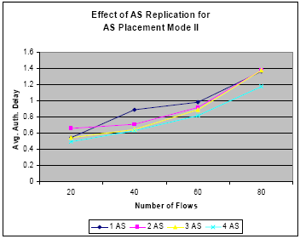
Fig. 18: Simulation results showing authentication delay as the number of flows increases from 20-80 flows for 1-4 authentication servers placed using model II. Delay of each set of flows is averaged over 10 simulation runs.

While it is expected that the network performance decreases as the authors introduce the authentication operation into the network, the simulation results show that the packet loss decreases when authentication of nodes is mandated before a flow starts. This is due to the “backoff” effect of authentication (source and destination of flows are authenticated before flows are allowed in the network). Therefore, the overhead added by authentication may be offset by the benefit of backoff. Figure 19 compares packet loss when authentication is mandated before a flow starts versus when no authentication is required.
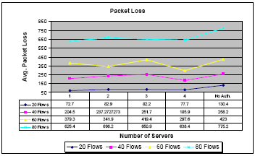
Fig: 19: Simulation results showing packet loss as the number of authentication servers increases 1-4 authentication servers placed using model I. Results also show packet loss when authentication is not required. Packet loss is averaged over 10 simulation runs.
The authors’ simulations also show that as they increase the number of authentication servers, the authentication delay is decreased for 20, 40, 60, and 80 flows. This is expected since the replication of authentication servers should distribute the authentication overhead over the servers, which is expected to positively effect the network performance. Interestingly, at higher number of flows, these results are reversed showing an increase in delay as the number of authentication severs increases as shown in figure 20. This can be explained as follows. The backoff effect of authentication and the authentication delay decreases by increasing the number of servers due to load distribution. Therefore, the load on the network increases as a result of having flows start faster. Consequently, this leads to more packets in the network, which may lead to increasing the authentication delay.

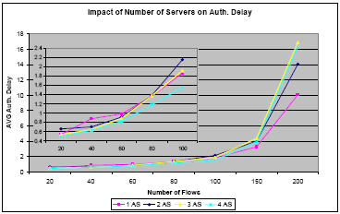
Fig. 20: Simulation results showing authentication delay as the number of flows increases from 20-200 flows for 1-4 authentication servers placed using model I. Delay of each set of flows is averaged over 10 simulation runs. Delay for 20-100 flows is magnified in the embedded figure.

  - Authenticating Public Keys [W. Du et al, 2004]
The authors of this paper [2] have provided a detailed quantitative analysis evaluating the performance of their scheme. The metrics for the evaluation are the communication overhead, memory usage, computation costs, and energy consumptions. The deployment area is a square plane of 800 meters by 800 meters. They have used the square grid pattern deployment as in Fig. 6. The plane is divided into 8 X 8 grids of size 100m X 100m. Centers of these grids are chosen as deployment points. They have used R to represent a sensor’s transmission range. They have set R = 40 in all of their experiments.

The goal of their experiment is to study how memory usages affect communication overhead, and how much of communication costs can be saved using deployment knowledge. For each experiment, they have fixed σ = 50 (considering Gaussian distribution or Normal distribution) for the deployment distribution. They change the memory usage m from 1 to 200 (in terms of number of hash values), and then they compute the average communication overhead (also in terms of number of hash values). They have conducted experiments for both the deployment knowledge-based scheme and the basic scheme.
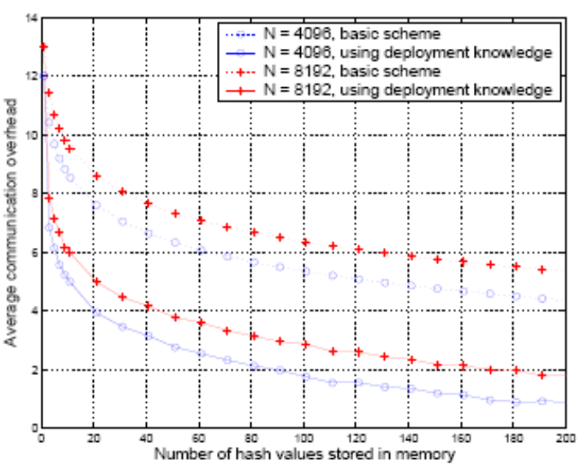
Fig. 21. Communication overhead vs. memory usages.

The experiment results are depicted in Figure 21. The figure clearly shows that the communication overhead decreases with the increase of memory usages. More specifically, it shows that for network size 4096, the average communication overhead for the deployment knowledge-based scheme is less than two hash values. For 160-bit SHA1as one-way hash function, the average overhead is less than 320 bits. The figure also shows that compared to the basic scheme, the deployment knowledge helps to save approximately 3.5 hash values in communication overhead.

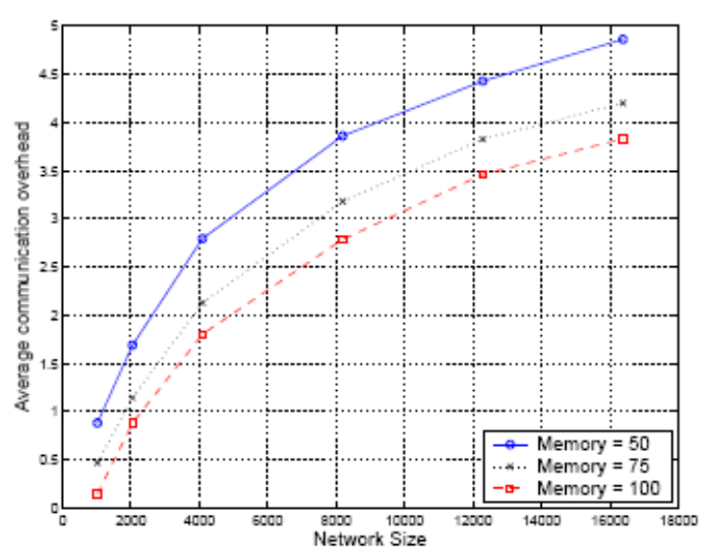
Fig. 22: Communication overhead vs. network size.

They have also conducted experiments for network sizes ranging from 1024 nodes to 16384 nodes, while setting the memory usage to 50, 75, and 100. Figure 22 depicts the results, which clearly show the trend of communication overhead with the increase of network size.

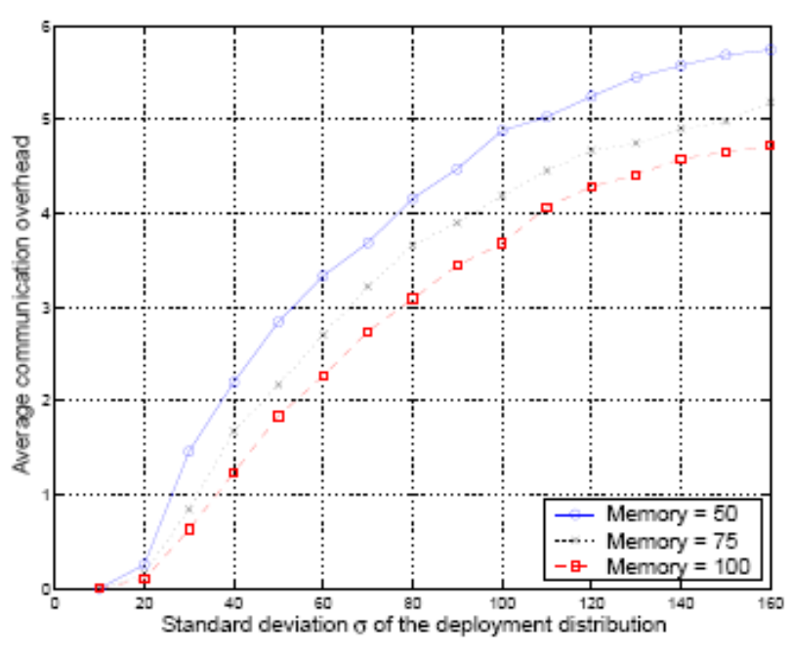
Fig. 23: Communication overhead vs. distribution (σ).

In their next experiment, they changed the σ values of the distribution from 10 to 160, while they set the network size to 4096. Figure 23 depicts the results under different memory usage scenarios. It shows that the communication overhead increases with the increase of σ. Its reason is straightforward: when σ becomes large, the distribution becomes more even, thus the deployment knowledge becomes less useful. When σ increases to certain value, the performance of the deployment knowledge-based scheme can approach the performance of the basic scheme.

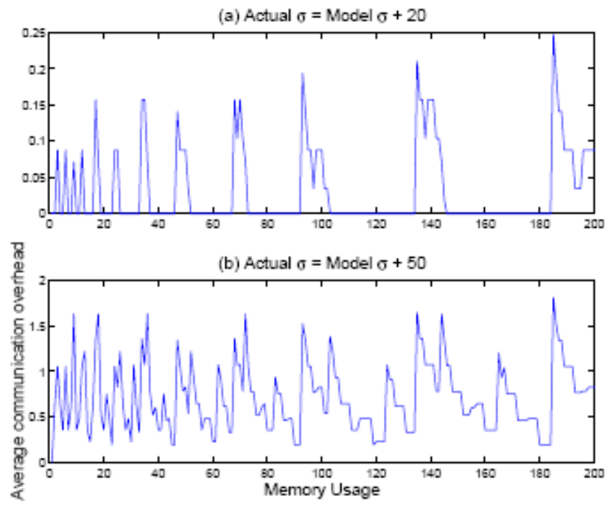
Fig. 24: The effect of errors in modeling.

In the next experiment they have compared between their model pre-deployment distribution and actual post-deployment distribution. They have assumed that the post-deployment distribution is still Gaussian, but the σ value of the distribution deviates from our model. In their experiment, they have assume that the deployment model uses σ_{model} = 50, while the actual deployment distribution has σ_{actual} = 50 + e, where e is the error. They have derived the optimal Merkle forest for the deployment model, and then computed the actual communication overhead when this Merkle forest is used in a distribution with σ_{actual}. They have also computed the optimal communication overhead for σ_{actual}. Then they have ploted the difference between the actual communication overhead and the optimal communication overhead. Figure 24 depicts the results for 8192 sensor nodes. The results show that their scheme is not much sensitive to the small degree of modeling errors. For example, when the σ value deviates by 20, from 50 to 70, the difference of communication overhead between an accurate model and an inaccurate model is less than 0.25 (in the unit of hash-value length). However, when the modeling error is large, the difference becomes significantly large.

To compare energy consumption caused by computations with that caused by communications, the authors have used an estimation made by Pottie and Kaiser, who pointed out that the energy consumed in transmitting a 1K-bit packet over 100m is approximately the same as performing 3 million instructions on a typical scenario. Thus, with an 8MHz CPU, the energy spent on running CPU for 1 millisecond is equivalent to sending 2.67 bits of message.

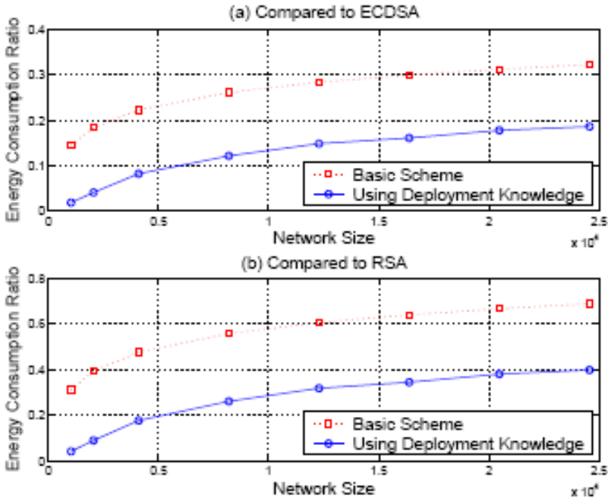
Fig. 25: Comparison on energy consumption.

The authors have computed the ratio of their scheme to the RSA algorithm and ECC algorithm. For ECC, they assumed that Elliptic Curve Digital Signature Algorithm (ECDSA) is used. The result is depicted in Figure 25. The amount of energy saving is substantial, especially for ECDSA algorithm. For example, the deployment knowledge-based scheme consumes only 14% of the energy used by ECDSA algorithm for a network of 10, 000 nodes while the basic scheme consumes 28%. The saving over RSA algorithm is relatively less; this is because the signature verification of RSA is about four times as fast as that of ECDSA due to the small public key used in RSA. However, it is believed that ECC is more practical for sensor networks because RSA signature generation is quite slow: about 20 times slower than signature verification

  - Energy Efficient Secure Protocols [Cam et at., 2003]
Prototype sensor nodes of SmartDust project [6] are used to implement the proposed Secure Data Transmission Algorithm for the cluster-based wireless sensor networks. Mini version of Blowfish cryptographic symmetric algorithm is employed using non-blocking OVSF technique. To provide confidentiality of the transmitting data, encryption keys are changed dynamically. No simulation result is presented in the paper.

  - Attacks and Countermeasures [Karlof et al., 2003]
Different types of attacks and their countermeasures are presented for the wireless sensor networks. Detail security analysis of some major existing routing protocols for sensor networks are also discussed here. But the authors did not take any simulation to show that the proposed countermeasures really work.

- Conclusion
The severe constraints and demanding deployment environments of wireless sensor networks make computer security for these systems more challenging than for conventional networks. Limited power and resources of sensor nodes make the key challenge in maximizing lifetime as well as providing security in sensor networks. However, several properties of sensor networks may help address the challenge of building secure networks. In this survey, we studied most relevant 4 papers and presented their proposal to build a secure WSNs. N. Aboudagga et al have presented taxonomy for the classification of authentication protocols in ad hoc networks. They identify three major criteria for classification, based on a node’s role in the authentication process, the type of credentials used for authentication, and the phase during which the establishment of credentials takes place. W. Du et al have proved that for the sensor networks public keys can be authenticated using one-way hash functions, which are much more efficient than signature verification on certificates. Cam et al. proposed symmetric cryptographic algorithm by using non-blocking OVSF technique on cluster-based sensor network. This algorithm is claimed as energy efficient secured protocol. Karlof et al. introduced two new classes of attacks against sensor - networks Sinkhole and HELLO floods, and analyzed the security of all the major sensor network routing protocols. The countermeasures for the attacks and the network design considerations are also suggested in this paper. The scale of deployments of WSNs requires careful decisions and trade-offs among various security measures. Several exciting research challenge remain before we can trust WSNs to take over important missions.

- References

[1] N. Aboudagga, M.T. Refaei, M. Eltoweissy, L. DaSilva and J. Quisquater, “Authentication Protocols for Ad Hoc Networks : Taxonomy and Research Issues,” In Proceedings of the 1st ACM international workshop on Quality of service & security in wireless and mobile networks, Quebec, Canada, 2005, pp. 96-104.

[2] W. Du, R. Wang and P. Ning, “An Efficient Scheme for Authentication Public Keys in Sensor Networks,” In Proceeding of 6th ACM International Symposium on Mobile Ad Hoc Networking and Computing (MobiHoc), IL, USA, 2005, pp. 58-67.

[3] H. Cam, S. Ozdemir, D. Muthuavinashiappan and P. Nair, “Energy Efficient Security Protocol for Wireless Sensor Networks,” Vehicular Technology Conference, 2003, vol. 5, pp. 2981-2984.

[4] C. Karlof and D. Wagner, “Secure Routing in Wireless Sensor Networks: Attacks and Countermeasures,” In Proceedings of the 1st IEEE International Workshop on Sensor Network Protocols and Applications, Anchorage, AK, 2003.

[5] J. P. Walters, Z. Liang, W. Shi and V. Chaudhary, “Wireless Sensor Network Security : A Survey”, www.cs.wayne.edu/~weisong/papers/walters05-wsn-security-survey. pdf, 2005.

[6] K.S.J. Pister, J.M. Kahn and B.E. Boser, “Smart Dust : Wireless networks of milli-meter scale sensor nodes”, 1999.

[7] A. Perrig, R. Szewczyk, J.D. Tygar, V. Wen, and D.E. Culler, “SPINS: Security protocols for sensor networks”, Wireless Networks, 2002, vol. 8, pp. 521-534.

[8] H. Luo, P. Zerfos, J. Kong, S. Lu, and L. Zhang, “Self-Securing Ad Hoc Wireless Networks.” In Seventh IEEE Symposium on Computers and Communications (ISCC '02), 2002.

[9] D. Park, C. Boyd, E. Dawson. “Classification of Authentication Protocols: A Practical Approach.” Proceedings of the Third International Workshop on Information Security.

[10] S. Zhu, S. Setia and S. Jajodia, “LEAP: Efficient Security Mechanisms for Large-Scale Distributed Sensor Networks.” In 10th ACM Conference on Computer and Communications Security (CCS '03).

[11] D. Eastlake and P. Jones. US secure hash algorithm 1 (SHA1). IETF RFC 3174, September 2001.

[12] R. Merkle, “Protocols for public key cryptosystems.” In Proceedings of the IEEE Symposium on Research in Security and Privacy, Apr 1980.
[13] H. Cam, “Nonblocking OVSF Codes and Enhancing Network Capacity for 3G Wireless and Beyond Systems”, To appear in the Special Issue of Computer Communications on "3G Wireless and Beyond For Computer Communications", Spring 2003.

[14] J. Daemen and V. Rijmen, AES proposal: Rijndael (1999).

[15] B. Schneier “Fast Software Encryption”, Cambridge Security Workshop Proceedings (December 1993), Springer-Verlag, 1994, pp. 191-204.

[16] N. Gura, A. Patel, A. Wander, H. Eberle, and S. C. Shantz. Comparing Elliptic Curve Cryptography and RSA on 8-bit CPUs. August 11-13 2004.

