NeWT Security Scanner VS GFI LANguard
Project II

University of Windsor
60-475

Student Name: Li,Guorui
Submitted to: Dr A.K. Aggarwal

Table of Contents

Introduction 2
Features comparison 2
System requirements 2
Installation 2
Cost/licensing comparison 2
Testing environment 2
Test phase 1: 2
Test phase 2: 2
Test phase 3: 2
Testing result comparison 2
Test phase 1 result: 2
Test phase 2 result 2
Test phase 3 result 2
Conclusion 2
Reference: 2

Table of figures

Figure 1 GFI LANguard Scanning Profiles 2
Figure 2 GFI LANguard Scan Result 2
Figure 3 GFI LANguard High Vulnerabilities 2
Figure 4 NeWT concurrent scanning 2
Figure 5 GFI LANguard results comparison 2
Figure 6 NeWT results comparison 2

Introduction

As Internet is growing and becoming a giant network, various enterprises, businesses and personal information on the network are now becoming more and more vulnerable due to insecurity and unauthorized access from outside parties. In order to prevent your servers and personal computers from unnecessary attacking, a vulnerability free system must be maintained. Network scanning is one of the many ways to ensure your network is vulnerable free. Many products in the market are available to select and the products have their own cons and pros. In this report, I will be introducing two of the most popular security scanners in the Security scanning industry: They are GFI LANguard Network Security Scanner version 5.0 and NeWT vulnerability scanner version 2.1.

The main purpose of this report is also to identify the differences between these two security scanners. The Pros and Cons of these two software will be identified by comparing the ease of installation, the cost and licensing, the integrated tools, the effectiveness of scanning and lastly is the extensible of the software.

Features comparison
The two security scanners provide wide and rich vulnerability scanning. With the NeWT vulnerability scanner, any user can scan their immediate network for vulnerabilities. All local hosts, routers, servers, laptops and any other network device will be discovered, scanned and a list of vulnerabilities produced. In addition, if system administrator rights are provided to NeWT, a patch audit of any Windows or UNIX server will be conducted.
On the other hand, GFI LANguard Network Security Scanner allows network administrators to quickly and easily perform a network security audit, creates reports that can be used to fix security issues on a network. It can perform patch management also.
The following are some common features that both scanners have:
- Flexible scanning:
Network administrators are able to select single and multiple computers to be scanned by selecting customized or pre-defined scanning profiles / plug-ins from these two software. In the current version of the GFI LANguard 5.0, you have the option of setting the ports (TCP/UDP) to scan, display of OS data, selection of Vulnerabilities, Patches and scanner option like network discovery methods, network discovery options etc.

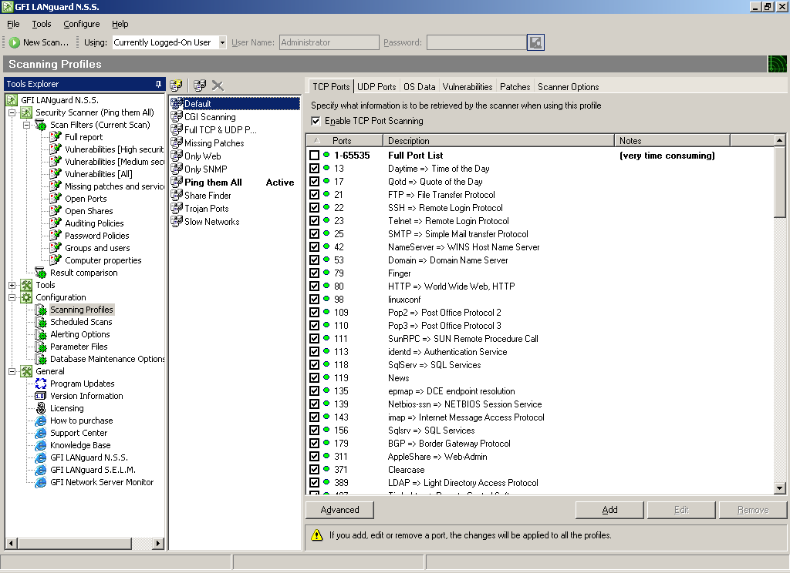
Figure 1 GFI LANguard Scanning Profiles
As we can see from the figure 1, the network administrator is able to configure different types of scans, and use these different scans to focus on particular types of information that he/she wants to check for.

The NeWT has the concept of plug-ins, which is the pre-defined on going scanning ports, vulnerabilities of the systems. The pre-defined plug-ins is grouped into following plug-ins sets.
Table 1 NeWT Plug-ins Sets
Name | Description
Database | Variety of SQL server & injection tests
DNS | Detects name server security issues
Microsoft | Enables all checks for NT, W2K and XP
Networking | All Cisco, SNMP and router/switch checks
Port Scan | Ping host then perform a port scan
SANS Top 20 2004 | The SANS Top 20 Internet Security Vulnerabilities  See http://www.sans.org/top20
Secure Shell | Tests for common SSH holes
Trace Route | Do a traceroute
Web Server - Apache | Enables tests for Apache 1.x and 2.x
Web Server - IIS | Checks for Microsoft IIS

- Common Vulnerabilities and Exposures (CVE) compatible:
Both GFI LANguard and NeWT Scanners are CVE compatible, which means they use standardized names for vulnerabilities and other information security exposures. They also provide Bugtraq ID so that the network administrator will be able to get more information on specific vulnerability and possible solutions to these problems.

- Easy vulnerability database updates:
By simply activate the updated module on both scanners, the network administrator will be able to retrieve the latest vulnerability information /plug-ins from corresponding update server. In fact, both scanners also are able to add custom vulnerabilities using scripts/conditions. GFI LANguard provides
VB language base script editor and debugger so that it can create, analyze, refine and investigate problems prior to putting the script into action on a live security scan. Detail instruction on adding a new scripting based vulnerability checks to the scanner tool is omitted in this report. NeWT uses the Nessus Attack Scripting Language (NASL) to write the customize plug-in. NASL allows anyone to write a test for a given security hole/ plug-in in a few minutes with built-in objects class. After writing a new plugin, just put it into [NeWT dir]\users\admin\plugins\ folder, then run "Update Plugin" from the GUI or use "build.exe" from the command line.

- Results Comparison:
Both scanners auditing results are generated in XML format, so that it provides flexible mechanism for program to represent different views or various document formats. Also, we can use these XML files to perform results comparison. By performing audits regularly and comparing results from previous scans, we can get an idea of what security holes continually pop up or are reopened by users. This creates a more secure network.

Functionality that GFI LANguard has only:
GFI LANguard scans entire network from a hacker standpoint, it offers lots of extra functions that NeWT security scanner that does not have.
- It provides in-depth information about all machines/devices
It provides information such as service pack level of the machine, missing security patches, open shares, open ports, services/applications active on the computer, key registry entries, weak passwords, users and groups etc.
- Patch management
GFI LANguard N.S.S. is also a complete patch management solution. After it has scanned your network and determined missing patches and service packs - both in the operating system (OS) and in the applications - you can use GFI LANguard N.S.S. to deploy those service packs and patches network-wide.
- Check for unused user accounts on workstations
GFI LANguard N.S.S. enumerates all local users and groups, and identifies user accounts no longer being used.
- Check password policy
GFI LANguard N.S.S. can automatically check password policy of local users, for all machines on the network

Functionality that NeWT Security Scanner has only:
- Provides Dos Attack in addition to the standard set of tests
NeWT Scanner differs from the GFI LANguard by providing an extra set of tests called "Dangerous Tests" which contain common DOS attacks. These attacks provide excellent information on the stability of the server in question.
- Intelligent port scanning
NeWT is able to determine if a server is running on a different port than is standard (i.e. you could run http off of port 6541 instead of 80 and it would find it)

System requirements
The installation of GFI LANguard Network Security Scanner requires the following:

- Windows 2000/2003 or Windows XP
- Internet Explorer 5.1 or higher
- Client for Microsoft Networks must be installed.
- NO Personal Firewall software or the Windows XP Internet Connection Firewall can be running while doing scans. It can block functionality of GFI LANguard N.S.S.
- To deploy patches on remote machines you need to have administrator privileges

Respectively, NeWT requires following:
- Windows 2000/2003 or Windows XP
- A resident copy of Microsoft’s Internet Explorer is required.
- To forge custom TCP/IP packets, NeWT uses the WinPcap (http://winpcap.polito.it ) driver.
- Pentium II 600 Mhz class system to operate NeWT
on a “class C” network
- For “class C” networks, a minimum of 512MB of memory is also
suggested

Installation
You will be able to download 60 days full evaluation or freeware version of GFI LANguard from http://www.gfi.com/downloads/downloads.asp?pid=8&lid=1
Run the LANguard Network Security Scanner setup program by double clicking on the lannetscan.exe file. The whole software proximally requires 40Mb of your hard disk space. By following the easy wizard instructions, it should be able to install on your computer without any troublesome.

The latest version of NeWT is available from the Tenable Network Security web site at http://www.tenablesecurity.com/newt.html
To Install the NeWT, you may just need to click the setup.exe file. And a GUI setup wizard will lead you easier finish installation.

Cost/licensing comparison
As part of the software purchasing and evaluation, the pricing and licensing are one of the important issues to be considered.

GFI LANguard Network Security Scanner 5
Pricing includes 3 months of free support from date of purchase and 3 months of upgrade protection.
 |  | Price |  |  | Price
up to 25 IPs | LANSS25 | $ 315 | up to 250 IPs | LANSS250 | $ 795
up to 50 IPs | LANSS50 | $ 395 | unlimited IPs * | LANSSUNL | $ 995
up to 100 IPs | LANSS100 | $ 495

* UNLIMITED IP scanning per installation! If you use multiple copies of GFI LANguard N.S.S., you must buy multiple licenses. For example, if you have 5,000 machines on your network, and 4 administrators use GFI LANguard N.S.S. daily on their machine, you need to buy 4 unlimited IP copies.

*All prices are in US dollars

The NeWT Security Scanner 2.1:
There are two types of NeWT licenses that are available in today’s market. NeWT is available as a download to anyone with an Internet connection. A NeWT user can only scan their local subnet. For example, a NeWT user who had an IP address of 192.168.10.11 would be able to scan 192.168.10.0 through 192.168.10.255. Tenable has made NeWT available to the general public such that home users, small businesses, non-profit organizations and a host of others can now scan their networks for vulnerabilities. NeWT Pro is a commercially supported vulnerability scanning product for enterprise customers and consultants. NeWT Pro has no limitation on which IP addresses it can scan. It is also fully supported by Tenable Network Security. NeWT Pro costs $6000.

Testing environment
For a better comparison between these two security scanners, the tests will be performed on the single computer and as well as a Windows OS home network. The main task of these tests will be focus on vulnerability checking, hardware usage, scanning speed and the comparison of test results.

The server that runs both of these scanners is a Intel Celeron 1.8 GHz, 512 Mb of RAM, Windows 2000 SP 4, Internet Explorer 6, IP address: 192.168.1.93.
The client machines are listed as follow:
JESSE: 192.168.1.93 OS: Windows 2000 SP4
LiSALIU: 192.168.1.92 OS: Windows 2000 SP4
TONY: 192.168.1.151 OS: Windows XP SP2
EDWIN: 192.168.1.150 OS: Windows XP SP2

GFI LANguard N.S.S. 5.0 attendant service is needed to start GFI LANguard scanner. And Tenable NeWT service is also required prior to run NeWT security scanner.

Test phase 1:
The network under testing is a home group network without domain controller.
The user account on the server is the same as LISALIU, but different in EDWIN and TONY.

The first phase of the testing is under the assumption that we are not confident with our network environment and the default testing set will be performed. In addition the default testing in GFI LANguard includes standard TCP/UDP ports, Vulnerability sets (CGI Abuse, DNS Vulnerabilities, FTP Vulnerabilities, Mail Vulnerabilities, Miscellaneous, Registry Vulnerabilities, RPC Vulnerabilities, Service Vulnerabilities) and Patches. On the other hand, the NeWT Scanner testing uses all vulnerability plug-ins, like Database, DNS, Microsoft, Networking, Port Scan, SSANS Top 20 2004, Secure Shell, Web Server – Apache, Web Server - IIS.

Test phase 2:
On testing phase 2, we gather scanning results from both scanners and then remove the vulnerabilities that were identified in the system, and also install some of the necessary patches. We then scan the network for the second time with the same sets of plug-ins and profile.

Test phase 3:
As mentioned in the previous section, both of these scanners have the document comparison function. On this phase, we will focus on the comparison function of the scanners. After obtaining the testing result from phase 1 and phase 2, we then compare these two results by using comparison function.

Testing result comparison
The scanning testing results will be analyzed and compared in this section.

Test phase 1 result:
We first test GFI LANguard by performing default profile vulnerability sets. One noticeable fact during the scanning process is that the server computer CPU usage is very high; most of the time is above 70%. It took 6 minutes and 35 seconds to perform all the vulnerabilities checks on four computers.
Results are showing clearly shown on the result panel (Figure 2). On the left side of result panel is the group of computers that have been scanned, as stated in the previous chapter, the category information like vulnerabilities, share folders, password policy, open TCP ports, system patches status, users, service and etc. are displayed. In addition, on the right side of result panel is the detail information of these categories.

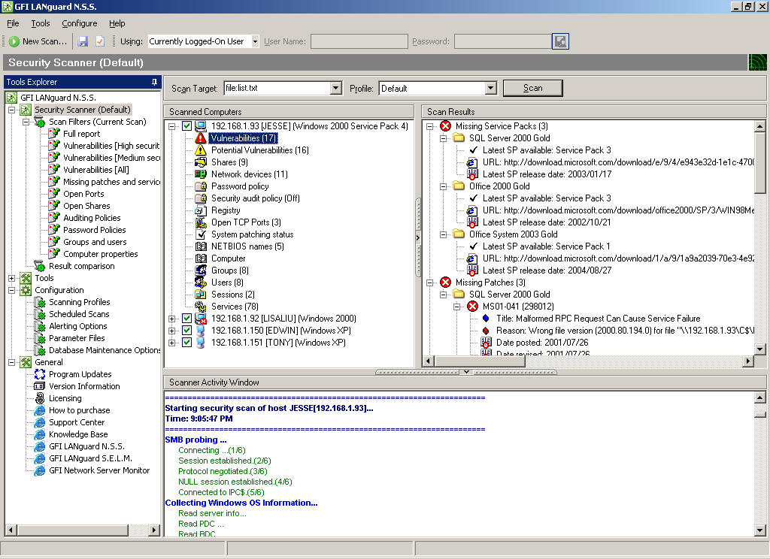
Figure 2 GFI LANguard Scan Result

We now use the Scan filters to filter our results with only showing the High security thread vulnerabilities.

JESSE: 192.168.1.93
Missing Security Patches/Service Packs – 6
Office 2000 Gold
The latest service pack for this product is not installed !
Latest SP available : Service Pack 3
http://download.microsoft.com/download/office2000/SP/3/WIN98MeXP/EN-US/o2ksp3.exe

Office System 2003 Gold
The latest service pack for this product is not installed !
Latest SP available : Service Pack 1
http://download.microsoft.com/download/1/a/9/1a9a2039-70e3-4e92-b977-756fe884f731/Office2003SP1-kb842532-fullfile-enu.exe

SQL Server 2000 Gold
The latest service pack for this product is not installed !
Latest SP available : Service Pack 3
http://download.microsoft.com/download/e/9/4/e943e32d-1e1c-4700-abd9-4b3df9c9c495/sql2kasp3.exe;http://download.microsoft.com/download/e/9/4/e943e32d-1e1c-4700-abd9-4b3df9c9c495/SQL2KDeskSP3.exe;http://download.microsoft.com/download/e/9/4/e943e32d-1e1c-4
MS01-041 (298012)
Malformed RPC Request Can Cause Service Failure
Wrong file version (2000.80.194.0) for file "\\192.168.1.93\C$\Program Files\Microsoft SQL Server\MSSQL\binn\ssmsrp70.dll", should be (2000.80.213.0)
http://download.microsoft.com/download/sqlsvr2000/hotfix/q298012/win98mexp/en-us/q298012_sql2000_x86_en.exe
MS01-032 (299717)
SQL Query Method Enables Cached Administrator Connection to be Reused
Wrong file version (2000.80.194.0) for file "\\192.168.1.93\C$\Program Files\Microsoft SQL Server\MSSQL\binn\sqlservr.exe", should be (2000.80.296.0)
http://download.microsoft.com/download/sqlsvr2000/patch/s80296i/w98nt42kme/en-us/s80296i.exe
MS00-092 (280380)
Extended Stored Procedure Parameter Parsing Vulnerability
Wrong file version (2000.80.194.0) for file "\\192.168.1.93\C$\Program Files\Microsoft SQL Server\MSSQL\binn\odsole70.dll", should be (2000.80.223.0)
http://download.microsoft.com/download/sqlsvr2000/ss2kxp/2000/w98nt42kme/en-us/s80233i.exe

LiSALIU: 192.168.1.92
NONE

TONY: 192.168.1.91
Vulnerabilities - 1
Administrator account without password!
You MUST set a password for the administrator account.

EDWIN: 192.168.1.150
Vulnerabilities - 1
Administrator account without password!
You MUST set a password for the administrator account.

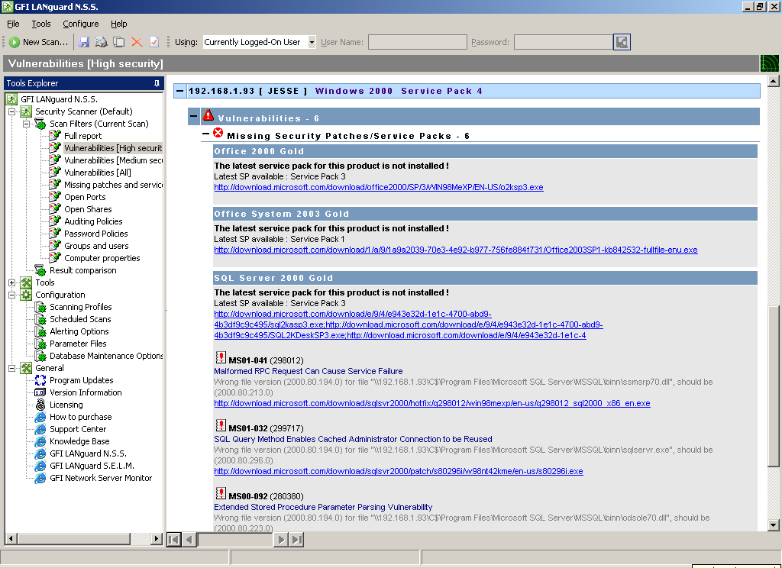
Figure 3 GFI LANguard High Vulnerabilities

We now scan the same list of computers with NeWT scanner. The NeWT scanner performs scanning on all the computers simultaneously; however it is relatively slow (around 16 minutes).
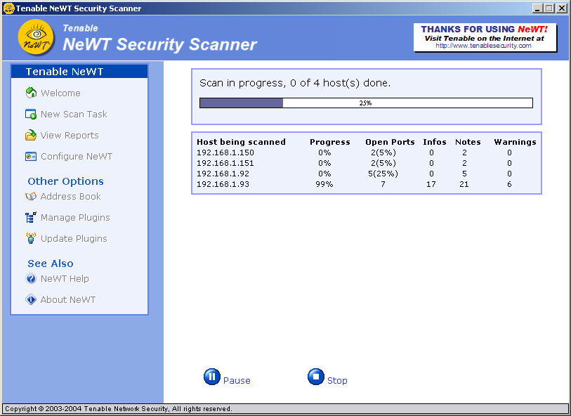
Figure 4 NeWT concurrent scanning

The result of NeWT scanner is quite different from GFI LANguard. Even the numbers of the opening ports are quite different. Compared to the GFI LANguard, NeWT provides more convincing results in terms of the number of vulnerabilities:

JESSE: 192.168.1.93 (Partial)

The remote host is using BRILLIANT DIGITAL
You should ensure that:
- the user intended to install BRILLIANT DIGITAL (it is sometimes silently
installed)
- the use of BRILLIANT DIGITAL matches your corporate mandates and security
policies.
To remove this sort of software, you may wish to check out ad-aware or spybot.
See also : http://www.safersite.com/PestInfo/b/brilliantdigital.asp
Solution : Uninstall this software
Risk factor : High
Plugin ID : 11996

The remote host has old versions of Word and Excel installed.
An attacker may use these to execute arbitrary code on this host.
To succeed, the attacker would have to send a rogue excel or word
file to the owner of this computer and have it open it.
Solution : See http://www.microsoft.com/technet/security/bulletin/ms02-031.mspx
Risk factor : High
CVE : CVE-2002-0616, CVE-2002-0617, CVE-2002-0618, CVE-2002-0619
BID : 4821, 5063, 5064, 5066
Plugin ID : 11336

The JRE Java version installed is vulnerable to a DoS attack.
Upgrade to JRE version 1.4.2_04
BID : 10301
Plugin ID : 12244

The JDK Java version installed is vulnerable to a DoS attack.
Upgrade to JDK version 1.4.2_04
BID : 10301
Plugin ID : 12244

The remote Microsoft SQL server is vulnerable to several flaws :
- Named pipe hijacking
- Named Pipe Denial of Service
- SQL server buffer overrun
These flaws may allow a user to gain elevated privileges on this
host.
Solution : See http://www.microsoft.com/technet/security/bulletin/ms03-031.mspx
Risk factor : High
CVE : CAN-2003-0230, CAN-2003-0231, CAN-2003-0232
BID : 8274, 8275, 8276
Plugin ID : 11804

The remote host is running a version of Microsoft Office which contains
a flaw in its WordPerfect converter, which might allow an attacker to
execute arbitrary code on the remote host.
To exploit this flaw, an attacker would need to send a specially crafted file
to a user on the remote host and wait for him to open it using Microsoft Office.
When opening the malformed file, Microsoft Office will encounter a buffer
overflow which may be exploited to execute arbitrary code.
Solution : http://www.microsoft.com/technet/security/bulletin/ms04-027.mspx
Risk factor : High
CVE : CAN-2004-0573
BID : 11172
Plugin ID : 14732

The remote host is using WinAMP5, a popular media player
which handles many files format (mp3, wavs and more...)
This version has a buffer overflow which may allow an attacker
to execute arbitrary code on this host, with the rights of the user
running WinAMP.
To perform an attack, the attack would have to send a malformed
playlist (.m3u) to the user of this host who would then have to
load it by double clicking on it.
Solution : Uninstall this software or upgrade to a version newer than 5.06
Risk factor : High
BID : 11730
Plugin ID : 15817

The NeWT scan results are more detailed and in-depth. It shows plenty of vulnerabilities that GFI LANguard is not able to identify and its plug-in database update is on a daily basis, for example the plug-in for WinAMP5 has been added right after the vulnerability is identified on the web 2 days ago. NeWT is considered a very strong port-scanning scanner. For more detail about the vulnerability and fix, you may simply click on the related link on the result browser to retrieve those information on the web.

Here’s the summary of the phrase one test:
Testing Items | GFI LANguard | NeWT Scanner
Total machine scanning | 4 | 4
Scanning set | Default | Default
Total time | 6-7 minutes | 16-17 minutes
Total High vulnerability | 8 | 29
Total Medium vulnerability | 5 | 17

*Please note that the total number of vulnerability does not necessary mean which scanner is better, for example the NeWT Scanner the emulation of windows user and group names to the local user is considered as medium risk, but in GFI LANguard it is just shown as part of Groups and Users policy.

Test phase 2 result
We have installed most of the patch and necessary modification on the computer JESSE 192.168.1.93. During the installation of the patches that is indicated by GFI LANguard, a number of problems have occurred. GFI LANguard did not identify the software version correctly, e.g. after downloading office 2000 service pack 3 and office 2003 service pack 1 from the link of result panel, it revealed that there was a mismatch in my office version.
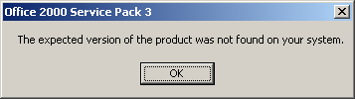
Also with SQL server 2000, the link on GFI LANguard was not able to work either. But all the links on NeWT scanner were correct and have been properly linked.
Even though the links were not working but at least it showed that my office 2000 and SQL 2000 needed to be updated. Therefore, the safest way is to go to the official Microsoft website to download the patches and do the automatic update from http://officeupdate.Microsoft.com. After installing the patches for Office 2000 and SQL 2000 from Microsoft, we can then scan the system again. At the end, it was found that some of the high-risk vulnerabilities have disappeared.

For NeWT scanner, I have updated the vulnerable WinAMP5 mp3 player from 5.5 to 5.6, and we also upgrade JRE /JDK to version 1.4.2_06.

Test phase 3 result
On test phase 3, we will be testing the comparison function of both scanners. The basic idea of the comparison is to compare two testing XML result files and analyst and comparison result, so that we can follow up with the network security.

The result comparison report from GFI LANguard is very clear to the network Administrators. It tracks all the changes of the two scanning results.
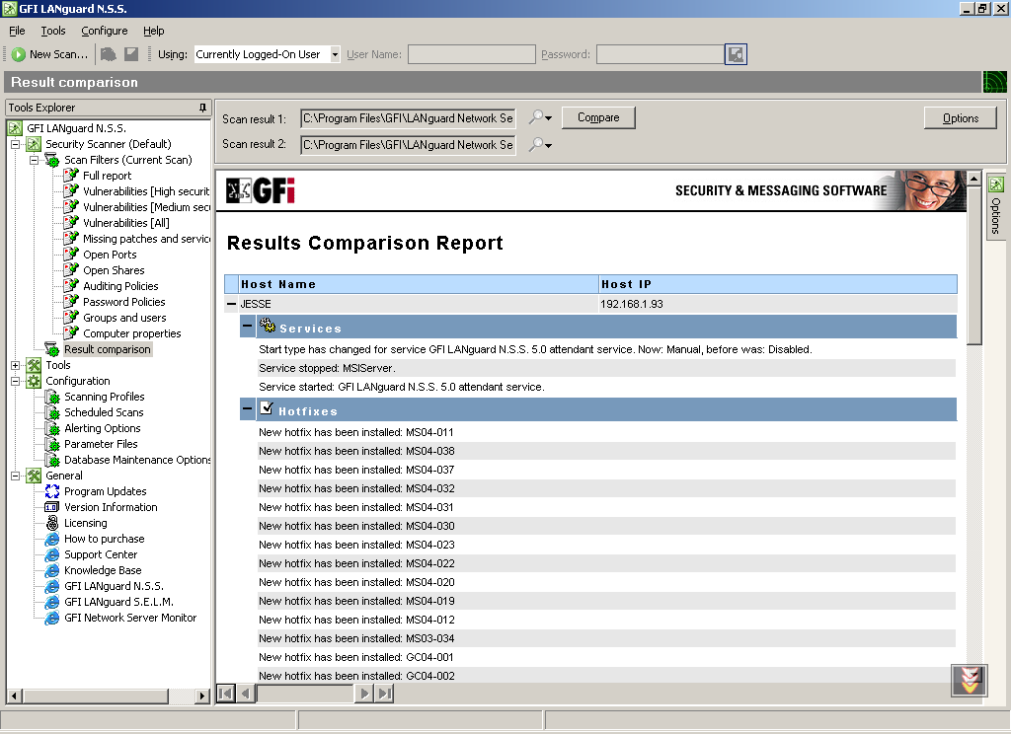
Figure 5 GFI LANguard results comparison

As we can see from figure 6, the red box on the left is the result from phase 2 and the yellow box is from phase 1. We clearly see that the scanner does recognize the changes of system.
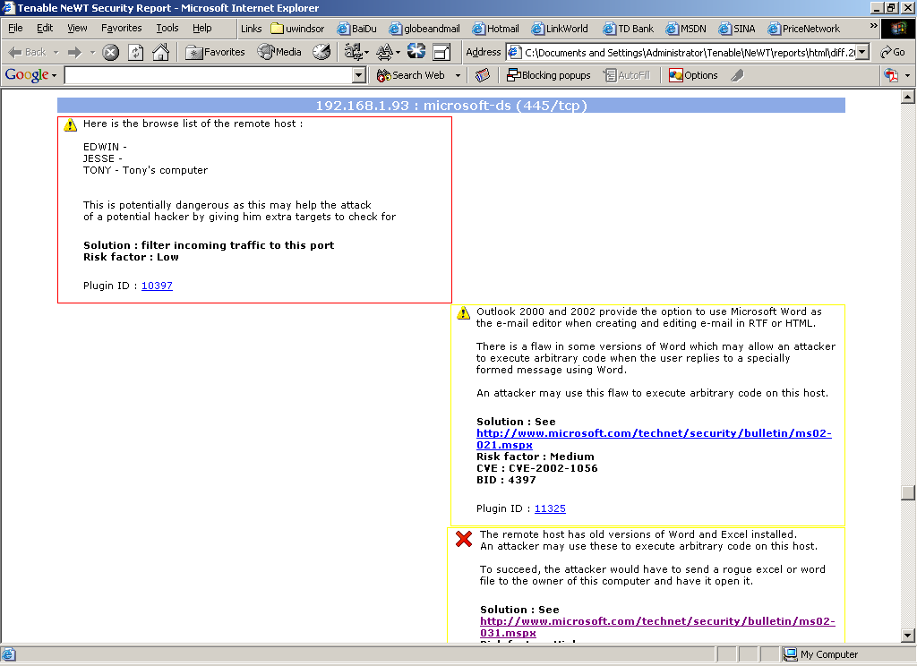
Figure 6 NeWT results comparison

Conclusion
By comparing these two scanners, I discover that GFI LANguard not only checks the system of vulnerabilities quickly but also provides many extra features and tools for the system administrators like patches management, schedule scanning, DNS lookup, Alerting options etc. However, it is important to note that the program itself is buggy and many problems do exist. For example, filtering function and database cannot be located. I have reinstalled this program for couple of times. For NeWT scanner, consider the fact that is a freeware, it shows very powerful scanning ability and stable system performance. Somehow, it is a bit slow in terms of scanning speed. Furthermore, it provides only the features of a normal typical scanner.

Reference:
http://www.tenablesecurity.com/newt.html

NeWT user manual

http://www.gfi.com/languard/

GFI LANguard user manual

Main product pricing, http://www.gfi.com/pricing/pricelist.aspx?product=LANSS
http://www.tenablesecurity.com/newt.html

