A Short Survey on Security Issues IN web services

Abstract

This paper presents a Report on the short survey on a few selected papers on Web Services security. The surevey was accomplished as one of the requirements of a Graduate Course offered at the University of windsor In Winter 2006 [8]. As we talk about the next generation of Internet we actually implicitly talk about the web services. Web Services are likely going to be the leading technology, framework and standard on the internet base transaction. But still this technology is in its primary ages. The ideology behind the next generation of internet is to offer open, restriction free and accessible computation service to everyone. In these coming years of Open Services Age the security standard of the future technologies like Web Services must be investigated and tuned accordingly. Since the Web Service technology itself is infant the security standard of this field is even more immature. In this survey document we accumulated few papers that points out the security issues, threats, resolving techniques and standardization of security policies on Web Services

1.0 Introduction
Web Services have become a very attractive technology now days. Even though it’s framework in not 100% complete, people have been widely using it. The main reason of this popularity is the heterogeneous, loosely coupled architecture of web services. According to Clabby, et al.[6]: “Web services are an evolving distributed computing architecture that uses its own program-to-program interfaces, communications protocols and a registry service to enable similar and disparate applications to communicate and perform ‘services’ for one-and-other.”

The following is an example of a simple le web service in action:
Abu Uddin
School of Computer Science
University of Windsor
Windsor, Ontario
uddin2@uwindsor.ca

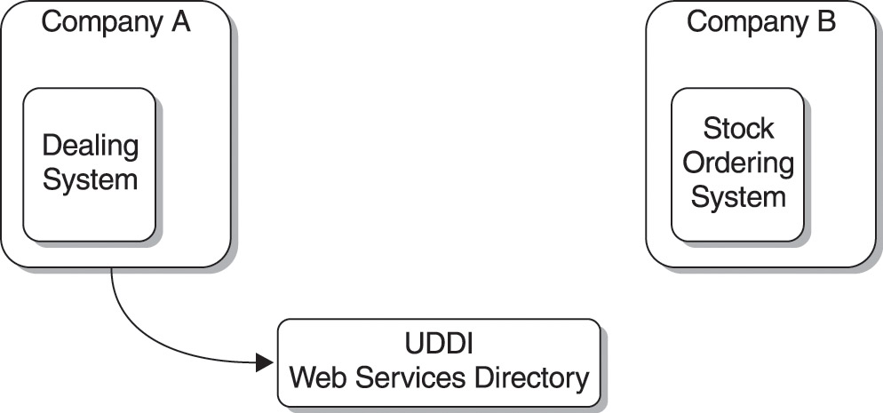

Figure 1: typical web service in action, step 1

In figure 1, company A wants to use the stock ordering system provided by company B. First step is finding the company B’s web service location and interface. For this company B connects to UDDI registry.

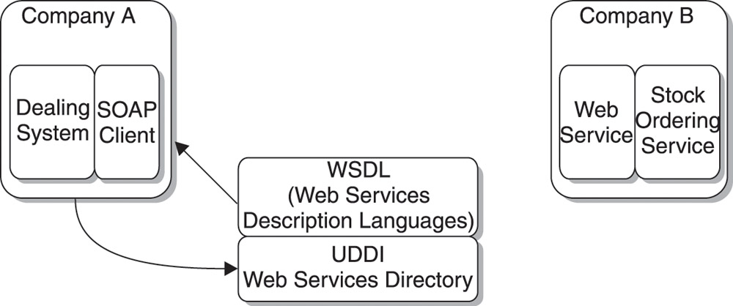
Figure 2: typical web service in action, step 2

As shown in figure 2, UDDI then returns that information to company A in WSDL (Web Services Description Language). Once company A gets the WSDL file, it knows the location and interface of web services provided by company B. Using that it connects to company B using SSL and SOAP protocols.

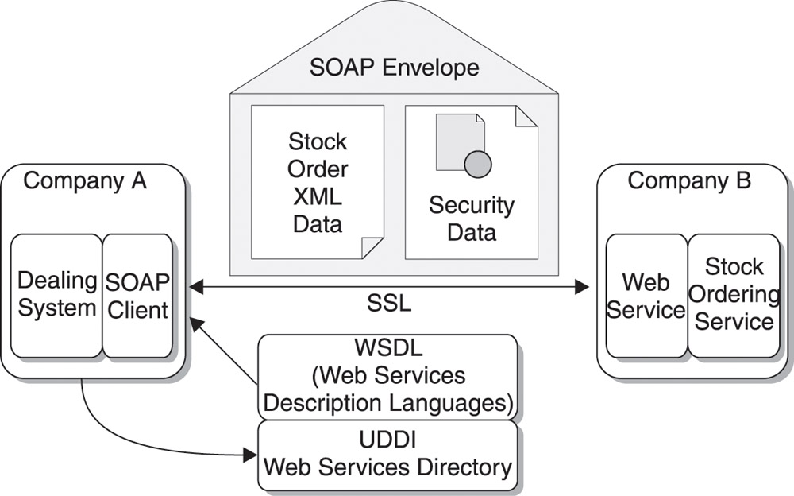

Figure 3: typical web service in action, step 3

2.0 Security Issues in Web Services
Web services are now being used in many critical applications, such as Internet Banking, online shopping. That’s why security is a very important aspect of web services. But despite of the popularity of the web services, many industry observers are still concerned about the security of the web services [5]. Since web services application performs XML based transactions, default web services transactions are unsecured and unencrypted [5]. The attackers/inceptors can gain the XML-based traffic without much of effort.

In this paper we tried to present a few selected papers and their authors’ effort to overcome the current security stack in the Web services. In [2] the authors discussed the security constraints that must be complemented by any Web services System and in this connection they focused on the importance of the standardization policies. They also discussed the potential of a still immature but dominant Security Standard called WS-Security. In [1] the authors described the commonly observed threats typically available in a Web Services System. In [4] the authors proposed a systems approach instead of analytical approach. In the later case the security is ensured by key exchange between the involved but which proves to be incompetent in the world of Web Services which is built on a high level Specification like XML. Therefore they suggested the alternate technique of exchanging the algorithm. In [3] a methodology for composing web services has been devised where the composition is built in such way satisfies the security interest of all the involved parties.

In the following sections we will give a brief over view of each of the papers. Before the conclusion comments on the methodologies of paper [3] and [4] is presented.

3.0 Summary of Selected Papers

Paper 1: Threats and Security of Web Services – A theoretical Short Study

In this paper Rao has discussed various threats and remedies for web services. He also discussed their advantage and disadvantages. This is basically an overview to the attacks for the web services.

As web services are gaining popularity rapidly, they are also becoming a good target for the hackers. Web services are inherently unsecured, and there are various kinds of threats that can harm them. But this paper mainly focuses mainly on three different attacks: Dictionary Attack, Replay Attack, and Buffer Overflow.

Dictionary Attack:
Reverse Turing Test: Reverse Turing Test was developed to protect system from automated program that launches dictionary attack. The idea was to combine the traditional password authentication with a challenge that is very easy to answer for a human but not possible for an automated program. This technique is now widely used by Hotmail, Yahoo and many other companies. It does not affect the usability of the program much but offers a much better protection. Also no special hardware or software is needed to implement, hence, lowering the implementation cost. But it does have some drawbacks; it requires certain capabilities on the user side, such as image viewing and audio playing. Also it can frighten the user who is unwilling to solve the riddles. Also this can affect the scalability of the system. So this method is not optimal for large scale system.

Java Cryptography: Dictionary attacks take twice the time to break a simple protection algorithm than doubly protected password. Java Cryptography now used in various critical applications such as Online Banking, Document Encryption, Signing etc. Java also has Java Cryptography Architecture to aid in-depth support in cryptography. The advantages of using Java Cryptography are: Portability, permits controlled execution of less trusted code (vs. Active), fine grained permission control. But it has a drawback of complex dependencies on other system, OS, browser, network(DNS), PKI. Also flexible policies accepted by user may permit hidden breaching interactions.

Secure Socket Layer (SSL): SSL is the most popular transport layer security protocol for internet. It offers the basic security services of encryption, source authentication and integrity protection for data exchanged over underlying unprotected networks. Many product and OS has support for SSL. Also many web services permits the SSL communication. SSL has all available security functions that are needed to make a project secure (authentication, asymmetric/symmetric encryption, MAC and certificates). But the problem with SSL is that programmers have to know a lot of details about the OS, and system calls.

Transport Layer Secure (TLS): TLS can support confidentiality, integrity, authentication or some combination of all of these. Thus, this helps clients and Servers dynamically, during a session, to decide on the level of security required for a particular data transfer. While this may not be desirable for all uses of secured file transfer, it offers advantages in certain structured environments.

Replay Attack: When an attacker simply listens and sniffs the packets and then later he resends the same packet, it’s called replay attack. The intruder might extract information and alter or inject his own information in the message stream. The hacker can be between a protocol session or transaction between a client program and a server to capture the traffic. Replay attacks are easier to detect with Web Services because payload information is readily available. The key points that are vital in web services security are: Authentication, Authorization, Confidentiality, Integrity, Non-Repudiation. All of these can be satisfied by using encryption except authorization, where SOAP messages can be used to exchange information.

Buffer Overflow: Buffer Overflow is one of the major threats on data integrity. Lots of security breaches have occurred due to buffer overflow. Some of the solutions to the buffer overflow problem are:
- Applying patch to the affected code that will check the length of the data before saving it to the buffer.
- Apply backup code to replace the overflowed one to gain back authorities of the system.
- Use programming languages that has automatic bound checking, such as Perl, Python, Java.

Paper 2: Web Service Security – Vulnerability and Threats, Within the context of WS-Security.
The paper begins with describing the common features and architectures of the web services system. It gives simple overview of the standards involved in this domain like Web Service Description Language (WSDL), Universal Description Discovery and Integration (UDDI) and Simple Object Access Protocol (SOAP). In the second chapter a description of the security issues involved in information technology and in web services has been addressed. It is clearly pointed out that the security mechanism deployed in web services must ensure the security of data both in transit on the internet and in storage of the server. Like any other security system the web services security system must ensure 6 requirement namely Confidentiality, Integrity, Non- repudiation, Authentication, Authorization and Availability. The terms described above are major concern of any security implementation. Confidentiality means that the information cannot be viewed by any party other that the one for which it is meant to, Integrity means the information cannot be changed or tempered, non-repudiation means the sender and the receiver cannot deny their involvement with the information, Authentication means the user must prove his/her identity while authorization means the authenticated person must be authorized to access the information or services. Traditional security measures are actually very well equipped to handle all the above mentioned issue in case of regular traffic flow on the internet. But in the field of web services those techniques are simply not adequate The reason can be explained using the following diagram

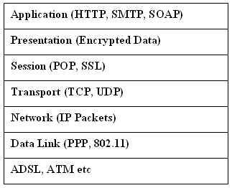
Figure 4: The OSI Stack and WS technology at each level

The above diagram shows the famous OSI stack in data transfer over the internet and the WS technologies involved in each layer of the stack. When data travels from the top through the bottom of the stack the data is padded with addition bits and when it travels up the stack up the padding bits are removed before it presented to the application for meaningful processing. Now if at a given layer the padded bits are locked in some way the data cannot be retrieved without unlocking it first. The traditional security techniques put lock (by means of keys and signatures) on the padding so that the data can be secured from un authorized access. But in the case of web services if there is a intermediary WS other than the actual requester or actual Service Provider than the data must be presented to that service at the Application Layer. The Application Layer of WS is SOAP which is simple XML base document can be comprehended by any system or person involved with the third WS. Therefore confidentiality and Integrity can not be preserved by means of traditional Security measures.

Given the situation any web service must face the following threats:

Unauthorized access, Parameter manipulation, Network eavesdropping and message replay, Denial of Service, By passing of firewalls, Immaturity of the platform. The paper provides a brief description of the WS-Security and than describes the capability of WS-Security on handling those threats.

The key features in WS-Security are Security Tokens, XML Encryption and XML Signature. The tokens are actually security keys included in the SOAP messages. This provides the authentication of the user as well as verifies the users’ access right to the requested service or information. WS-Security support simple user id password based authentication and also a few advanced ones like X.509 that uses certificates for verification. The XML Encryption is a key based encryption that provides confidentiality against unauthorized access to the XML data. The art in this technique is that the different part of the document can be decrypted using different keys. This makes it possible to have multiple receiver for a single message without violating others privacy. The XML signature provides integrity of the XML message. It authenticates the user as who s/he claims to be and ensures data integrity. Just like XML Encryption multiple part of XML document may have multiple signatures.

Exploiting the above features of the WS-Security it is clear that all the previously mentioned threat to Web Services can be handled using WS-Security. The exceptions are only the 2 threats namely Denial of Service attacks and Bypassing of firewalls.

The paper concludes with the future and improvement of WS-Security. Since WS-Security specification is a new one and never been deployed in any real time WS system it runs the risk of going under new kind of threat and attacks by hackers. But all those things can not be addressed properly until they actually happen. Though WS-Security is not a complete specification it is expected that other Specification will come and complement this new Specification.

Paper 3: Web Service Composition a Security Perspective
This paper focuses on the composition of the Web Services from a security point of view. It describes the scenario when multiple web services are involved in providing a given service and how the security policies and requirement and restriction of all the parties involved can be maintained. When multiple Web Services are involved in a Composition to carry out a given request It is important that there security capability and policies match with the requestor’s security criteria and/or specification. For example a requestor may not want to get any service from any WS provider who doesn’t use XML Encryption. On the other hand a Service Provider may want to limit its service response to a limited number of IP addresses. Given the complexity and heterogeneity involved in WS the paper proposes a Web Services Composition Algorithm namely Security Match Maker.

Before describing the key algorithm the authors provided some basic ideas on modeling the security features of Web Services. Since The specifications of Web Services like SOAP, UDDI and WSDL are still incomplete and immature they don’t provide much towards the issue of describing security. Therefore the authors describe a way to model the security features using XML based language like SAML and others.

The main two class of security information that must be described for a Web Service is Compatibility and Constraints. By the Compatibility of the WS the authors meant the security techniques adopted by the WS. For example a WS may use P3P technology specification to preserve the Privacy of the users. In order to describe such security capability the authors suggested the use of Security Assessment Markup Language (SAML). A element of such Language can be as follows.

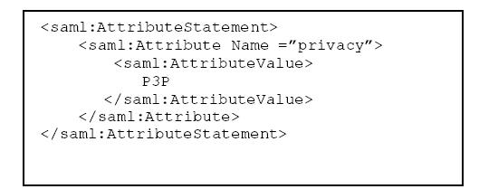
Figure 5: An example of SAML [4]
The above element simply describes the privacy preserve techniques adopted by a certain WS provider

The other thing we must describe is the constraint of the WS. The paper outlined three different kinds of constraint namely compatibility constraint, general constraint and final constraint. The compatibility constraints can be put into the WSDL document of the WS using the extensibility element of WSDL. The following diagram shows such presentation

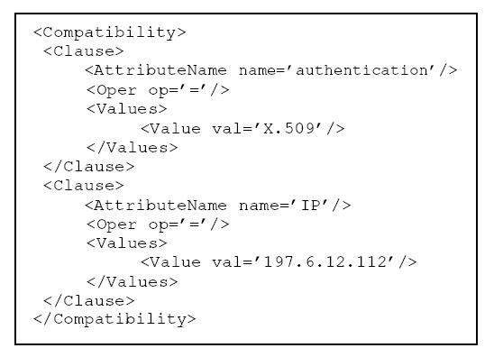
Figure 6: The WSDL element describing capability of a WS [4]

The above diagram describes the fact the WS supports excepts request WS who uses X.509 based authentication or any request that comes from the 197.6.12.112 IP address.

The other two kind of constraints are actually provided during the composition of the WEB Services and hence the authors proposed that they should be described in the SOAP messages among the Services.

After providing the language specification of the Security features in WS the authors presented security conscious Broker Architecture that enables. The Broker is actually responsible for building the workflow and to compose the service relating all the necessary Web Services. The Broker Architecture is some thing as follows:
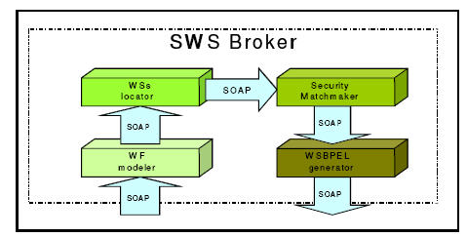
Figure 7: SWS-Broker Architecture
The architecture composed of 4 basic component. Modeler, Locator, Matchmaker and WSBPEL generator. Upon receiving a service request from requestor the Modeler builds up a work flow to solve service the request. The workflow is actually a set of activity that must be carried out in sequence or parallel to completely fulfill the request. Once the workflow is in place the Broker uses the WS locator to locate all the Web Services that are capable of service each of those activity. When the list of available Web Services is available they are tested for security compatibility and Constraints through the Security Match Maker Component.

The final section of the paper describes the Security Match Maker Technique which is actually the major proposal of the paper. The algorithm is pretty straight forward and simple. It can be better explained using a simple example.

Let consider in response to service request the modeler develops a workflow which is a set of activities {A1, A2, A3, A4} which must be carried out in the same sequence in order to complete the task. And the web service locator produces the following list of Web services for each of the activities.
A1 → {WS2, WS6, WS8}
A2 → {WS3, WS4, WS9}
A3 → {WS11, WS12}
A4 → {WS13, WS14}
Given all these information the Match Maker Produces a tree structure some thing like the following
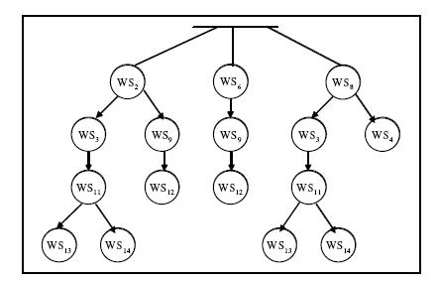
Figure 8: The Web Service Composition Tree [4]
The tree has 4 levels each level corresponds one of the activity (e.g. level 1 refers to activity 1; level 2 refers 2 activity and so on). the first level tells us that we have 3 alternate to carry out the task A1. If we chose WS2 for A1 then we have 2 choices to carry out A2 either through WS3 or through or WS9 but not WS4 since it is not compatible with WS2. Progressing in this fashion we can build the whole three. And once the tree is built we can choose any of the following sets to compose our Web Services.

Composition 1 → {WS2, WS3, WS11, WS13}
Composition 2 → {WS2, WS3, WS11, WS14}
Composition 3 → {WS8, WS3, WS11, WS13}
Composition 4 → {WS8, WS3, WS11, WS14}

In conclusion the authors emphasized on the future work of developing an efficient version of the Match Making Algorithm. They are also planning extend their proposal to other kinds of constraints like Quality of service constraint. They also outlined their intention to work on privacy issues of the Web Services.

Paper 4: Algorithm Exchange of a Security Control System for Web Services Applications
Currently Among the security mechanism, WS-Security standard seem to be the most matured one. The standards have been implemented and exposed with positive results over the last couple of years. But WS-Security has described clearly that the current mechanism doe not provide the complete security and therefore allows external security model to be collaborated with [7]. Even though WS-Security standards fully support message integrity and message confidentiality, they are still dependant on the PKI infrastructure. Which means application must have its own additional security, protection.

In this paper Nasution et al. tried to achieve web services security by utilizing a systems approach rather than an analytical approach. They have proposed an overview of the development architecture TTSN(Trusted Transient Simple Network). This is an internet security control system, which was under development while the paper was written. But the main focus of the paper was on algorithm exchange, one of the core parts of TTSN architecture.

Trusted Transient Simple Network:
Web Services uses SOAP, Simple Object Access Protocol, which by definition can include some intermediaries, who is neither requestor nor responder, but a third party. Hence, it is necessary for each party to provide itself with a sophisticated security system which can be very independently of any other middle parties. The most frequent strategies to solve the security problem have mainly focused on already known risks. But such strategy will fail when an unknown risk occurs. TTSN along with some other strategy tries to solve the problem. While others have used analytic approach, TTSN uses systems approach. Figure 1 shows the interconnection between TTSN members (A, B, and tow middle parties X and Y)

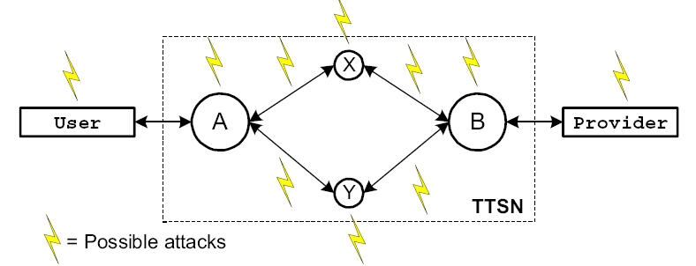
Figure 9: The TTSN’s interconnection

In the above figure, A is the requestor of a transaction to B. The traffic package leaving from A through one path will be sent back to B through the other path. Also, B will also append the reversed traffic package to B with the response. In this way, A will know enough information regarding the state of the transaction and some behavior of its counterpart.

One important point in this TTSN architecture is that it is transient. That means it can be either activated or deactivated dynamically by the owner. But when a party activates TTSN his counterpart also need to do that.
The following figure shows the A’s perspective for Control System in the TTSN:

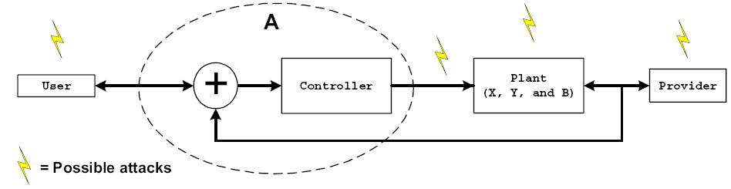
Figure 10: TTSN Security control system

The security controller in A treats X,Y and B as plant of the control system. If the plant is not stable or the traffic has distortions, A must maintain the process in a continuously stable state(all the security properties within A and B are still guaranteed). The reasoning mechanism in TTSN is implemented using fuzzy logic. The following figure shows the interdependency of all security properties. Each property will be occupied by an intelligent.
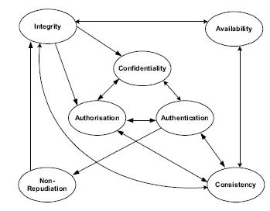
Figure 11: interdependency of security properties

The following figure shows that the TTSN’s main modules:

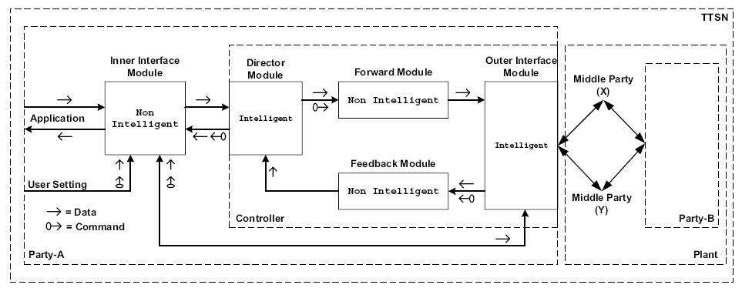
Figure 12: Interconnectivity of the TTSN’s modules [4]

By deploying co-operative intelligent agents, loosely coupled interrelationship and strong definition of policy and rules, the aim is that TTSN will be able to solve and handle any current and potentially new vulnerability and threats. The following figure shows the agents connectivity. It also shows that every security agents outputs its transaction to the director agent(inside the director module).

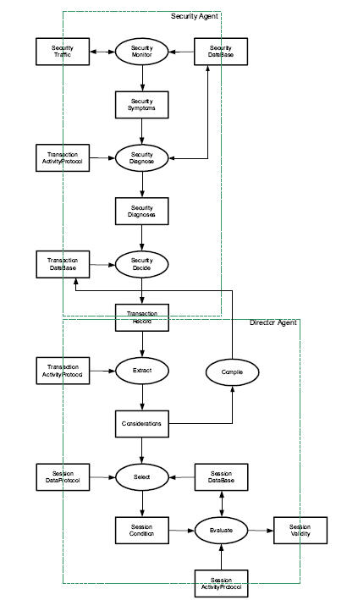

Figure 13: Agents connectivity in a session [4]

Algorithm Exchange:
Since web services perform XML-based transactions and most internet transaction performs secret key exchange, it is very likely to be intercepted. The interceptor has a chance of cracking the content of the message sooner or later, since the encryption algorithm is known to everyone (in the worst case the interceptor can try brute force methods). In contrast, TTSN performs algorithm exchange instead of key exchange(managed in the outer interface module of TTSN).Both parties dynamically exchanges their algorithm throughout the session. Since both parties used their unique algorithm, the authors claimed that, it will be really difficult, if at all possible, for the interceptor to crack the message performing a brute force analysis to the algorithm, not to the key. According to the authors there are no known techniques available to crack algorithm.

For exchanging the algorithms they have used the reflection packages and serialized class features of JAVA. Since the java class can be decompiled, it was first obscured using a tool such as JBuilder. They claimed that this method not only guarantee confidentiality, but also authentication and message integrity. Since the algorithm is not known, any one else cannot impersonate the sender. The recipient must deploy the previous algorithm to check the integrity of the data validating the signature.

Testing Methodology:
The authors have successfully implemented and tested a cryptographic algorithm exchange in a web service environment using IMB WebSphere Studio Device Developer(WSDD5.6) and JDK1.4.1. The implemented system has been tested in Windows XP platform.

The web service responder provides the following addition services:

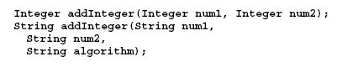

The following two algorithm classes were prepared for exchange by the requestor:
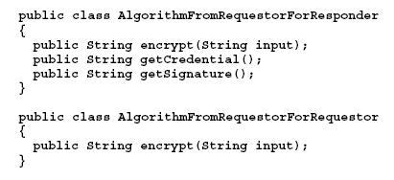
Similarly responder provides two algorithm classes:
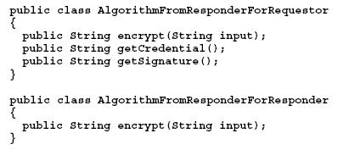
All the parameters and output of the method string representing bytes in decimal symbols.

The ClassLoader has been subclasses to dynamically load the algorithm:

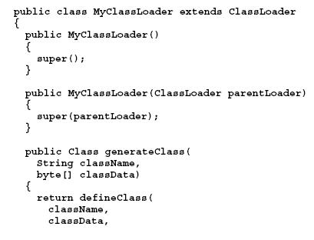
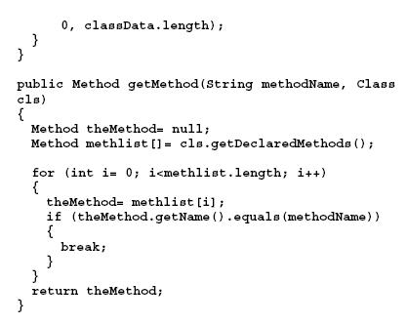
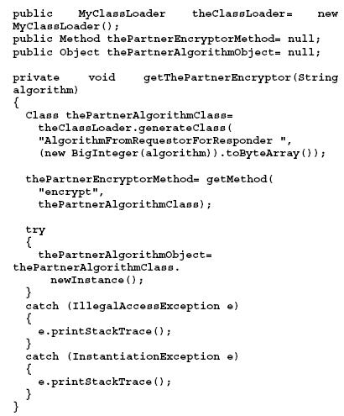

After the class was loaded it has been instantiated and the method has been extracted and invoked:

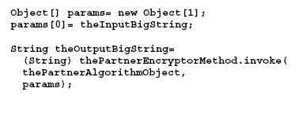

As the implementation for supporting authorization and non-repudiation directory structure tools for TTSN utilizing Java’s Basic Attribute and BasicAttributes classes have been developed. For supporting availability, agents as the entities to run the whole TTSN structure have been deployed. If the partner is no longer available or is under attack, the TTSN agents will disconnect the transaction independently. The “transient” characteristic of TTSN means that the path will change dynamically according to the current situation. If one or both parties of X and Y are no longer trusted, the agents will change the path to another trusted nodes. This mechanism is important for keeping the functionalities of TTSN available for as long as needed.

Remarks on The Methodologies

On the selected papers the last 2 ([3] and [4]) provides some algorithms and techniques to accomplish their respective proposals. In [3] the authors presented an algorithm to compose Web Services dynamically that will satisfy the security requirement of all the associated parties. But the performance of such a an algorithm (The Match Maker algorithm) is actually never been tested in real time scenario. To be precise there is no test bed available at least until the time the paper was published to fully verify the aspect of such algorithm. The proposed XML specifications to describe the Security capabilities and Constraints of the Web Services are not standardized and probably will require lot more changes and modification to fully address the issues.

The methodologies described in [4] also suffer from the same draw back, i.e. lack of testing in real scenario. The paper gives the impression that java is only capable language to provide Object serialization and class reflection. But in practice the similar capabilities were available in C# during the time of publication of this paper. Therefore the performance issue of the algorithm is still not fully explored as better result may be available using the .NET platform.

Paper [1] only provides few of the threats available in Web Services. Those mentioned security threats are actually resolved for traditional internet transactions. But why they are still a threat for Web Services is not clear from that paper. Though the paper titled as Theoretical Shot Study on Web Services, it actually focuses those issues from a general point of view.

But on the hand paper [2] addressed the threats on the Web Services in a mature way and described why traditional Internet transaction threats are still a threat to Web Services. In this connection they also investigated the aspects of new

Conclusions

Since web service is going to be the leading technologies in the future internet world the security issues on this will become a critical factor. Therefore it is very important to explore this issues as much as possible before the technologies goes in mass for production level. On the other hand it is again impossible to fully understand the complete set of security threats in Web Services technology until its usage become common and wide spread in the businesses. Many new threats will very much likely to show up in coming years. To cope up with such threats it is important to develop robust security standards and specification.

References
- G. S. Radha Krishna Rao, “Threats and Security of Web Services – A Theoretical Short Study,” International Symposium on Communications and Information Technologies 2004 (ISCIT 2004), Sapporo, Japan, October 26-29, 2004, page(s): 783-786.
- Holgersson, J.; Soderstrom, E.; "Web service security - vulnerabilities and threats within the context of WS-security", The 4th Conference on Standardization and Innovation in Information Technology, 2005, 21-23 September, 2005 Page(s): 138 - 146
- Carminati, B.; Ferrari, E.; Hung, P.C.K.; "Web Service Composition: A Security Perspective", Proceedings. International Workshop on Challenges in Web Information Retrieval and Integration, WIRI '05., 08-09 April 2005 Page(s):248 - 253
- Nasution, B.B.; Kendall, E.A.; Khan, A.I.; “Algorithm Exchange of a Security Control System for Web Services Applications,” Proceedings of the 38th Annual Hawaii International Conference on System Sciences, 2005. HICSS '05. 03-06 Jan. 2005 Page(s):167a - 167a
- D. Geer, "Taking steps to secure Web services," Computer, vol. 36, pp. 14-16, 2003.
- J. Clabby, "Web Services Gotchas," Bloor Research N.A., Yarmouth, ME, Report July 2002. 2005, Volume 2, 20-22 July 2005 Page(s):78–82, 2005.
- B. Atkinson, G. Della-Libera, S. Hada, M. Hondo, and P. Hallam-Baker, "Specification: Web Services Security (WSSecurity)," available at vol. http://www-106.ibm.com/developerworks/library/ws-secure/ , May 24, 2004.
- “Security and Privacy on the Internet (60-564)”, available at http://web2.uwindsor.ca/courses/cs/aggarwal/cs60564/index.html

 

