FineCrypt 8.1


Professional Encryption Software

Project: 60-564

Farhan Mirza

Department of Computer Science

University of Windsor

Table of Contents
1.0 Background 3
2.0 Importance 3
3.0 FineCrypt 8.1 4
3.1 Features 4
3.2 FineCrypt Encryption Algorithms 4
3.3 Algorithms used in FineCrypt 5
3.3.0 AES (Rijndael) 5
3.3.1 Blowfish 5
3.3.2 Cast-256 6
3.3.3 Gost 6
3.3.4 Square 6
3.3.5 Mars 6
3.3.6 RC-6 7
3.3.7 Serpent 7
3.3.8 DES 7
3.3.9 Twofish 7
  - Encryption Modes used in FineCrypt 8
    - Electronic Codebook mode (ECB) 8
    - Cipher Block Chaining mode (CBC) 9
    - Cipher Feedback mode (CFB) 9

Output Feedback mode (OFB) 9
3.5 Protecting Secret keys 9
4.0 Installing FineCrypt 10
5.0 Encryption Method in FineCrypt 14
5.0.0 Encryption using Password 14
5.0.1 Decryption using Password 16
5.0.2 Encryption using Key 18
5.0.3 Decryption using Key 21
6.0 How to check reliability of FineCrypt's encryption? 22
6.0.1 Example of checking FineCrypt 23
7.0 Conclusion 27
8.0 References 27

1.0 Background
Cryptography is the art or science of secret writing, or more exactly, of storing information (for a shorter or longer period of time) in a form which allows it to be revealed to those you wish to see it yet hides it from all others.

Cryptography has been used almost since writing was invented. For the larger part of its history, cryptography remained an art, a game of ad hoc designs and attacks. Although the field retains some of this flavor, the last twenty-five years have brought in something new.

2.0 Importance:
Cryptography used to be considered a very esoteric subject. It seemed to have no important practical applications outside of the government/military world, and was considered a harmless mathematical diversion if anyone else should pursue it. The age of computers has changed that. In a world where everything we do is recorded on computers, and all computers are linked to the Internet (and thus to each other) we find that cryptography is of vital importance in many areas:
- When a business with multiple office locations needs to send computer data files between them, encryption can assure that outsiders cannot just grab a copy while the data is in transit
- When different people share a computer system, encryption allows them to hide information from each other.
- By issuing personalized encryption keys to people, it is possible to create a document that can be read only by one designated party, even though everybody has physical access to it.

3.0 FineCrypt 8.1
FineCrypt is a security software application that enables you to secure store your data on your computer using strong encryption and safely communicate with other users of FineCrypt via Internet. FineCrypt uses secret-key encryption, also referred to as symmetric encryption i.e. the same key to encrypt and decrypt files and folders.

3.1 Features:
- Supports 10 Encryption Algorithms i.e. AES, Blowfish, 3DES etc
- Uses 4 Encryption Modes i.e. ECB, CBC, CFB and OFB
- Only program which checks the correctness of encryption
- Secure exchanging encrypted files and encryption keys with other users using FineCrypt Communicator
- Key Management using key manager
- Encrypt several files either into single encrypted archive or into different encrypted files
- FineCrypt perform encryption both with the password and with the key specified by the user
- Using the "Wipe" utility one can permanently delete the file content so it cannot be retrieved using disk recovery software

3.2 FineCrypt Encryption Algorithms:
FineCrypt uses a single key for encryption and decryption i.e. Symmetric Algorithms. Symmetric algorithms can be divided into two categories: stream algorithms and block algorithms (also called stream and block ciphers), but for FineCrypt we are using block algorithm.
A block cipher is a type of symmetric-key encryption algorithm that transforms a fixed-length block of plaintext data into a block of ciphertext data of the same length. This transformation takes place under the action of a user-provided secret key. Decryption is performed by applying the reverse transformation to the ciphertext block using the same secret key. The fixed length is called the block size. All algorithms used in this program have the block size 64 bits or 128 bits.
Iterated block ciphers encrypt a plaintext block by a process that has several rounds. In each round, the same transformation (also known as a round function) is applied to the data using a subkey. The set of subkeys is usually derived from the user-provided secret key by a special function. The set of subkeys is called the key schedule. The number of rounds in an iterated cipher depends on the desired security level and the consequent trade-off with performance. In most cases, an increased number of rounds will improve the security offered by a block cipher.

3.3 Algorithms used in FineCrypt

3.3.0 AES (Rijndael)
AES (stands for Advanced Encryption Standard, former name: "Rijndael") is a winner of AES competition (got 86 votes). It is a 128-bit block cipher with keysize of up to 256 bits developed by Joan Daemen and Vincent Rijmen. The round transformation of AES does not have the Feistel structure. Instead, the round transformation is composed of three distinct invertible uniform transformations, called layers.

3.3.1 Blowfish
Blowfish is a 64-bit block cipher developed by Bruce Schneier. It is a 16-round Feistel cipher and each round consists of a key-dependent permutation and a key-and-data-dependent substitution. All operations are based on exclusive-ors and additions on 32-bit words. The key has a variable length (with a maximum length of 576 bits). This cipher was designed specifically for 32-bit machines and although there is a complex initialization phase required before any encryption can take place, the actual encryption of data is very efficient on large microprocessors.

3.3.2 CAST-256
CAST is a 64-bit block cipher with keysize of 128 bits developed by Carlisle Adams and Stafford Taveres. It is a 16-round Feistel cipher that uses rotation to provide intrinsic immunity to linear and differential attacks.

3.3.3 GOST
GOST 28147-89 is a Russian encryption standard. It is a 64-bit block cipher with keysize of 256 bits. GOST is a DES-like 32-round Feistel cipher and each round consists of key-and-data-dependent substitution and rotation. All operations are based on exclusive-ors and additions on 32-bit words.
3.3.4 SQUARE
SQUARE is an iterated block cipher that uses a 128-bit key length and a 128-bit block length. The round function of SQUARE is composed of four transformations: a linear transformation, a nonlinear transformation, a byte permutation, and a bitwise round-key addition. SQUARE was designed to be resistant to linear and differential cryptanalysis, and succeeds in this respect.

3.3.5 MARS
MARS is a 128-bit block cipher with keysize of up to 448 bits developed by IBM. MARS has a heterogeneous structure, with cryptographic core rounds that are wrapped by simpler mixing rounds. The cryptographic core rounds provide strong resistance to all known cryptanalytical attacks, while the mixing rounds provide good avalanche and offer very wide security margins to thwart new (yet unknown) attacks.

3.3.6 RC-6
The RC-6 block cipher was designed by Ron Rivest in collaboration with Matt Robshaw, Ray Sidney, and Yiqun Lisa Yin from RSA Laboratories. The algorithm is an evolutionary improvement over the RC-5 block cipher, and like RC-5, it makes essential use of data-dependent rotations. It has 128-bit block size, a key size of up to 2040 bits, and a 32 rounds. There are three routines in RC-6: key expansion, encryption, and decryption.
3.3.7 Serpent
Serpent is a 32-round SP-network, designed by Ross Anderson, Eli Biham and Lars Knudsen. It operating on four 32-bit words, thus giving a block size of 128 bits. All values used in the cipher are represented as bitstreams. Serpent encrypts a 128-bit plaintext to a 128-bit ciphertext in 32 rounds under the control of 33 128-bit subkeys.

3.3.8 3DES

A variant of DES, Triple DES (also 3DES) is based on using DES three times. This means that the input data is encrypted three times. The Triple-DES is considered much stronger than DES, however, it is rather slow compared to some new block ciphers.

3.3.9 Twofish
Twofish is a 128-bit block cipher that accepts a variable-length key up to 256 bits. The cipher is a 16-round Feistel network with a bijective F function made up of four key-dependent 8-by-8-bit S-boxes, a fixed 4-by-4 maximum distance separable matrix over GF(28), a pseudo-Hadamard transform, bitwise rotations, and a carefully designed key schedule. The design of both the round function and the key schedule permits a wide variety of tradeoffs between speed, software size, key setup time, gate count, and memory.

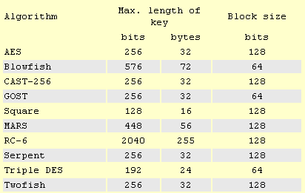

3.4 Encryption Modes used in FineCrypt
When we use a block cipher to encrypt a message of arbitrary length, we use techniques known as modes of operation for the block cipher. To be useful a mode must be at least as secure and as efficient as the underlying cipher. Modes may have properties in addition to those inherent in the basic cipher. A more general version of the standard generalized the four modes of DES to be applicable to a block cipher of any block size. Modes standard modes used in FineCrypt are Electronic Code Book (ECB), Cipher Block Chaining (CBC), Cipher Feedback (CFB), and Output Feedback (OFB).

3.4.0 Electronic Codebook mode (ECB)
When this cipher mode is used, each block is encrypted individually. No feedback is used. This means any blocks of plaintext that are identical and are either in the same message, or in a different message that is encrypted with the same key, will be transformed into identical ciphertext blocks.

3.4.1 Cipher Block Chaining mode (CBC)
This cipher mode introduces feedback. Before each plaintext block is encrypted, it is combined with the ciphertext of the previous block by a bitwise XOR. This ensures that even if the plaintext contains many identical blocks, they will each encrypt to a different ciphertext block.

3.4.2 Cipher Feedback mode (CFB)
In CFB mode the previous ciphertext block is encrypted and the output produced is combined with the plaintext block using exclusive-OR to produce the current ciphertext block. It is possible to define CFB mode so it uses feedback that is less than one full data block. An initialization vector is used as a “seed” for the process.

3.4.3 Output Feedback mode (OFB)
OFB mode is similar to CFB mode except the quantity exclusive-ORed with each plaintext block is generated independently of both the plaintext and ciphertext. An initialization vector is used as a “seed” for a sequence of data blocks, and each data block is derived from the encryption of the previous data block

3.5 Protecting Secret keys
Safe storage of secret keys is one of the most important thing to provide for securing the encrypted data. We should provide the safe storage of our secret keys bearing two goals in mind:
- Protecting secret keys from disclosure;
- Protecting secret keys from being lost.
The most reliable way to prevent secret keys from disclosure is to maximally restrict physical access to them. The best practice is to keep secret keys on removable media such as floppy disk, CD, removable hard drive, etc. This medium in turn should be kept in a secure location to which only owner of that key have access, such as a safe, or locked cabinet.
In order to protect the secret key from being lost it's strongly recommended to always have one or even two backup copies of secret keys and keep them separately. If the data encrypted with a secret key is extremely important and valuable, We can even consider to rent a bank deposit box, and keep a backup copy of secret keys there. Also it's a good idea to print out secret keys and keep the paper copy of keys in a fireproof place.
4.0 Installing FineCrypt:

Download and install setup file
- FineCrypt can be downloaded from http://www.finecrypt.net/download.html
- Click on any of the 4 optional link to download fcinst.exe
- Once fcinst.exe downloaded on the machine, click the package to start installation
- You will come up with the following screen. Click continue to proceed

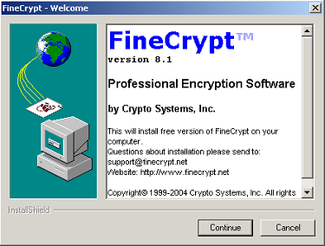

5. Then click next

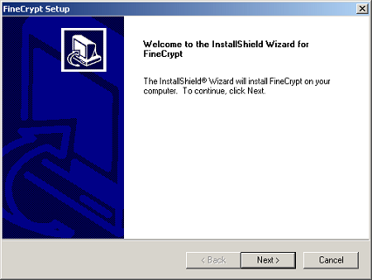

6. Read the license Agreement and if you agree the terms and condition then proceed

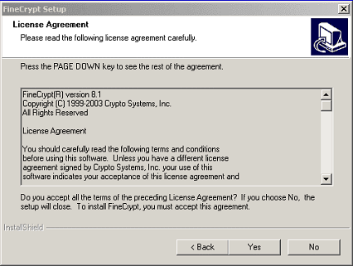

7. Choose the destination location where you want to install FineCrypt.

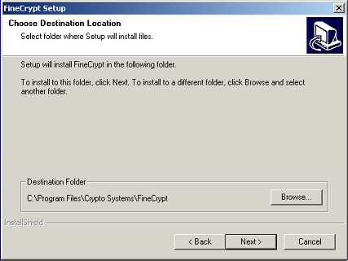

8. After giving the destination location, click next to proceed

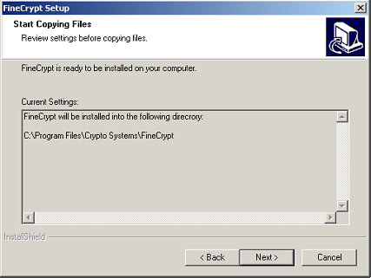

9. Select the radio button “Yes, I want to restart my computer now”, this will finish your installation and your system will be restarted.

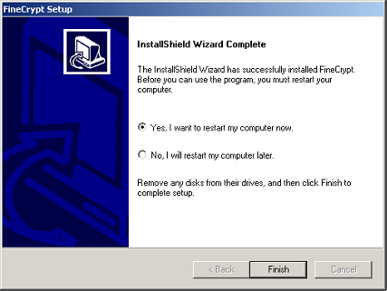

10. After restarting your computer, click on FineCrypt icon and you will come up with the below FineCrypt Interface known as ArcViewer Window

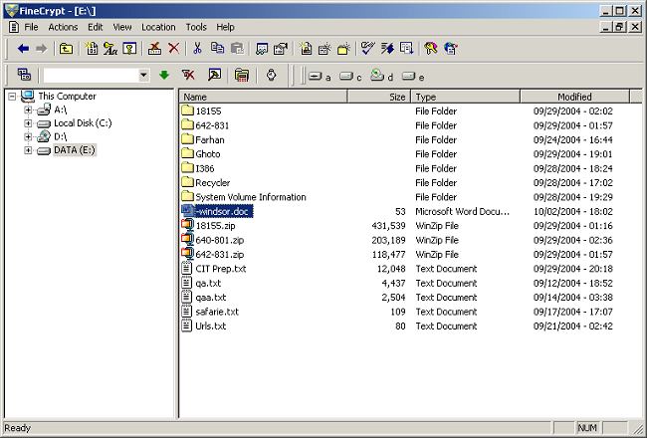

5.0 Encryption Method in FineCrypt

To encrypt or decrypt a file using FineCrypt we have 2 different methods.

  - Encryption using Password
This method is more easy to use but that method is not recommended where we need strong encryption and we have to sacrifice some degree of security. This length may be as long as 255 bytes (symbols). Different algorithms use different length of key, and a key, which was used for encryption with one algorithm, may not work with other algorithm.
Steps to Encrypt a file using Password Encryption:
1. Click with the right mouse button on selected files; from the FineCrypt submenu choose "Encrypt with password" menu item ;
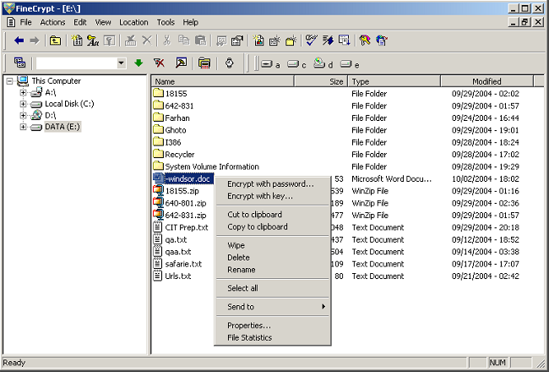

2. You will get the screen below. Enter the passphrase you want to encrypt a file

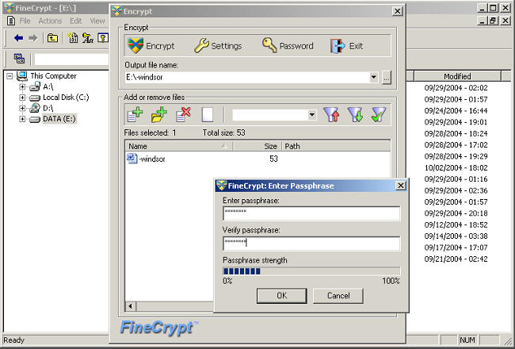

- Choose the Encryption Algorithm and Encryption Mode you want to encrypt your file with. In below example, we selected the algorithm TripleDES with Cipher Feedback mode.

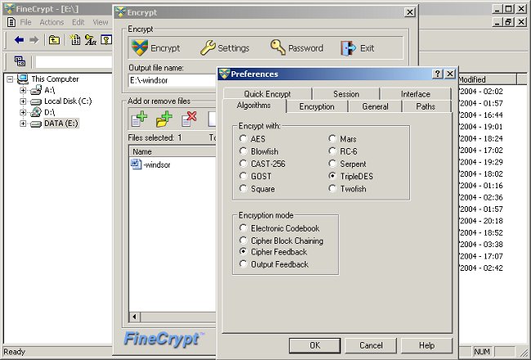

- Then click on Encrypt button and save the file with .fca format. You will get the encrypted file, as shown highlighted in below screen.

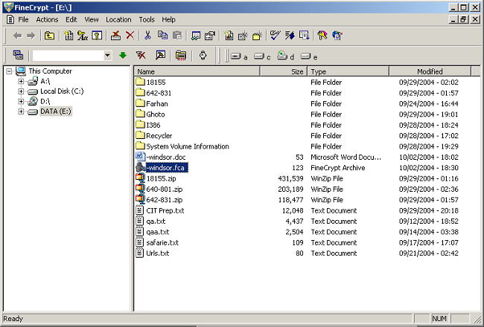

5.0.1 Decryption using Password
- In order to decrypt a file or folder, click the desired source.

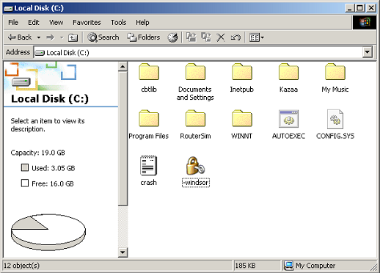

2. Once you click the desired file you want to decrypt, if that file is encrypted with password, FineCrypt will as you for password as shown below. Enter the same password you used to encrypt the file and press ok.

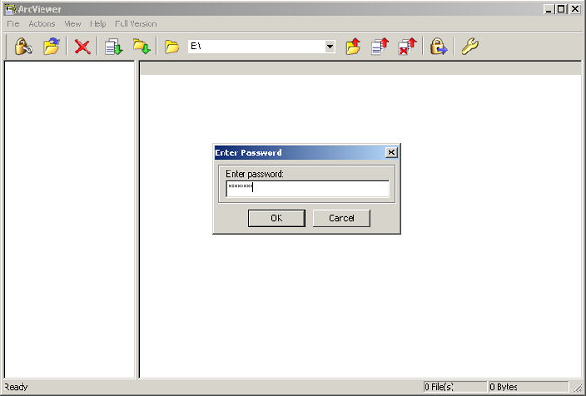

3. By pressing the Ok button you will get the decrypted file as shown below.

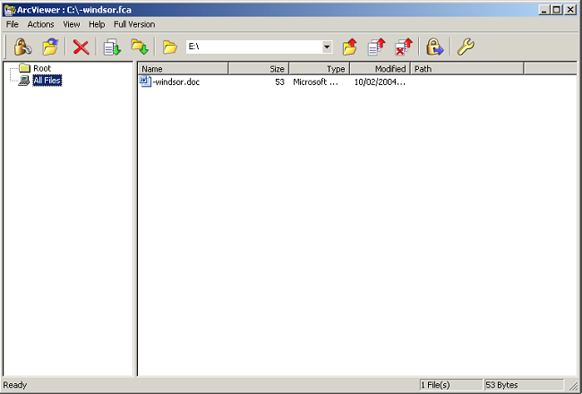
5.0.2 Encryption using Key:

1. Right Click the file or folder you want to Encrypt. In below example, we are encrypting a file “-windsor.doc”. Click on “Encrypt with Key…”

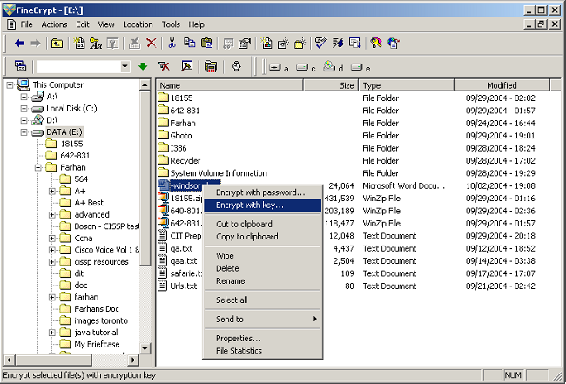

2. Click on Settings and you will get the screen below. Select the algorithm and mode, which you want to use to encrypt the file. This time we are selecting AES Algorithm and Cipher Feedback mode, as shown below

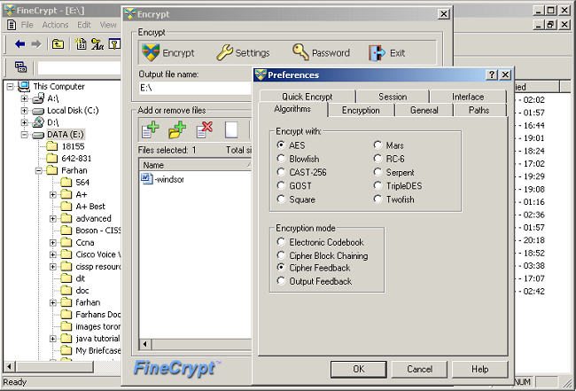

3. Click on Password Button and you will get the Encryption key box, as shown below. You can set the configuration as per your requirement. Size of the key in this example is 32 bytes, which can be different if other algorithms can be used. Click on Generate Button and you will be able to get the key by clicking the save button. Save the key on desired location and then specify the path and file name for encrypted text and then press Encrypt Button

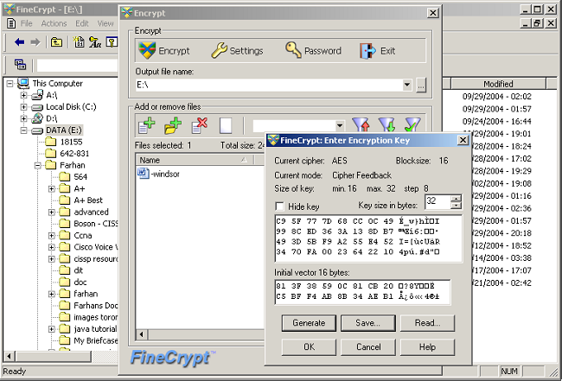

4. You will get the encrypted file along with the key, as shown below.

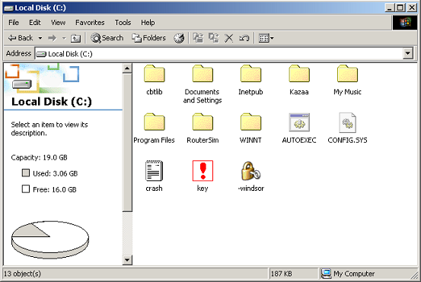
5.0.3 Decryption using Key:

1. In order to decrypt a file or folder, open the encrypted file and you will get the screen below.

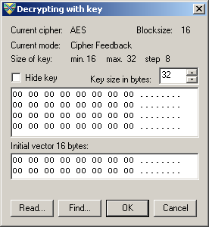

2. Click the “Read…” button and select the saved key which was used to encrypt the file and then press ok

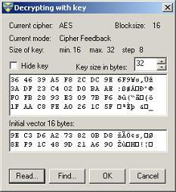

- You can see the decrypted file below

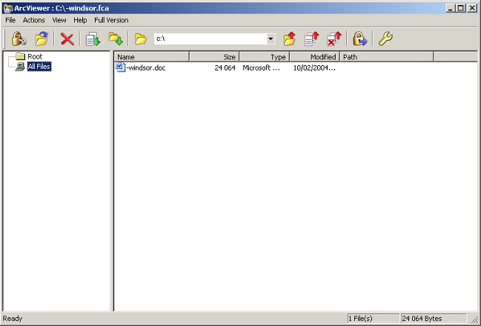

6.0 Checking reliability of FineCrypt's Encryption
How can we know that the program with which we are protecting our confidential information encrypts our data with the declared algorithm and with the declared length of key? It is worth to mention, that published source code of a program is NOT the guarantee of the correct encryption unless we built source files and got executables by ourselves.
We can check the correctness of encryption with the most simple and most reliable method which has specially been designed for such checking: by comparing the original text (so called "plaintext") and the resulting ciphertext, which is being produced by the program from the plaintext, with some examples that are offered by developers of algorithms (these examples are called "test vectors").
Such test vectors are widely published and we can find them in the Internet on the web sites of authors of algorithms. For example, we can find test vectors for the Blowfish algorithm on the site of Counterpane Systems company (Bruce Schneier, the author of the Blowfish algorithm, is the president of this company): http://www.counterpane.com/vectors.txt. In order to perform such a test we will need any hexadecimal file editor. We can download a free copy of a simple hexadecimal editor "HighLight" @ http://www.finecrypt.net/mylight22.exe

6.0.1 Example of checking FineCrypt
Let’s test the encryption with the AES algorithm in the Electronic Codebook mode. We use the HighLight editor in this example but we may use any other hexadecimal editor.
At the site of the National Institute of Standards and Technology (NIST) there are test vectors for the AES algorithm. We can download them in a single zip file from here: http://csrc.nist.gov/ encryption/aes/rijndael/rijndael-vals.zip Here is one of these test vectors from the file "ecb_tbl.txt" (all values are hexadecimal):
Plaintext: | 83 4E AD FC CA C7 E1 B3 06 64 B1 AB A4 48 15 AB
Key: | 00 01 02 03 05 06 07 08 0A 0B 0C 0D 0F 10 11 12  14 15 16 17 19 1A 1B 1C 1E 1F 20 21 23 24 25 26
Ciphertext: | 19 46 DA BF 6A 03 A2 A2 C3 D0 B0 50 80 AE D6 FC

1. Create new file in hexadecimal editor. In order to do this, select "File/New/New Binary File" menu item in the HighLight editor. After you have created new file, make sure that there is a blinking cursor in the top left corner of the editor window, and then enter the plaintext exactly as shown in the test vector:
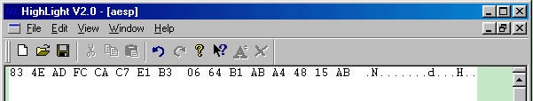
2. Select the "File/Save" menu item, choose a directory where we want to save the file and save the file as "aesp". Then select the "File/Close" menu item. Our plaintext is created.
3. Start FineCrypt and select the "Tools/Settings" menu item. On the "Algorithms" page set "AES" as the encryption algorithm and "Electronic Codebook" as the encryption mode.
On the "General" page set the compression option as "Don’t compress.".
4. In the FineCrypt window go to the directory where we have saved the file "aesp". Click with the right mouse button this file and choose "Encrypt with key…". A dialog box will appear. Make sure that the current cipher is "AES", the current mode is "Electronic Codebook" and length of the key is equal to 32 bytes.
Enter the encryption key exactly as shown in the test vector. Below is a view of the "encryption key" editor window after that:
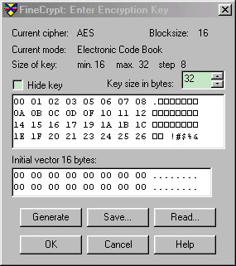
ASCII symbols to the right of the hexadecimal values may look differently on computer. How the ASCII symbols look depends on the codepage of computer, but for now this is not important.
This is the key for encrypting plaintext. We do not change anything in the "initial vector" editor window (below the "encryption key" editor window) because the initial vector is not used in Electronic Codebook mode. In the "Output file name" field set the filename as "aesp".
Press the "Encrypt" button and encrypt the file.
The process is finished. The test plaintext has been encrypted with the test key and we just have to check whether the ciphertext in the file "aesp" corresponds with NIST’s ciphertext or not.
5. Go back to the hexadecimal editor. Choose "File\Open…"; go to the directory where the file "aesp" has been saved; in the "Files of type" combo box select "All Files (*.*)", in the "Open as:" combo box select "Binary". Find the encrypted file "aesp" and open it.
If everything has been done correctly you will see the following picture:
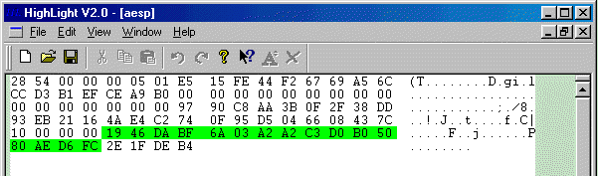
The first 68 bytes are the file header. This header contains information about the algorithm and the mode used for encryption, whether the file was encrypted with the password or with the user’s encryption key, whether the file was compressed before encryption or not. The header also contains encrypted creation time of original file and last write time of original file, encrypted size of the original file, the length of the name of the original file and the encrypted name of the original file with relative path.
The next 16 bytes (marked here with green color) are the ciphertext. Compare it with the ciphertext from the test vector and make sure they are identical. So we can see that the internal realization of the algorithm is fully adequate to the author’s scheme.
The last 4 bytes is the checksum of the file content, which is used for ensuring that the file content is not damaged.
We can test in the same way with appropriate test vectors all algorithms in all modes. In order to check FineCrypt in modes such as CBC, CFB and OFB the fourth array called initial vector must be added. Keep in mind that the size of the file header will change together with the length of the name of the encrypted file. In our example length of file name was equal to 4 bytes, if you will encrypt file whose file name is 5 bytes long, then size of the header also become longer on one byte. And do not forget to turn off compression before testing.

7.0 Conclusion
Encryption products are the locks and keys of the Information Age, enabling individuals and businesses to protect sensitive information as it is transmitted over the Internet. The ability to protect and secure information is vital to the growth of electronic commerce and to the growth of the Internet itself.
Encryption technologies, which scramble communications so that they can only be read by their intended recipients are also vitally important to protect privacy, secure commercial transactions, and prevent crime.
The ability to protect and secure information is vital to the growth of electronic commerce and to the growth of the Internet itself. But Cryptography isn’t just for the government and commercial organizations; it is for you and me. It protects your individuality against a more wired, unregulated, over intrusive, privacy-deprived planet.
FineCrypt is a security software application that enables you to secure store your data on your computer using strong encryption and safely communicate with other users of FineCrypt via Internet. Use Finecrypt or other encryption tools, no matter how unimportant your messages may be. Practice the new form of authentication and signing just as you might do with your hand-written signature. The wider implications of a closely controlled public are staggering. The government right now is attempting to make it law for themselves to hold your secret key. So don’t let it happen, get educated and more importantly educate.
The power of Cryptography and the benefits that go with it must shift from governments to the people.

8.0 References
http://www.finecrypt.net
http://www.faqs.org/faqs/cryptography-faq/part03/
http://www.finecrypt.net/meyer.html
http://venus.uwindsor.ca/courses/cs/aggarwal/cs60564/materials.htm

