Prevention and Detection of DoS/DDoS

Aqila Dissanayake
University of Windsor
dissanaa@uwindsor.ca

Olalekan Kadri
University of Windsor
kadrio@uwindsor.ca

1. Abstract

As computing has virtually replaced the traditional ways in which daily activities are done, so also are the activities meant to disrupt our day-to-day routines. Various attacks on applications running over networks/internet have been reported. These attacks are access control attacks, confidentiality attacks, integrity attacks, authentication attacks and availability attacks [2]. The last category which is often referred to as Denial of Service (DoS) attack is the type of attack this paper will be centred on. This type of attack is characterised by malicious use of computer resources to its capacity, thereby preventing the legitimate use of such resources. DoS attacks came into popularity in the year 2000 when websites such as Yahoo, Amazon, and CNN were crippled using these attacks [3]. While DoS attacks hardly cause any physical damage to the network, it nevertheless prevents available resources from being efficiently utilized. Various loop- holes in the architecture of networks and implementations have been exploited in delivering this grievous act. This type of attack applies to both wired and wireless networks. In this survey we will be discussing methods used to prevent or at least counteract DoS and Distributed Denial of Service (DDoS) attacks.

2. Introduction

The sources of DoS can be single or multiple as seen in Distributed Denial of Service attacks (DDoS). “Today, the most common DoS attack type reported to the CERT/CC involves sending a large number of packets to a destination causing excessive amount of endpoint, and possibly transit, network to be consumed. Single source against single target attacks are common, as are multiple source against single target attack” [4]. Figure 1 below gives a general description of what a general DDoS architecture looks like.

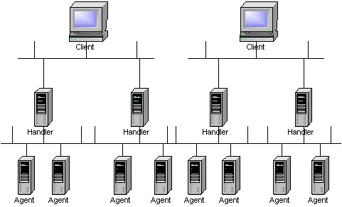
Figure 1
Adapted from http://www.cisco.com/warp/public/707/newsflash.html

Clients are under the control of the attackers [7]. Handlers are hijacked units by the attacker through his clients. Agents are controlled by the handlers, both running some special programs that are meant to launch the attack [7]. It is the agents that eventually generate the thousands of packets that flood the victims’ systems. The whole process is an automated, thereby making it possible to compromise a good number of hosts in minutes. This automated system can be described with following steps:

- Initiate a scan phase in which a large number of hosts (on the order of 100,000 or more) are probed for a known vulnerability [7].
- Compromise the vulnerable hosts to gain access [7].
- Install the tool on each host [7].
- Use the compromised hosts for further scanning and compromises [7].

This survey will be based on three different papers that were based on Distributed Denial of Service attacks with the view of examining the issues addressed, the designed methodology and criticism/suggestion on the way forward on any aspect as deemed fit.

Defeating DDoS attacks by fixing the incentive chain paper argues that, although there is room for more improvements in technological solutions, the priority should be placed on economic solutions [1]. Also, the paper argues that a “vast amount of research has been done on technological solutions while only a handful exist on economic aspects” [1]. According to the paper “the parties that suffer the most are not in the best position to defend, while the parties in the best position do not suffer enough to defend” [1].

In order to deliver digital content successfully, collaboration of multiple parties are required. These include Internet Content Providers (ICP), Backbone ISPs, regional ISPs, and end users [1]. Each one of these parties contributes and invests various amounts to the final product. Therefore successful delivery of content or the final product depends on the effort of each party. An incentive chain is the set of value and monetary transactions along digital delivery channels [1]. It can act as a glue to stick various parties together in collaboration [1]. In a DDoS scenario, defensive action taken by ISPs benefit ICPs and end users the most, but ISPs are rarely compensated which discourage them to take action against such attacks [1].

The solution is to transfer the incentives from the parties that suffer the most to the parties that are in the best position to defend. This is achieved by a “usage-based traffic pricing structure that stimulates cooperative filtering” [1].

3. The Digital Supply Chain and Cooperative Technological Solutions to DDoS Attacks

According to the paper the digital supply chain consist of the following [1]

1. The Internet core, which consists of dozens of interconnected backbone ISPs who collectively maintain the backbone of the Internet.
2. The Internet cloud except the core, which consists of less than 10,000 regional ISPs that connect to the core through one or several backbone ISPs and serve different geographical regions.
3. The edge of the Internet, which consists of around 100,000 networks that are locally administrated.
4. Millions of online computers including content servers and clients

This is depicted in the diagram below

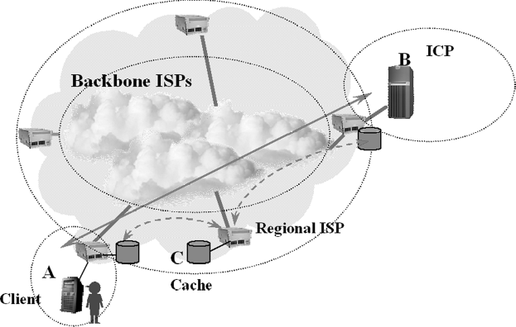
Figure 2: The Digital Supply Chain
Adapted from [1]

4. Cooperative Filtering

This works in 3 steps [1].

- Alarming - analyzing the pattern of network traffic, Intrusion Detection Systems (IDS) identify suspicious traffic and send out alarms.
- Tracing - Following the alarms, a tracing mechanism kicks in to track back each attack path as far as possible.
- Filtering - filters along every attack path that is configured to filter out attack traffic.

One approach to filter out attack traffic is to ban IP-spoofing at the edge of the network [1]. The reason being, if the source addresses are correct, then the tracing mechanism can accurately trace every bad packet and find the attackers which could result in the ISP banning those responsible IP Address’.

We think that even though this approach sounds like very effective, it’ll be very hard to implement. Especially with NAT (Network Address Translation) being widely used everywhere. If an ISP doesn’t take NAT into account and ban IP Address’ that send DoS traffic, it could mean a lot of innocent users getting affected. One can argue that IP spoofing can be implemented at the very edge of the network like routers in a home network or a small organization. It can be done, but the problem is that most users in those networks do not understand what IP spoofing is yet alone DDoS attacks.

5. Ingress & Egress Filtering

Ingress Filtering – controlling of traffic coming into a network

Egress Filtering – controlling of traffic leaving from a network

Ingress filtering can prevent certain DDoS attacks coming toward a network. Egress filtering can prevent internal systems from performing outbound IP spoofing attacks.

6. Cooperative Caching

Another solution is to divert and evenly distribute attack traffic from a victim into a large number of cache servers such that each stream of diverted traffic is not significant enough in volume to create any congestion [1]. “Cooperative caching is an effective solution to DDoS attacks when cooperative filtering is costly to implement, or when attack traffic is well concealed in legitimate data requests such that pattern recognition is technically difficult” [1]. Also, both filtering and caching can be jointly used to more effectively reduce and divert attack traffic.

The flow of the digital content is driven by two major sources [1]

(1) End users’ demand to consume digital content
(2) ICPs demand to publish digital content

End users and ICPs both pay directly to ISPs for internet connections [1]. Regional ISPs pay larger regional ISPs and backbone ISPs for the internet connectivity [1]. This series of payments is called the “incentive chain” [1].

These days most internet connections are subscription based meaning an end user or a regional ISP pays a fixed monthly fee to a regional ISP/backbone [1]. The fee is paid for a certain traffic volume. Furthermore, most ISPs have extra bandwidth that is not being used. Why should ISPs use these unused resources to provide better services and help on cooperative filtering? More importantly, what are the costs and benefits an ISP will get by doing so? The costs will include administrative work in setting up filters and reduction in transmission performance due to filtering [1]. Unfortunately the benefits for the ISPs are little to nothing as long as the DDoS attacks only take the extra bandwidth which the ISP does not use anyway [1].

The lack of incremental payment structures on the internet makes it difficult for victims of DDoS attacks to motivate ISPs who are in a better position to filter traffic [1]. As one can see from this scenario, ISPs have no incentive to control/filter traffic as long as they do not have congestion in their own network. In other words, the attack traffic used to do harm to ICP’s are only taking bandwidth that is already free in the network. As a potential solution, a usage-based, pricing structure provides the right incentive for cooperative filtering [1]. A usage based pricing structure will tie payments to actual traffic [1]. This means a user will have to pay for the actual traffic usage or in other words the number of IP packets transmitted. Also, another solution proposed is dynamic pricing where the actual cost of transmission depends on the congestion level of the network [1].

The main requirement of usage-based pricing is that the cost of transmitting the attack traffic has to be large enough for the ISPs even when it does not lead to congestion [1]. That way they will have enough incentives to set up filters. So, by replacing the current subscription based internet access with a usage-based one we can have a win-win situation for regional and Internet Content Providers (ICPs) as they will only pay for what is used at any point in time. This argument is based on the fact that regional ISPs will want to reduce their bills as much as possible; they will be motivated to filter unwanted traffic so that only useful traffic is paid for. In doing so, various ICPs will also have their bills reduced based on the reduced/filtered traffic. This will ultimately make DDoS traffic filtered out as such would have been identified by the regional ISPs.

One problem that rises from this method is how to count the number of packets that is used by a user in order to charge that user. Another question that can be asked is what if the people conducting the DDoS attack can purchase enough bandwidth because the DDoS attack itself will gain them more profit than what it costs to do the attack. Also, the benefits gained from the solution should not be less than the costs to implement the solution. If it is the case, then there is no point in implementing such a solution. After all, to filter out traffic and to monitor usage many extra devices will have to be purchased. Furthermore there will be costs for configuring, billing, auditing and disputing [1].

7. DDoS Defense by Offense

The paper DDoS Defense by Offense talks about defending servers against application-level Distributed Denial of Service (DDoS) attacks. “This paper presents the design, implementation, analysis, and experimental evaluation of speak-up, a defense against application level distributed denial-of-service (DDoS), in which attackers cripple a server by sending legitimate-looking requests that consume computational resources”[10]. According to the paper, with “Speak Up” a server under attack encourages all clients, resources permitting, to automatically send higher volumes of traffic [10]. The theory behind this is that attackers are already using most of their upload bandwidth [10]. However, good clients have bandwidth left which results in high volumes of traffic when encouraged [10]. “The intended outcome of this traffic inflation is that the good clients crowd out the bad ones, thereby capturing a much larger fraction of the server’s resources than before.” [10]

Usually DDoS defense mechanisms work to slow down bad traffic or eliminate them completely. But in DDoS defense by offense, the process relies on all clients to send more traffic than they are currently sending. In this scenario 2 assumptions are made

- Good clients are not utilizing full available bandwidth
- Bad clients are utilizing full available bandwidth

Therefore, when a DDoS attack is detected, the server asks everyone to send more traffic than they are currently sending. Since bad clients are utilizing their full available bandwidth they will be unable to fulfill the request. But good clients will be able to send more traffic as they are not using their full bandwidth. “As good clients send more traffic, the traffic into the server inflates, but the good clients will be much better represented in the mix and thereby capture a much larger portion of the server than before” [10]. Unfortunately, if the bad clients are not working at their full bandwidth when conducting the attack, the speak-up strategy would backfire.

Most Web sites try to conserve computation by detecting and denying access to bots that conduct DDoS attacks using various methods. A simple method used is to distinguish between good and bad clients by profiling IP address’ [10]. A technique known as rate-limiting can be used to limit the request rate for all clients to be the same amount. “These techniques are powerful because they seek to block or explicitly limit unauthorized users, but their discriminations can err” [10].

The central mechanism in speak-up is a server front-end, the thinner, which protects the server from overload and performs encouragement [10]. “When the server is overloaded, the thinner causes each new client to automatically send a congestion-controlled stream of dummy bytes on a separate payment channel, and when the server is ready to process a request, the thinner selects the client that has sent the most bytes” [10].

“Speak-up helps good clients, no matter how much bandwidth they have” [10]. Speak-up makes sure the good clients get all the service they need or increases the service they get when compared to an attack without speak-up [10]. The problem is that the server will need to keep extra bandwidth available for speed-up to successfully work. In other words if the DDoS attack can consume most of servers bandwidth speed-up will not be successful. The paper suggests that speed-up is not a good solution for small sites that has less bandwidth for the simple reason in DDoS attacks their bandwidth will be completely consumed.

8. The protection of QoS for Multimedia Transmission against Denial of Service Attacks

This paper is based on the general knowledge that Denial of Service (DoS) attacks compete for the limited available resources with legitimate traffic. DoS is viewed from a multimedia environment with the aim of preventing it from interfering with the quality of transmission of multimedia services over the internet. The framework proposed is based on two major components; The Intrusion Detection System and Adaptive Transmission Management [9]. Figure 3 below gives a diagrammatic representation of this framework.

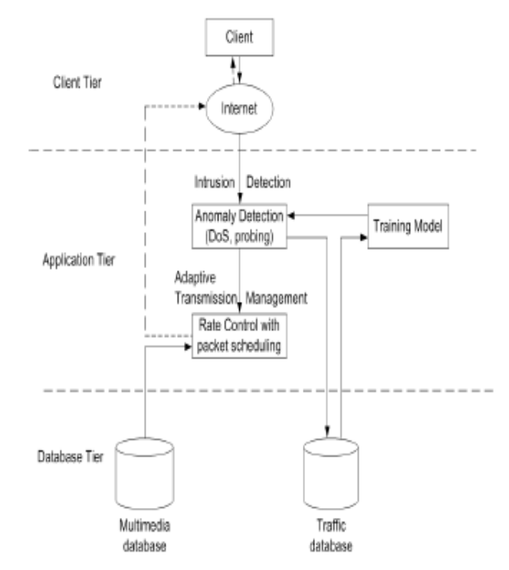
Figure 3: Showing the proposed framework for protecting a multimedia QoS against Denial of Service [9]

The Intrusion Detection System contains both the anomaly detection and data stream monitor [9]. The data stream directs traffic to the anomaly detection component that is built on pattern comparison. The anomaly detection system is not signature based but a learning system that compares a set of good traffic (packet headers) with any new coming traffic using data mining techniques [9]. If any strange pattern is determined, an alarm is raised to signal a denial of service attack. Based on an alarm, a signal can then be sent to the Adaptive Transmission Management unit.

The Adaptive Transmission component is responsible for allocation of resources for quality of service [9]. Since it is likely that some resources would have been allocated to the detected denial of service packets, such packets can be filtered/discarded if a certain threshold is reached depending on the algorithm under implementation [9]. This component works with synchronization of two other sub-units; rate control and packet scheduling. Factors such as bandwidth requirements, packet losses and delay jitters are dynamically adjusted depending on the network situation to guarantee the quality of transmission [9]. The Packet scheduling is responsible for implementing multi-buffer scheme at the source to increase the quality of video being transmitted [9].

An experiment was conducted to simulate the effect of the proposed framework using NS2. Two services; video streaming via UDP protocol and FTP via TCP were tested with the attack launched from a FTP service [9]. The architecture of the environment is as shown in figure 5. It was found that the framework can determine DoS attacks and remove resources allocated to such requests so that the overall quality transmission of the multimedia system can be maintained.

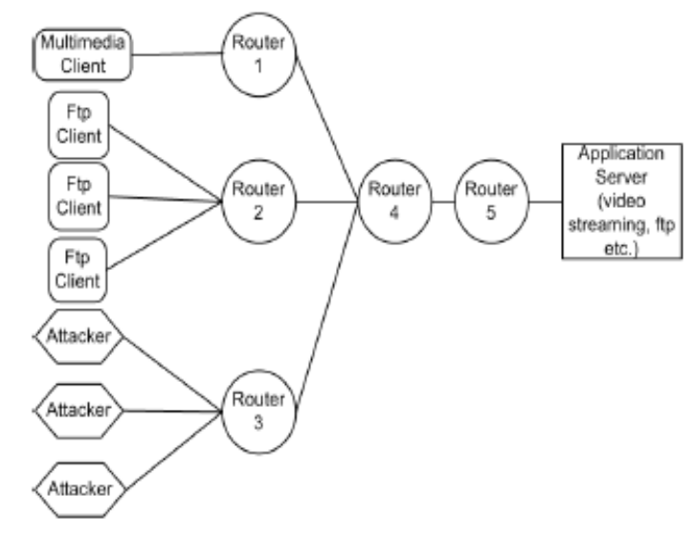
Figure 4: showing the architecture of the environment used

It is argued from the framework suggested that the anomaly system will do better than signature based Intrusion Detection Systems. There is however the doubt that the proposed system may not be intelligent enough to provide accurate alerts as there are tendencies of having false negatives and false positives. The fact that there are no certified dedicated rules and signatures that identify DoS traces, the possibility of wrong signals/alarms can not be ruled out. This will then ultimately lead to granting resources to illegal requests and denying legal requests.

The simulation is equally not detailed enough to see the detection carried out by the anomaly detection system when the attack is launched from a FTP service. This therefore makes it impossible to clearly see how intelligent the anomaly system can be and possibly suggest how it can be improved. Further evidence on how detection is done could have made the proposed framework more acceptable.

12. References

[1] Yun Huang, Xianjun Geng, Andrew B. Whinston “Defeating DDoS Attacks by Fixing the Incentive Chain”, ACM Transactions on Internet Technology (TOIT), 2007

[2] Wireless attacks, A to Z, searchsecurity.techtarget.com, “http://searchsecurity.techtarget.com/generic/0,295582,sid14_gci1167611,00.html”

[3] Wireless tapping, www.governmentsecurity.org, “http://www.governmentsecurity.org/articles/WirelessTaping.php”

[4] Houle K. J. and Weaver G. M. “Trends in Denial of Service Attack Technology”, CERT Coordination Center, Carnegie Mellon University, Oct. 2001

[5] New flaw takes Wifi off the air, www.seccuris.com, “http://www.seccuris.com/documents/newsletters/Seccuris%20Monthly%20Newsletter%2005.31.04/Seccuris%20Monthly%20Newsletter%2005.31.04.html#article_3 “

[6] Port scanning, www.cs.wright.edu, “http://www.cs.wright.edu/~pmateti/Courses/499/Probing/“

[7] Strategies to protect Against Distributed Denial of Service (DDoS) Attacks, www.cisco.com, “http://www.cisco.com/warp/public/707/newsflash.html”

[8] Luo Hongli and Shyu Mei-Ling, “Protection of QoS for Multimedia Transmission against Denial of Service Attacks”, Proceedings of seventh IEEE International Symposium on Multimedia, 2005

[9] Luo Hongli and Shyu Mei-Ling, “Protection of QoS for Multimedia Transmission against Denial of Service Attacks”, Proceedings of seventh IEEE International Symposium on Multimedia, 2005

[10] Michael Walfish, Mythili Vutukuru, Hari Balakrishnan, David Karger, and Scott Shenker, “DDoS defense by Offense”, Proceedings of the 2006 conference on Applications, technologies, architectures, and protocols for computer communications SIGCOMM, 2006

