Wired TCP SYN Flooding and Snort IDS

Matthew Ruston
School of Computer Science, University of Windsor

Abstract
One of the many types of denial of service attacks is known as a TCP SYN Flood attack. This attack utilizes the design of the TCP protocol against it self to flood a network resources’ limited connection slots. This is done by flooding connection requests to these slots from illegitimate sources so the connection never actually can be established. The goal of the attacker here is to leave no available connection resources for legitimate clients or users. This report details how to configure a simple SYN Flood attack using two computers and a simple wired network It will then go into detail on how to configure and use the intrusion detection system known as Snort in order to monitor for this type of attack. Finally the effects of the SYN Flood attack will be analyzed.

Note: Screenshots present in this document are also available alongside the electronic submission of this report.

1. Introduction

Denial Service Attacks (DoS) are a very common method for attacking network resources. A denial of service attack is designed to limit or outright block the access of legitimate users or traffic to a network resource. This attack is usually performed by methods that are designed to saturate the limited resources of a target. Through the malicious consumption of a service’s bandwidth, CPU, memory, or storage devices, attackers can swamp the resource with so much malicious network traffic or data that it becomes inaccessible by normal communication channels. In rarer cases a denial of service attack can take the shape of physical destruction of network components and equipment. To summarize, any malicious action that is used to deny normal legitimate access to a network resource can be grouped under the domain of denial of service attacks.

When a server becomes inaccessible due to over utilization or data saturation, a denial of service attack is not always the culprit. Highly popular network services can often portray the appearance of a denial of service attack simply by having too many legitimate users trying to concurrently access the resource. This is most easily witnessed during the release dates for popular downloadable software off publicly accessible servers or at popular news websites such as Digg.com [http://digg.com]. These types of inadvertent DoS attacks are usually caused by the total consumption of available bandwidth to a network resource.

Typically, the term ‘DoS’ attack usually implies that a limited or single network resource is responsible for the attack. Much larger scale attacks however are referred to as Distributed Denial of Service (DDoS) attacks. These types of attacks can be of the global scale where hundreds, thousands, or millions of (typically infected or ‘zombie’) computers are used to attack single or multiple network resources. This is a very potent attack and is a common threat that enterprise IT environments need to be prepared for.

Types of attacks that are known for their DoS and DDoS nature come in a variety of names and styles. For example, bandwidth consumption DoS attacks come in the form of Ping Attack’s or ICMP Echo attacks. Both of these methods rely on the over consumption of a targets bandwidth through the flooding of network ICMP ‘ping’ and ‘echo’ commands. Each packet used in this communication, albeit small, can have a large effect on the resources of a server if used en masse. Another type of DoS attack is called SYN Flooding and it uses the design of the TCP protocol against itself in order to attack a network resource through over consumption of limited resources. This type of attack will be the main focus of this report.

2. Problem Overview

The scope of this report is to introduce, analyze, and discuss the implementation of SYN Flooding as a type of denial of service attack. Now that the premise of a DoS attack has been developed, an understanding of the TCP process needs to be explained before SYN Flooding can be discussed. After TCP and SYN Flooding have been introduced, there will be a detailed experiment launching a simple SYN Flood attack over a wired network. This will be followed by the introduction of Snort as an intrusion detection system that will be configured to attempt to log the attack.

3. Overview of Transmission Control Protocol (TCP)

The transmission control protocol is a huge fundamental technology standard that powers networks all around the globe. TCP works through a system of ‘handshake’ mechanisms that are used to construct a reliable connection between two communicating network nodes. TCP is considered ‘reliable’ because it requires the recipient to acknowledge to the sender that each packet - although potentially out of order - is received. Before the transfer of data can be performed, first the TCP protocol needs to set up a connection between two resources. This is done through the three step TCP handshake process.

The TCP handshake process occurs as follows:

Client A wishes to establish a TCP connection to Client B.

- Client A sends a TCP-SYN packet to Client B.
- If Client B receives the TCP-SYN packet then Client B sends a TCP-SYN-ACK packet to Client A.
- Client B waits for Client A to send a TCP-ACK packet to Client B in response to the TCP-SYN-ACK message sent by Client B.

Figure 1 TCP Handshake Process
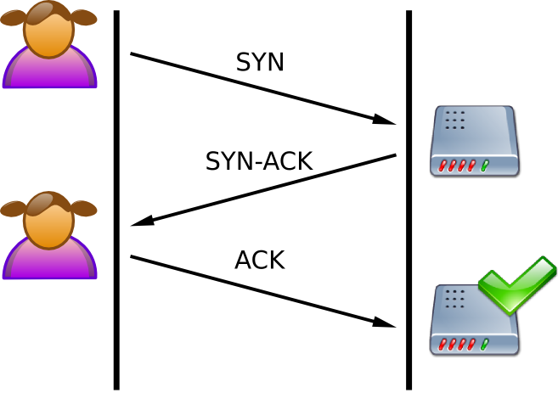

Once this connection process has been completed, the two clients will be able to transfer messages, in the form of packets, between each other. Each time Client A sends a packet to Client B, Client B will acknowledge receipt of that packet with a ACK message to Client A, and vice versa.

4. SYN Flood Denial of Service Attacks

A SYN Flood DoS attack utilizes an excessive number of TCP SYN packet requests to the target server in order to perform the attack. When a resource receives a SYN request it will create a ‘half open’ connection and then send out a SYN-ACK message to the originating source address in the SYN packet. The attack occurs when the source address has been forged and no actual ACK response from the source (thus completing the three way TCP handshake) ever occurs. This leaves the target node waiting for a specific amount of time (as set on the network resource) waiting for the ACK response that will never arrive. When repeated over time, this causes the attacked node create numerous of these half open connections that are just idling and waiting for the ACK response that will never arrive. Eventually these half open connections will time out naturally, but the goal of a SYN Flood is to then immediately reacquire the connection slot once it has timed out. If all of the possible connection slots can be saturated by the attacker then no legitimate traffic will be able to connect to or use the target resource. Providing the SYN Flood is sustained by the attacker and no counter-measures are configured or used on the target machine, a sustained SYN Flood attack could theoretically cause a DoS state on the target machine for an indefinite amount of time.

Figure 3 SYN Flood Example
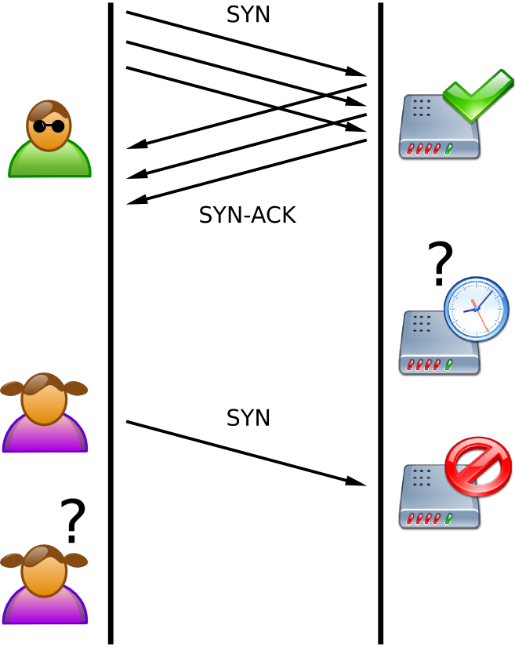

As seen in Figure 3, an example of a simple SYN Flood attack, an attacker (as defined by the character with the sunglasses) sends a number of SYN requests to a target. The target sends back an appropriate number of SYN-ACK requests and waits for the responses. Since the attacker forged the source addresses of the originating packets the SYN-ACK will have no valid location to go to and thus, the half-open connection on the target resource never receives the ACK request that it is waiting for. This ties up valid connection resources and prevents legitimate traffic (as defined by the female character on the diagram) from connecting to the network resource. Thus the resource has been denied to a non-malicious user.

5. Configuring and Building a Wired SYN Flood Attack

The steps in order to set up a wired SYN Flood attack will now be detailed. Note that no actual SYN Flood attack will be launched through the scope of this report.

5.1 Equipment

The equipment used for the configuration of a SYN Flood attack was the following.

- 1 Laptop (ATTACKER)
  - AMD Sempron 3000+ (1.80GHz) CPU, 384MB RAM. Realtek RTL8139/810x Family Fast Ethernet NIC (10/100Mbs)
  - Windows XP SP2
- 1 Desktop PC (TARGET)
  - Intel Pentium 4 2.00GHz CPU, 768MB RAM. SIS 900-Based PCI Fast Ethernet Adapter (10/100Mbs)
  - Windows XP SP2
- 1 D-Link DI-624 Wireless Router/Switch
  - Configured for DHCP on 192.168.0.* subnet
  - TARGET PC configured to reside in demilitarized zone (DMZ) through the router. This was to prevent the firewall software on the DI-624 from effecting or filtering the attack.

The attacker and target nodes were connected through the router and automatically assigned IP’s via the DHCP protocol running on the router.

5.2 Software Applications

The following free software applications were used in the process of configuring the SYN Flood attack.

5.2.1 Wireshark
Free software network protocol analyzer. This multiplatform application comes bundled with a GUI to make network troubleshooting and analysis easy to work with and view in real time. It is most often used for its packet sniffing capabilities that allow users to capture and view packets in real time across a multitude of network protocols. For this experiment, Wireshark was used on the target machine to analyze network traffic.

5.2.2 NMAP (“Network Mapper”)

NMap is an open-source and freely available network analysis tool. NMap features include port scanning, operating system detection and host discovery, among others. For the scope of the experiment the command line Windows version of the software was used by the attacker.

5.2.3 Engage Packet Builder

Engage is a Windows platform GUI application that allows the construction of packets starting from the link layer of the OSI Network Model Standard. It allows users to create IMCP, TCP and UDP packets and send them to any IP or MAC address that they wish. It also supports the spoofing of sender MAC and IP addresses. This software is used to launch the actual attack against the target machine.
\
5.3 Attack Configuration

The first step when preparing the attack is to determine an available host and a open port on that host to attack. An open TCP port is required so the SYN packets can be sent to the port and actually accepted. Sending a SYN packet to a closed port will not result in an effective denial of service attack.

It was predetermined that the IP of the target machine was 192.168.0.102. Next, from the attacking machine, NMap was used to determine open TCP ports on the target. This was done using the following NMap parameters
> nmap –sS 192.168.0.102

Which gave the following results:

Figure 4 NMap Results
Starting Nmap 4.20 ( http://insecure.org ) at 2007-10-20 16:37 Eastern Daylight
Time
Interesting ports on 192.168.0.102:
Not shown: 1694 closed ports
PORT STATE SERVICE
135/tcp open msrpc
139/tcp open netbios-ssn
445/tcp open microsoft-ds
MAC Address: 00:15:F2:72:D4:4C (Asustek Computer)

Nmap finished: 1 IP address (1 host up) scanned in 2.422 seconds

From this report it was determined that port 139 would be a good port to attack. Port 139 is the Windows NetBOIS Session port. It is used by Windows File and Printer Sharing. This port will often have activity in a network where Windows-based machines are actively sharing printers and files. Thus this port serves as a good target point for attacking. If a successful SYN Flood is launched against this port Windows File and Printer Sharing service should theoretically begin to malfunction and cause a DoS environment.

Now that a target machine and a target port have been identified it is now time to configure custom TCP packets in order to perform the attack. The goal here is to construct simple TCP-SYN packets and to forge the source address to the target keeps a half-open connection reserved for the malicious TCP handshake that will never complete.

Engage Packet Builder is used by the attacker to construct and send the packets to the target machine. The following options were used to construct the packet

Figure 5 Engage Packet Builder Configuration
Network Interface: Realtek RTL8139/810x Family Fast Ethernet NIC
Source IP: 33.66.66.110
Source Port: 80
Destination IP: 192.168.0.102
Destination Port: 139
Header Size: 28 bytes
Type of Service: Routine
Specify Total Length: 40
Fragmentation DF: 0 (May Fragment)
Fragmenttation MF: 0 (Last Fragment)
TTL : 64
Sequence : 0, Ackknowledge : 0
Flags : SYN
Nb of Packets : 10000, Packet Type : TCP

Figure 6 Engage Packet Builder Screenshot
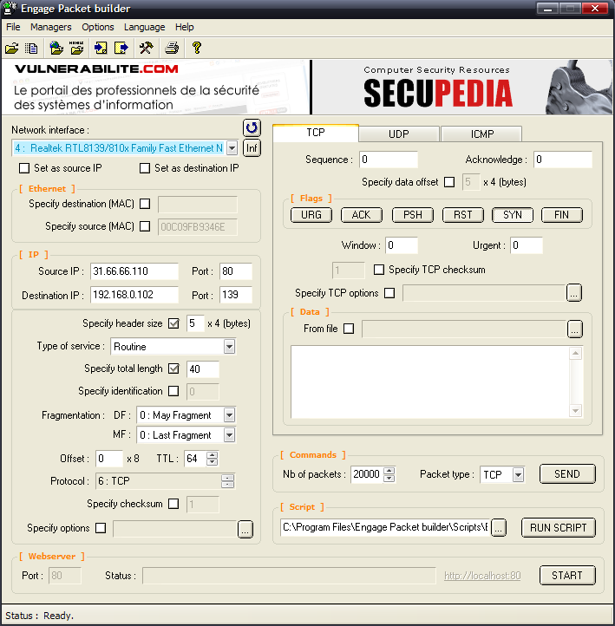

As it can be seen from the Enrage Packet Builder configuration, the source (attacker’s) address has been spoofed with an alternative address. The attacker’s address in this scenario is really 192.168.0.107 – an internal DHCP assigned address – but the target is being directed to a random host IP location that exists outside of the private network. In reality, the spoofed source address appears not to be an actual responding server (tested via NMap). So there is no possible way for the spoofed address to actually send back the ACK packet to complete the TCP handshake. To actually create the SYN packet to be sent all that was required was to set the ‘SYN’ flag in the builder to ‘true’. To increase the network traffic caused by the SYN packets a 28 byte header size was used. This also allows the crafted packets to appear more legitimate.

When wishing to perform the actual attack a vastly large amount of packets need to be sent. Thus Engage Packet Builder was configured to send 10 000 of the specifically designed packet in order to invoke the attack. One client of Engage Packet Builder might not necessarily be enough in order to witness the effects of a DoS occurrence however. To increase the potency of the attack multiple instances of Engage Packet Builder could be initiated. Each of these instances could then be configured to send a certain amount of packets to a specific port from any spoofed attacker address. This could greatly increase the amount of malicious traffic to the target network resource.

6.0 Launching a Simple SYN Flood Attack

To launch the configured the SYN Flood attack the user simply has to start the embedded web server that comes packaged with Engage Packet Builder and then press the “SEND” button. This will launch the swarm of configured packets from the attacker machine towards the target with the configured options in place for each packet. Each packet will be sent sequentially by the software. On the attacker’s machine, 10 000 packets took approximately 13.8 seconds to send, which is a rate of approximately 725 per second.

While attacking, Wireshark was capturing the incoming and outgoing TCP packets on the target machine. This was to ensure that the custom packets were successfully arriving at the target. To witness the actual attack in action all a user would have to do is notice the massive influx of SYN packets arriving into the system through the Wireshark real-time packet analysis screen (Figure 7).

To help understand what occurs during a SYN Flood the details of a single spoofed SYN packet along with the target’s SYN-ACK response packet have been outlined in Figure 7.

Figure 7 Wireshark Captured Packet Information
Attacker’s SYN Packet

No: 1026 Time: 2.857385
Source: 31.66.66.110 Destination: 192.168.0.102
Protocol: TCP
Info: http > netbios-snn [SYN] Seq=0 Len=0

Targets SYN-ACK Packet Response

No: 1027 Time: 2.857691
Source: 192.168.0.102 Destination: 33.66.66.100
Protocol: TCP
Info: netbios-ssn > http [SYN-ACK] Seq=0 Ack=0 Win=64856 Len=0 MSS=1460

Figure 8.1 and 8.2 show the actual screen output from Wireshark during the SYN Flood attack.

Figure 8.1 Wireshark SYN Flood Visual
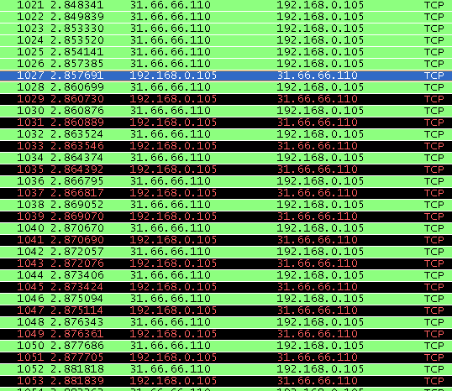

Figure 8.2 Wireshark SYN Flood Visual
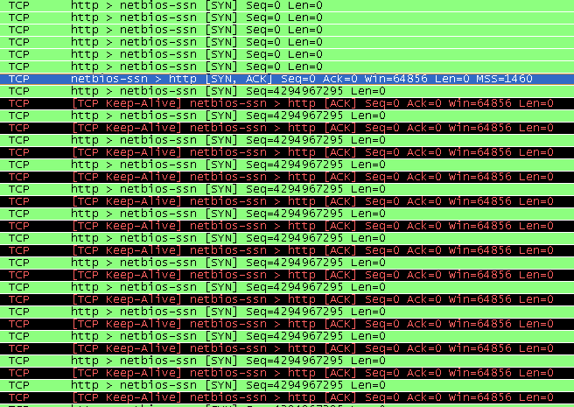

To determine if the SYN Flood was actively keeping the NetBIOS port 139 in a SYN-ACK state the Windows command netstat was used to determine the status of the port during the attack on the target machine.

Figure 9 netstat Results during SYN Flood
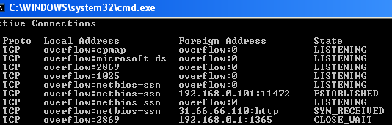

As seen in figure 9, there is a SYN_RECEIVED state TCP connection between the netbios-ssn port 139 and the spoofed IP address 31.66.66.110.

7.0 Snort as an Intrusion Detection System

Snort is a popular network intrusion detection system. Marketed as the “de facto standard” in intrusion detection by its developer SourceFire, it is a lightweight and open source tool for the monitoring and real-time analysis of computer networks. By itself Snort does not actually prevent network intrusions and attacks. It is primarily designed to monitor and report on the network status and traffic based on rules defined by the user. Rules in Snort follow a specific standard and are defined within plaintext *.rule files located in the application’s directory. An example of a simple rule in snort would be as follows

Alert tcp $EXTERNAL_NET any -> $HOME_NET any (msg: “Incoming Packet”; classtype:non-suspicious)

This rule is simply designed to raise an alert and log an alert if an external TCP packet enters the internal network. The “$” delimited words are variables defined in Snort to represent a range of possible hosts – as defined by the user in the Snort configuration. In industry practice this rule would not exist since it would log every single TCP packet entering the network, and this would be extremely excessive. In reality, the IDS would be configured using select rules and options that are feely available on the internet along with custom rules defined by the network security administrator that could be unique to the specific network that is being monitored.

The purpose of Snort in this report is to actively alert and monitor the target computer that is the victim of the SYN Flood DoS attack. The methods outlined will not be able to prevent the attack, but the goal will be to provide alerts through Snort to inform the user that a possible attack is taking place.

8.0 Configuring Snort

To simplify the initial set up and configuration of Snort on the target machine, a free tool called Engage IDSCentre was used to manage the operation of the Snort IDS. IDSCentre supports the end-to-end maintenance of Snort starting with the initial configuration and testing of the IDS to the adding of rules and starting/stopping of the Snort system. IDSCentre is extremely handy as it encapsulates nearly all of Snort’s features into a simple and easy to use GUI. Thus no toying around with the Snort command line is required in order to get the intrusion detection system up and running.

Figure 10 Engage IDSCentre Screenshot
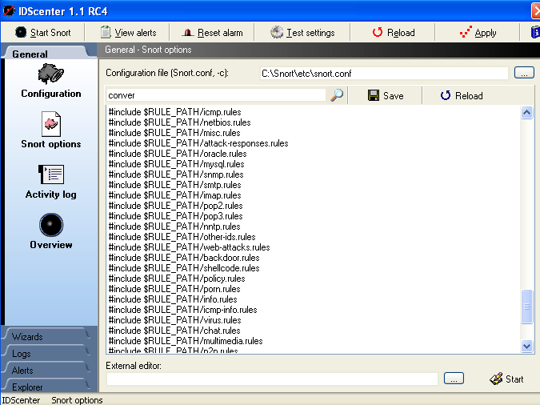

For this example the following Snort variables were declared. (Variables that are not included are assumed to be left as their default values).

Figure 11 Snort Configuration Variables

HOME_NET: 192.168.0/24
EXTERNAL_NET: !$HOME_NET
DNS_SERVERS: 192.168.0.1
RULE_PATH: C:\Snort\Rules
HTTP_PORTS: 80

These variables define what devices (based on IP) on the network are to be considered internal (HOME_NET) and external (EXTERNAL_NET). Internal IP’s are defined as any of the 192.168.0.* IP’s based on the subnet and DHCP service provided by the D-Link router being used. Clearly, it is seen that EXTERNAL_NET is considered to be any potential IP – not including any host from the internal network. Separate rules for logging between hosts on the internal network could be developed separately, but out of the scope of this experiment. Lastly, the snort.conf configuration file has been included with the electronic submission of this report.

8.1 Creating Rules in Snort

The next step was to configure the rules to be used by Snort. This is the most important part of the IDS configuration because it determines which packets are going to raise alerts. To provide a basic set of rules two files were downloaded from the Bleeding Edge Threats rule database. These files were:

- bleeding-scan.rules
- bleeding-dos.rules

The bleeding-scan.rules file contained various rules for alerting and logging various network scanning actions. The main rule that was that required from this file was a rule to log network scans from NMap and it’s “-sS” stealth SYN scan option. The rule is as follows:

alert tcp $EXTERNAL_NET any -> $HOME_NET any (msg: "BLEEDING-EDGE SCAN NMAP -sS"; fragbits: !D; dsize: 0; flags: S,12; ack: 0; window: 2048; reference:arachnids,162; classtype: attempted-recon; sid: 2000537; rev:3; )

This rule is important because it is the method used in the outlined attack to determine which TCP ports are open and accepting connections on the target machine. By logging scans an apt network administrator is able to be warned of a potential incoming attack or threat.

The next downloaded rule file, bleeding-dos.rules contained rules to identify and log a set of known denial of service attacks. Note that this file did not contain any actual rules that could identify the specific SYN Flood attack used in this experiment. Thus this rule file was just included so Snort would have a larger rule database to check against during its operation. If snort was only using a small set of rules than the chance of the IDS missing any potentially unsafe or malicious packets is limited.

8.2 Detecting a SYN Flood with Snort Rules

A rule must now be defined to alert and log the SYN Flood designed earlier in this report. To construct this rule it first needs to be determined what is required to be identified as a possible SYN Flood. Since the SYN Flood is attacking only port 139 this will be the only port we need to monitor with this rule on the target machine. Recall that port 139 is a NetBIOS port that takes part in Windows File and Printer Sharing. Thus any external connection should not be attempting communication to this port with the network configuration currently being used. So it could be safely concluded that any TCP connection attempt from an external network to an internal host in our 192.168.0.0/24 network through port 139 could be suspicious, and should thus raise an alarm.

With this information the following Snort rule can be constructed to fulfill our requirements:

alert tcp $EXTERNAL_NET any -> $HOME_NET 139 (msg:"EXTERNAL NETBIOS TCP-SYN"; flags: S; sid: 0002; classtype: unusual-client-port-connection;)

The problem with this rule is that it is going to raise an alert and append the log file for each and every packet that that triggers it. This means that if a SYN Flood is occurring then the IDS and the log file are going to be under a very high load raising an alert and writing to the log for each of the malicious SYN packets received in the flood. To test how poorly this rule would actually perform a test was conducted by launching a 20 000 packet count SYN Flood against the Snort IDS. The results were as follows:
Figure 12 Poor Rule Design Results
Attacker
Total Packets Sent: 10 000
Single spoofed source address
Single Engage Packet Builder client

Target
Total Packets Received: 60 070
Analyzed: 34 050 (56.684%)
Dropped: 12 605 (20.984%)
Outstanding: 13 415 (22.332%)

TCP Packets Total: 11 345

Alerts/Logged: 11 341

Figure 13 Snort Results Screenshot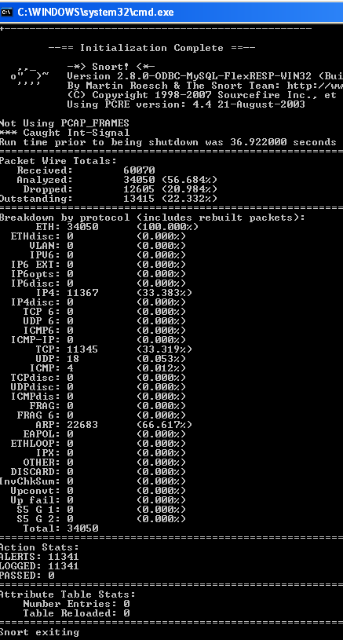

It can be clearly seen from these results that Snort was not able to keep up with the incoming attack streams while maintaining a rigorous logging process. When an IDS is forced to drop many packets, then attacks might be able to enter the network undetected. Flooding an IDS with packets is a valid way to sneak in other malicious attacks potentially unnoticed into the network. The goal here for an attacker would be in hopes that the intrusion detection system will not have the opportunity to scan the specific subset of packets that carry the attacker’s true payload.

In order to properly amend Snort to remedy this problem threshold parameters need to be introduced. Threshold parameters are designed to limit the occurrence of alerts based on the number of times that rule is triggered in a given time period. To alert for a possible SYN Flood DoS attack against port 139 it would be conservative to say that if 1000 SYN packets from any external source are destined for the target machine (on port 139) within a three minute interval than an alert should be raised. With these requirements set, the improved rule becomes:

alert tcp $EXTERNAL_NET any -> $HOME_NET 139 (msg:"EXTERNAL NETBIOS TCP-SYN"; flags: S; sid: 0002; classtype: unusual-client-port-connection; threshold: type threshold, track by_dst, count 1000, seconds 180;)

9.0 Launching A SYN Flood Attack Against Snort IDS

Now that Snort has been fully configured and prepared with the required rules it was time to re-launch the simple SYN Flood attack against the system, the goal in mind being to test the strength and effectiveness of an intelligently configured Snort IDS. The test consisted of four separate executions of the SYN Flood attack, with each iteration (numbered 1 through 4) involving an increasing number of packets sent. This was handled by launching multiple instances of Engage Packet Builder. Each instance was configured to send out a total of 20,000 crafted SYN packets from a different spoofed IP address with a different source port address.

The results of the experiment were as follows:

Figure 14 Experiment Results
 | Total # Crafted SYN Packets | Snort Analysis % | Total Snort Analyzed Packets
1 | 20 000 | 100% | 60 081
2 | 40 000 | 100% | 116 649
3 | 60 000 | 100% | 172 222
4 | 100 000 | 30 000 | 296 084

Figure 15 Snort Alert Count
 | IDS Alert Count
1 | 20
2 | 38
3 | 58
4 | 98

It can clearly been seen from these results that the target machine and the Snort IDS was able to perform flawlessly during the attack. With the improved rule in place CPU utilization on the target machine also greatly decreased. When the inefficient rule was being used the CPU averaged 100% utilization during the attack, whereas with the threshold rule in place CPU utilization averaged around 15-20%.

Lastly, Figure 15 details how many alerts were raised during the attack. As it can be seen a proportional number of alerts were issued by the IDS for each of the increasing flood of packets. In an industry setting this magnitude of alerts from Snort should be quite sufficient for raising the ire of an observant network administrator. From these results it was concluded that the launching and the subsequent detection of the SYN Flood DoS attack was successful.

10.0 Effects of the SYN Flood DoS Attack

To test the SYN Flood DoS attack a legitimate client has to be denied service by the target machine while the attack is underway. Thus an attacker’s goal in a general scenario would be to consume all possible connection resources on the target system. In the scope of this experiment however the attacker will be flooding both the connection slots and port 139 on the target machine. To test the effects of the DoS a third computer was introduced to the network. This Windows XP based machine was connected into the current network topology through a basic Cat5 cable and a DHCP assigned IP address. This new machine was then configured so it could browse and access a shared folder on the target machine. Within this folder resided a large 5GB file. The plan was for the new client to attempt to successfully copy the file while the DoS attack was being launched against the target machine. Since the Windows File and Printer sharing relies on creating a TCP connection on port 139 during file transfer, success of the experiment would be quantified by interruption or data corruption during the file transfer. A repeatable result would infer that the SYN Flood DoS attack as configured in this report is actually quantifiable as a denial of service attack.

10.1 SYN Flood DoS Attack Results

To attempt to create the DoS environment for the target machine 100 000 packets split across 4 Engage Packet Builder Clients (each with a different spoofed source address) were configured on the attacker machine. Once the flood was launched the third – newly introduced client machine then attempted to copy the 5GB file off of the target’s shared folder into their Windows Desktop. This process was repeated four times in order to ensure that the results were in fact, repeatable.

Figure 16 DoS Attack Results
 | File Copy Success?
1 | No
2 | Yes
3 | Yes
4 | Yes

Our results showed during three out of the four separate DoS attacks launched against the target machine in only one case service was actually denied to the client. The ‘denial’ came from the Windows network temporarily losing its network connection to the target machine. Since this was not repeatable it is unknown whether or not. From these results we must conclude that a SYN Flood denial of service attack cannot be performed with the current network, software and tool configuration.

The explanation for the inability to perform the SYN Flood lies within the limitations of the Engage Packet Builder tool. First off each Engage Packet builder client is limited to only sending 30 000 packets. On top of this it was observed during the initial experiments in Section 9.0 that with each new instance of Engage Packet builder running concurrently the packet per second rate decreased.

Figure 17 Average Packet Rate per Second
 | SYN Flood Run Time | Packets Sent/second
1 | 32 s | 625
2 | 73 s | 548
3 | 115 s | 521
4 | 242 s | 413

Figure 18 SYN Flood netstat Results
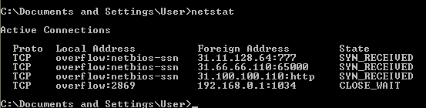

With this limiting packet rate it would just not be possible to get the throughput with Engage Packet Builder in order to create the effects of a denial of service environment. With these packet rates it was observed that network utilization never surpassed 1-2%, clearly not sufficient enough to invoke a denial of service flood attack. In order to attempt to create a SYN Flood DoS attack options other than using Engage Packet Builder would have to be explored. Unfortunately options are limited on Windows environments for tools that could perform this duty. Hindsight suggests that a Linux distribution would have been a stronger choice for the operating system of the attacker. This would have allowed more options for packet creation and flooding tools.

11.0 Preventing TCP SYN Flood Attacks

There any many options available when wishing to prepare for this type of attack. First we will look at ways to outright prevent the SYN Flood attack. With this specific scenario of attack where a port that should only have internal network use is being accessed from outside of the internal network the first plan of action would be to firewall that port from outside connection attempts. In the hardware example used in this experiment, this would be as simple as adding a new firewall rule in the D-Link router used here (the device includes an integrated configurable firewall). The Windows XP included software firewall could also be used to monitor connection attempts to this port, and then handle them as required. If connection attempts to port 139 are restricted, then a SYN Flood attack cannot occur in the first place.

This raises the situation where the port cannot simply be monitored or restricted. What if the port in question is port 80 - the HTTP traffic port. Obviously this port cannot be firewalled from outside traffic. If a Linux operating system needs to be protected, then the use of iptables can be implemented to aid in the defense of SYN Floods. In Linux, iptables is used for the configuration of the kernel integrated packet filter called Netfilter. In order to prevent the packet onslaught of a SYN Flood the following iptables rule chain can be used:

# iptables –N syn_flood
# iptables –A INPUT –i eth1 –p tcp --syn –j syn_flood
# iptables –A syn_flood –m limit --limit 1/second
--limit-burst 4 –j RETURN
# iptables –A syn_flood –j DROP

This rule, when activated will greatly limit the rate at which TCP SYN packets are accepted by the operating system. Due to the power of this rule, it should only be activated when an actual SYN Flood is taking place, otherwise the rule would hinder network communication extensively.

Another method for handling SYN Floods lies at the operating system level. There have been improvements to the networking stacks of operating systems which help them naturally cope with this vulnerability. The operating system could simply shorten the time-out value for the connection while waiting for the final ACK message from the sender. Another method that could reduce the effects of a SYN Flood would to have the operating system only allow a certain limited number of connections from a single host at any given time. This would prevent SYN Floods that had only a few unique ‘source’ IP’s from effectively attacking the system. A third option for handling this attack is called SYN Cookies. This strategy allows half-open TCP connections to be set aside when a special TCP-SYN queue fills. As more TCP SYN requests enter the system, the half-open connections that are idle (due to the incompletion of the TCP handshake) will be moved into a SYN Cookie cache area. The cache is simply a holding facility for these half-open connections since the number of active connection slots on a system is always a limited resource. Eventually connections that reside in this cache will either time out or have their corresponding SYN-ACK message arrive. While a connection resides in the cache, it is not using a resource that is nearly as limited as network connection slot it would be using otherwise. This method can effectively increase the total number of connection slots available to a system, thus allowing the system to theoretically handle a SYN Flood attack without any special network security software or administration.

11.0 Conclusion

This report introduced the concepts behind denial of service attacks and then went into detail on the specific type of DoS attack known as SYN Flooding. It was also shown how powerful the Snort IDS. All it takes is a single simple rule in order to protect a given port from a SYN Flood attack. With a larger network in an industry setting more rules could be defined in order to deliver more accurate results while protecting a wider range of ports and network services.

As the experiments showed a DoS environment could not actually have been created given the hardware and software used. The limits of Engage Packet Builder were mostly to blame for this issue. Given a larger budget and fewer time constraints for the research it would be recommended to involve more than a single attacker computer in the experiment. With 2-3 attacker computers, each flooding the target machine with a capable tool, a DoS environment should definitely be possible. Also a further improvement to the experiment would involve a much larger range of spoofed IPs – somewhere along the line of 25–40 spoofed source machines.

By knowing how a SYN Flood functions and how to configure an intrusion detection system to handle them, network security personal can be better prepared to deal with similar and newly emerging threats

12.0 References

[Figure 1] Tcp_normal.png. Author: Drake [http://en.wikipedia.org/wiki/Image:Tcp_normal.png]. Used under Creative Commons Attribution ShareAlike 2.5 license. Accessed October 28, 2007

[Figure 2] Tcp_synflood.png. Author: Drake [http://en.wikipedia.org/wiki/Image:Tcp_synflood.png]. Used under Creative Commons Attribution ShareAlike 2.5 license. Accessed October 28, 2007

[1] Engage Packet Builder [http://www.engagesecurity.com/products/engagepacketbuilder/]. Accessed October 28, 2007

[2] Wikipedia: SYN Flood [http://en.wikipedia.org/wiki/SYN_flood]. Accessed October 28, 2007

[3] CERT® Advisory CA-1996-21 TCP SYN Flooding and IP Spoofing Attacks, Carnegie Mellon University [http://www.cert.org/advisories/CA-1996-21.html]. Accessed October 28, 2007

[4] Nmap Reference Guide, Insecure.org [http://insecure.org/nmap/man/].
Accessed October 28, 2007

[5] Wireshark, Wireshark.org [http://www.wireshark.org/]. Accessed October 28, 2007

[6] CERT® Coordination Center
Denial of Service Attacks, Cert.org [http://www.cert.org/tech_tips/denial_of_service.html]. Accessed October 28, 2007

[7] TCP Port 139, LinkLogger.com [http://www.linklogger.com/TCP139.htm]. Accessed October 28, 2007

[8] W. Eddy. RFC 4987: TCP SYN Flooding Attacks and Common Mitigations (2007) [http://tools.ietf.org/html/rfc4987#section-3.1]. Accessed October 31, 2007

[9] Snort [http://www.snort.org]. Accessed October 31, 2007

[10] Bleeding Edge Threats [http://www.bleedingthreats.net/]. Accessed October 31 2007

[11] Engage Security IDSCentre [http://www.engagesecurity.com/products/idscenter/]. Accessed October 31, 2007

[12] Tao Peng, Christopher Leckie, Kotagiri Rammamohanarao, Department of Computer Science and Software Engineering, The University of Melbourne, Australia. “Survey of Network-Based Defense Mechanisms Countering the DoS and DDoS Problems”. ACM Computing Surveys Vol. 39, Issue 1. 2007.

[13] Clayton Bolz, Gordon W. Romney, Brandon L. Rogers, Brigham Young University. “Safely Train Security Engineers Regarding Dangers Presented by Denial of Service Attacks”. Conference On Information Technology Education, Proceedings of the 5th conference on Information technology education. 2004

Snort Rules [http://www.snort.orgl/rules/], Bleeding Edge Threats [http://bleedingthreats.net]

