Eavesdropping attack over Wi-Fi
Fadi Farhat
University of Windsor
Farhat4@uwindsor.ca

Abstract
This paper explains the eavesdropping attack over Wi-Fi networks, one of the confidentiality attacks. It will clarify the difference between wired and wireless networks and it will explain the related issues to the wireless one. The illustration will start taking place from defining the eavesdropping, passing by posting the hardware devices and the software tools responsible of achieving that mission continuing thru mentioning the reasons that makes a Wi-Fi network vulnerable and consequently the steps to follow in order to secure it and what is the work done by the Wi-Fi equipment makers to enhance the protecting of their Wi-Fi’s; The paper will continue to specify the difference between legally and illegally eavesdropping. And at the end, a detailed experiment will be given as an example.

1. Introduction

Eavesdropping is the process of gathering information from a network by snooping on transmitted data. And to eavesdrop is to secretly overhear a private conversation over a confidential communication in a not legally authorized way. The information remains intact, but its privacy is compromised.

It can take place over wired networks as over wireless networks. On wired network the operation of eavesdropping is more difficult because it needs the eavesdropper to tap the network, using a network tap which is a hardware device that provides a way to access the data flowing across the network. And that of course can’t be achieved unless the eavesdropper can be in touch with the wire of the network which is difficult sometimes and impossible the other times.

Eavesdropping can also take place on wireless networks where the eavesdropper is not obliged to be in the dangerous position of being compromised. All what he needs is a computer supplied by a wireless network adapter working on promiscuous mode to allow a network device to intercept and read each network packet that arrives even with other network address, to be in the area of the wireless network coverage and to have one of the particular software tools that allows the eavesdropping over Wi-Fi. Wi-Fi—short for “wireless fidelity”—is the commercial name for the 802.11 products. [1]
An example of eavesdropping is intercepting credit card numbers, using devices that interrupt wireless broadcast communications or tapping wire communications which is the preferable for eavesdroppers.

Eavesdropping can be useful by capturing none encrypted data or known decrypted, encrypted data, but it will be none useful if the data was encrypted by unknown encryption.

2. What to use for eavesdropping?

Hardware and software are involving in making eavesdropping easy.

Many hardware tools that allow promiscuous mode, such as Prisme2 network adapter can be used to simplify eavesdropping and high-power antennas can be used to provide intercepting wireless traffic from miles away.



Figure1. Modified Prism2 card [2]

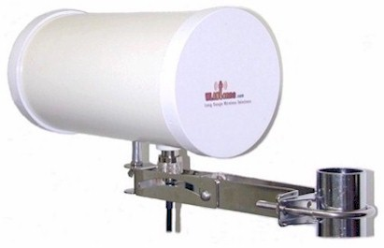

Figure 2. Waveguide Directional Wireless Antenna [3]

Software tools which are widely available for sale and even free over the Internet such as Network Stumbler Wireless Packet Sniffer, Hitchhiker, Aircrack-ng, Wireshark, Kisemet, Commview for wifi, Javvin packet analyzer, Wildpackets,Network monitor and Wireless monitor.

3. Legality of eavesdropping devices

An Eavesdropping device is electronic equipment allowing the interception of audio communications, visual images and data. For example: e-mail messages sent and received, names and content of Web sites visited and any downloaded files.
Most eavesdropping devices are sold over the Internet but before you buy any, you should know that it is a crime in most countries to eavesdrop on someone’s privacy and you should be aware of the legal issues because some are not legal to own, while others are legal, like those that may be used to record your own conversations with someone). [4]

4. Why Wi-Fi is easy to be compromised

There are about 10 million Wi-Fi networks around the world, most are unsecured and open to unauthorized use because many individuals’ and businesses don't understand how to secure a wireless network and also because many Wi-Fi products come ready-to-use right out of the box. In both cases they are easy attacked by eavesdroppers.
Eavesdroppers can also use the WarDriving technique which is the operation of tracking and accessing wireless access points while moving in order to obtain the data transmitted by the Wi-Fi signal. The only available way to fight eavesdropping is the encryption.
But even using the encryption technique will not prevent capturing the data in its encrypted form which can be even deciphered using some available tools but it still the only existing way to protect privacy.

5. Simple Steps to Secure Wi-Fi Network [5]

Following a few steps can provide some security to Wi-Fi networks:

5.1 Change the Administrative Password on your Wireless Routers

Routers came with default password from producers to provide easy access, and changing those passwords, is one of the first recommended steps to do, because those default passwords are posted on the vendor support sites, they should therefore be changed right away.

5.2 Installing a Firewall

A firewall which is the fence of your network from any unauthorized accessing can help protect your PC by blocking or allowing the pass to your network.

5.3 Change the Default SSID Name and Turn off SSID Broadcasting

In Wi-Fi Wireless LAN computer networking, a service set identifier (SSID) is a code attached to all packets on a wireless network to identify each packet as part of that network [6]. This will necessitate your wireless client computers to enter the name of your SSID by hand before they can connect to your network. But even though and because the data packets that are transmitted will include the SSID it will be easily discovered.

5.4 Disable DHCP

Disabling DHCP (Dynamic Host Configuration Protocol), and assigning IP addresses to your client computers manually will allow restriction access to the router to specific MAC addresses.

5.5 Replace WEP with WPA

WEP (Wired Equivalent Privacy) is a security protocol, encrypting data transmitted over the wireless computer network to provide security and privacy, and to protect the vulnerable wireless link between clients and access points. But as WEP is weak and can be cracked in about 3 minutes as the FBI showed in 2005 using some freely access tools, WPA (Wi-Fi Protected Access) which is more powerful using 128-bit encryption keys and dynamic session keys, must replace it to provide strong data protection.
6. Contributions of Wi-Fi Producers towards privacy

The Wireless Ethernet Compatibility Alliance (WECA) came up with something called Wired Equivalent Privacy (WEP), which uses encryption to protect the data. But not so far a serious flaw was found in the use of encryption technology and some simple attacks was discovered to be used to defeat the protections. IEEE 802.11 and the Wi-Fi Alliance enhanced encryption techniques by developing the WPA to provide a stronger authentication process than was previously available. Some Wi-Fi equipment makers have added other security measures like intrusion detection uses position location technology to detect the presence of a malicious station in order to track down the offending station and remove it. [7]

7. Special attacks for Wi-Fi

Some attacks can’t be applied to wire networks while it’s applicable to Wi-Fi in spite of the encryption key which it may use.

For example: Man-In-The-Middle Attacks: Where hackers can configure a rogue AP to imitate a legitimate AP. Once the client is connected to the rogue AP, the hacker can perform any attack that involves modifying the packet stream. Emails can be read, phishing attacks can be implemented etc...

8. What to keep in mind?

Network administrators need to analyze traffic on their networks to debug networks and to find access points that have been installed illegitimately on the network and that may need them to eavesdrop on Wi-Fi transmissions. A number of software products are available and mentioned before that both find and listen in on Wi-Fi transmissions. For the most part, these software packages are completely legitimate network analyzers. [8]

While eavesdropper is defined as a person who accesses a confidential communication without authorization so anyone who “Intentionally intercepts, endeavors to intercept, or procures any other person to intercept or endeavor to intercept, any electronic communication;” is in violation of the law, excluding electronic communications that are readily accessible to the general public.

9. Wi-Fi eavesdropping Experiment

In this part I’ll present a real experiment to proof the effectiveness of eavesdropping over a non secure Wi-Fi network.

9.1 Experiment setup

Two laptops, one desktop and wireless router were involved in this experiment. We will name them “A”, “B”, “C”, “D”.

“A” is Toshiba Laptop, Centrino 1.7 GHz, 1 GB Ram, 80 GB HD and Windows XP Professional as an Operating System.
It’s the Victim host.

“B” is HP Laptop, Centrino 1.7 GHz, 512 MB Ram, 60 GB HD and Windows XP Professional as an Operating System. CommView for Wi-Fi (packet sniffer and generator) was downloaded on this host.
It’s the Intruder host.

“C” is an IBM server desktop, Xeon 3.00 GHz, 1 GB, 80 GB HD and Windows 2000 Advanced Server as an Operating System installed on VMware ver 4.0. This server has the following application: MS-IIS web server, SMTP Relay service, FTP service.
It’s the server that the victim will communicate with.

“D” is a Netgear 54 wireless router XG614v7, 4 ports UTP switch (Intranet server is connected via), the SSID name is Stay Away, the channel used is channel 2 and the router acts between the wireless network and the intranet server without any security option.
It’s the AP thru where all the communication of our experiment will take place.

9.2 Hosts Installations and Configuration.

To setup our system environment we needed to install and configure several programs on the different machines.

It includes the following:

9.2.1. Installing and configuring Access Point (Netgear) including:

9.2.1.1 SSID
9.2.1.2 IP address
9.2.1.3 DHCP service
9.2.1.4 Channel ID

9.2.2. Installing and configuring Intranet Server including:

9.2.2.1 Installing IIS, SMTP and FTP
9.2.2.2 Configuring IIS, SMTP, FTP

9.2.3. Installing and configuring Intruder Machine.

9.2.3.1 Installing CommView for Wi-Fi

9.2.4 Installing & Configuring Victim Machine

9.2.4.1 Configuring Outlook Express email client

9.3 Experiment Scenario
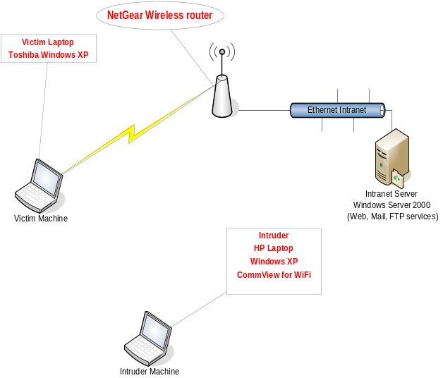
Figure 3. The experiment Scenario [9]

Before the eavesdropping attack will take place on the victim host “A”, the CommView sniffer on Host “B” should be run in order to configure the channel, the IP aliases and the CommView rules (such as IP addresses, Protocols and Ports). After the configuration was done, the attack starts by starting the scanning operation to capture the AP’s available in order to start sniffing the packets of a chosen AP.

CommView, at this point, is able to capture all the packets of the configured Protocols, like (HTTP, FTP and SMTP).

Host “A” will start it’s communication with the intranet server by demanding an HTTP service to access a webpage. As Host “A” accessing the webpage, the intruder receives all the packets of that service, and consequently, CommView transfer and display this webpage.

Now the victim is trying to download a file from the intranet server by using the FTP service. Typing the user name and the password and after the verification, downloading the file. The entire above service packets have been captured by the Intruder. CommView again is doing its job. Here is the username, the password and even the content of the text file downloaded.

Host “A” at the end, sent an email thru the intranet server using the SMTP service. But the intruder captured the details of that e-mail.

9.4 Experiment results

Four kinds of different data have been captured by the eavesdropper; Displayed Websites, User name and Password used to access the intranet server, the contents of downloaded files and all the e-mails that have been sent.

All the packets which were sent by the victim as well as the intranet server were captured by the intruder without any loss.

By changing the security option of the router from none to WEP, zero packets were captured.

10. Conclusion.

This paper presents an explanation about the eavesdropping attack and how it acts. It differentiates between the wired and the wireless attacks.

Legality of hardware devices as well as eavesdropping was one of the subjects that this paper talks about. It mentions the hardware devices and the special characteristics that it should have as well as the software tools to be used in order to achieve the attack. At the end we detailed a real experiment which was done, and where the attack proved its capabilities in capturing different kind of packets like HTTP, FTP and SMTP.

As I show in my experiment that eavesdropping over wireless network was easy to be achieved, I conducted the same experiment but using WEP security. And this time the results shown was the same, especially with an intruder who knows the access password of the network as he is an employee.

The same experiment was conducted again but this time the level of security was WPA. The intruder became more upset as he wasn’t capable to capture even a single packet.

At the end we have to wish that the WPA security can withstand for a long time.

11. References

[1] M. Domenico, A. Calandriello, G. Calandriello and A. Lioy. Dependability in Wireless Networks: Can We Rely on WiFi?. IEEE Security and Privacy, 5(1):23-29, 2007
[2] www.london-wifi.com
[3] www.wlantenna.com/wlantenna.htm
[4] http://www.tscmvideo.com/eavesdropping/eavesdropping-device.html
[5] LucidLink, the network security products company, WiFiTheft.com, wifi.weblogsinc.com, WarDriving.com, Wigle.net, www.intelligentedu.com
[6] Wikipedia encyclopedia. Eavesdropping on Wi-Fi, chapter 6 page 122
[7] http://www.sciam.com/article.cfm
[8] Eavesdropping on Wi-Fi, chapter 6 page 122
[9] The experiment Scenario figure, Eavesdropping project.

