Xmas Scan Detection with Snort Using CommView and Nmap

By

Aqila Dissanayake
University of Windsor
dissanaa@uwindsor.ca

and

Olalekan Kadri
University of Windsor
kadrio@uwindsor.ca

1. Introduction

In this project, we are going to demonstrate a wireless attack that can be caught by Snort the intrusion detection system. Also, we will generate network traffic to simulate a real wireless network with many users. For this purpose we will be using the network traffic generator CommView. Furthermore we will be measuring snort’s effectiveness when there are different levels of network traffic.

In order to capture packets we will require WinPcap windows packets capture library. “WinPcap is the industry-standard tool for link-layer network access in Windows environments: it allows applications to capture and transmit network packets bypassing the protocol stack, and has additional useful features, including kernel-level packet filtering, a network statistics engine and support for remote packet capture” [1]. “WinPcap consists of a driver that extends the operating system to provide low-level network access, and a library that is used to easily access the low-level network layers“ [1].

The network environment for the project is as follows:

Host A
Microsoft Windows XP Home with Service Pack 2
Intel CPU T2050 @ 1.6 GHz
1.6 GHz, 504 MB of RAM

Attacker
Microsoft Windows XP Professional with Service Pack 2
Intel Core 2 Duo CPU T5200 @ 1.6 GHz
798 MHz, 2.00 GB of RAM

Router Configuration
D-Link 802.11g/2.4 GHz Wireless Router
Model No: D1-524

2. Snort (Installed on Host A)

Download Snort from

http://www.snort.org/dl/binaries/win32/

Double click the file

Snort_2_8_0_Installer.exe

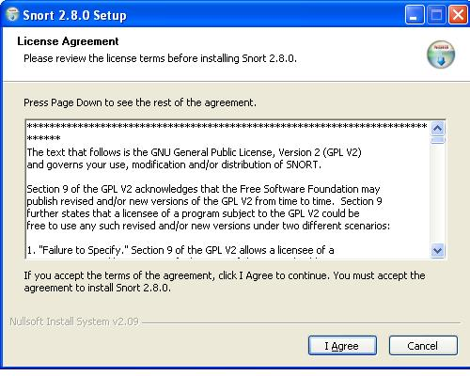

Click I Agree

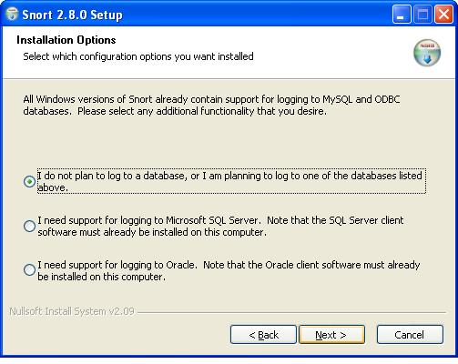

Choose “I do not plan to log to a database, or I am planning to log to one of the databases listed above.”

Then click Next
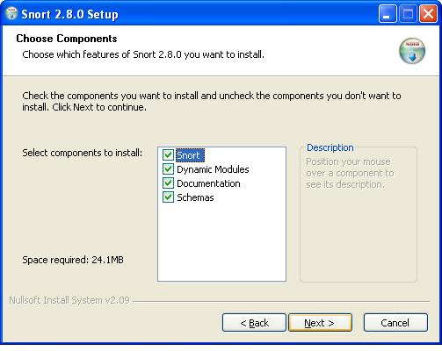

Choose which components to install and click Next

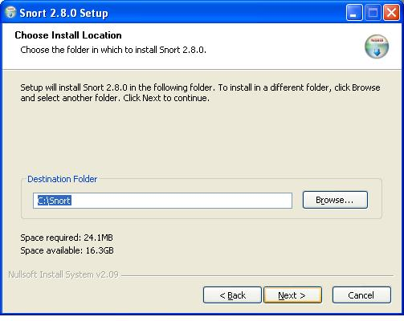
Choose Install Location and click Next

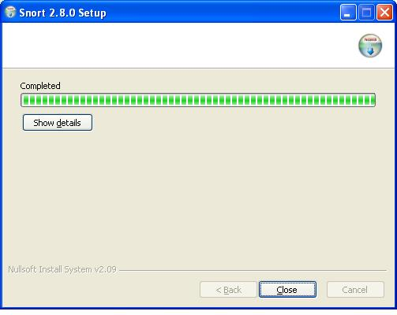
Click Close

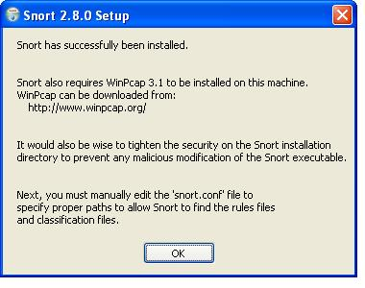

3. Installation of WinPcap (Installed on Host A)

Download the latest version of WinPcap from

http://www.winpcap.org/install/default.htm

Double click the file

WinPcap_4_0_1.exe

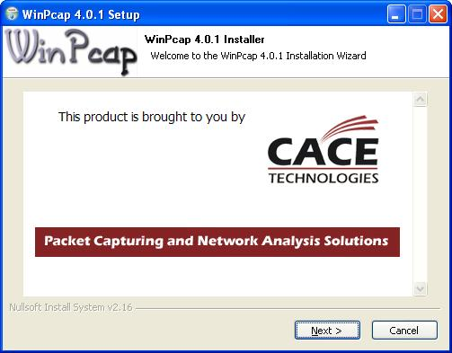

Click Next



Click Next

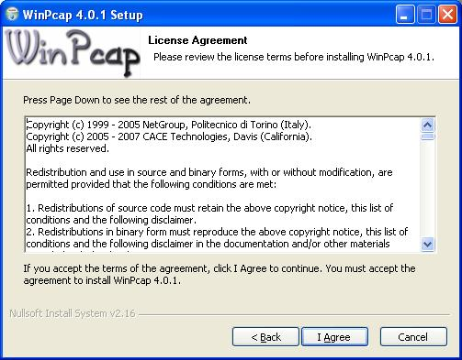

Click I Agree

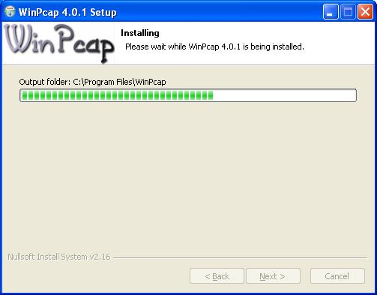

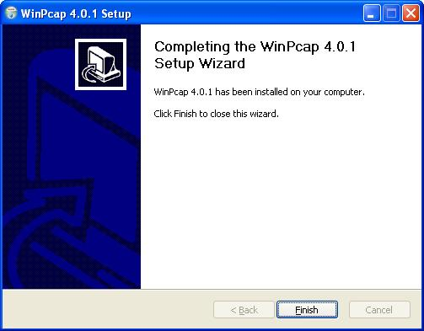

Click Finish

4. CommView Installation (Installed on Attacker)

Download the latest version of CommView from

http://www.tamos.com/download/main/

Unzip the file using WinZip of WinRar

cv5.zip

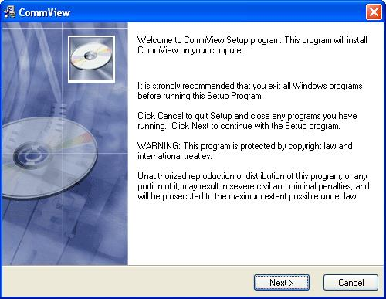

Click Next

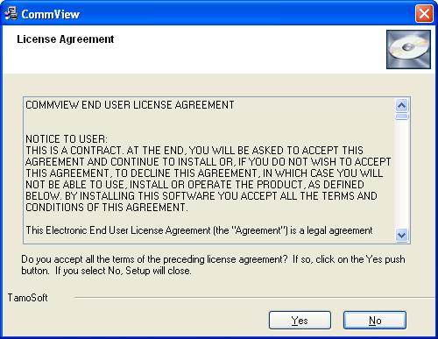

Click Yes

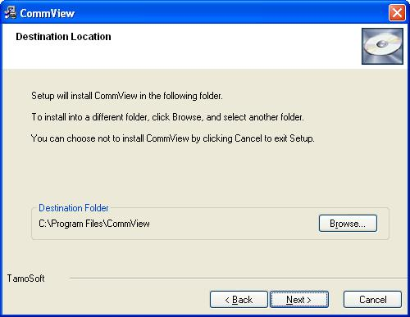

Click Next

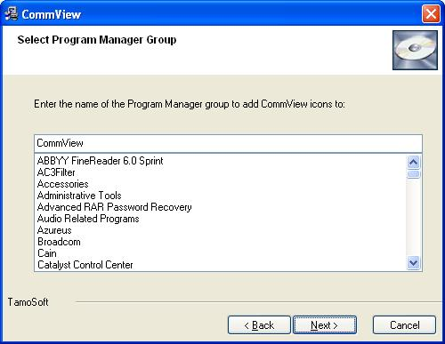

Click Next

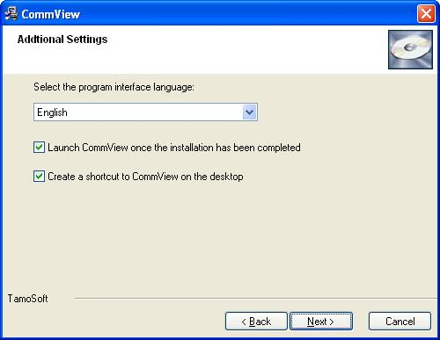

Click Next

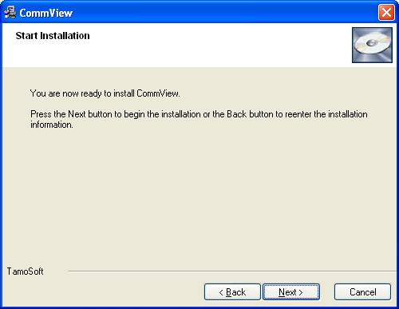

Click Next

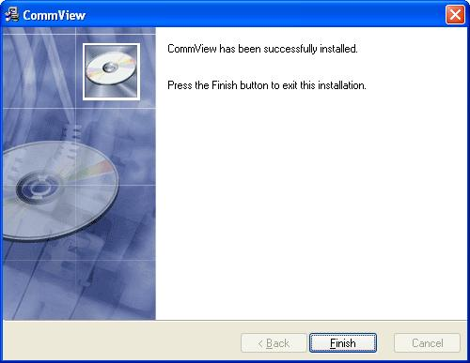

Click Finish

5. Nmap Installation (Installed on Attacker)

The nmap is downloaded and installed as follows:

Double click the exe file. The following is displayed:

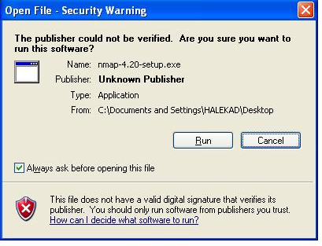
Click on Run

The next page is:

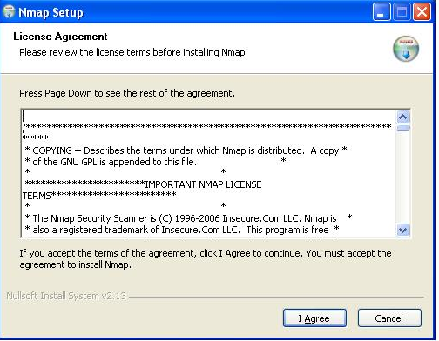

Click on I Agree, leading to the page:

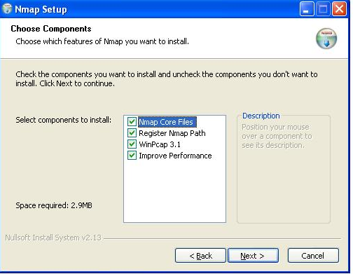

Click Next in order to choose the path

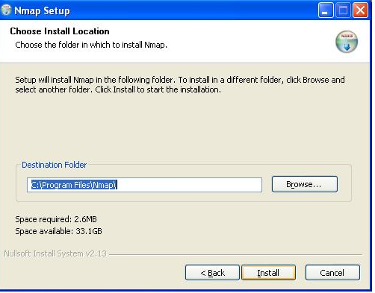

Click on Install

The final page is then displayed so that the installation can be closed.

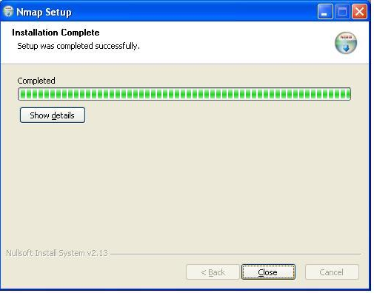

6. Configuration of Snort

The snort.conf file is located at C:\Snort\etc\snort.conf.
The following modifications were made

The output log is changed as follows:

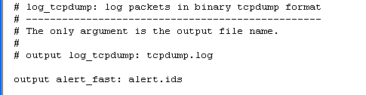

The Home_net var is modified to the network used for the project to reflect the

var HOME_NET 192.168.1.100/24

In the current Snort installation, rules have to be downloaded separately from the Snort website. This can be done at

http://www.snort.org/pub-bin/downloads.cgi

After that, the rule file must be unzipped using an unzipping utility such as WinZip or WinRar and the actual rule files must be copied to the c:/snort/rules directory. After that the config file must be modified to reflect the correct path for the Snort rules.

var RULE_PATH c:\snort\rules

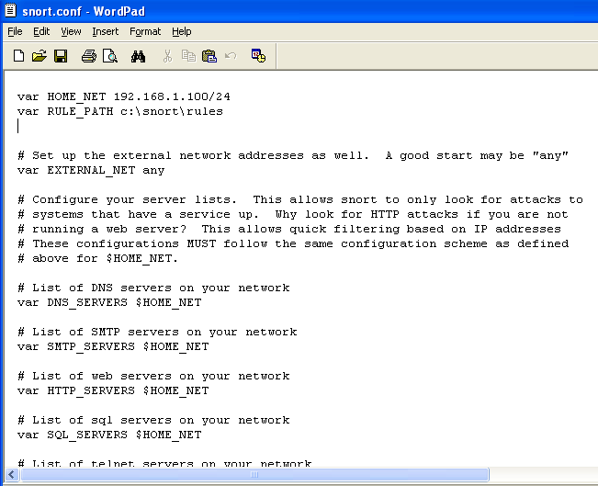

The following two fields are also included to allow snort reference them for the alerts triggered.

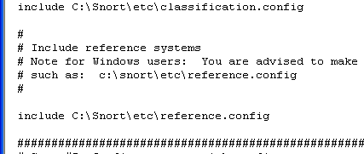

classification.config holds alert levels for the rules that Snort monitors
against network traffic.To set the classification.config file in the snort.conf configuration file, follow these steps:

1. Find this default line in the snort.conf file:

Include classfication.config

2. Insert the actual path for the classification.config file into the
preceding Include line, like this:

Include C:\Snort\etc\classification.config

As far as we are concerned, configuration of Snort was an extremely difficult task that took many hours of hard work.

7. The Xmas Tree scan

This attack is crafted with Nmap installed on the Attacker machine. We used Nmap to launch an Xmas tree scan

The following screen shots were taken

The sample command for the Xmas tree scan is as shown:

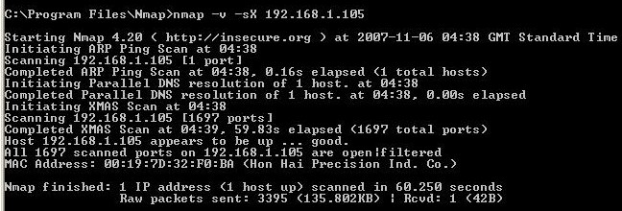

The attack is traced from Host A as soon as the Xmas scan is launched as shown below:

The following reports are shown as a result:

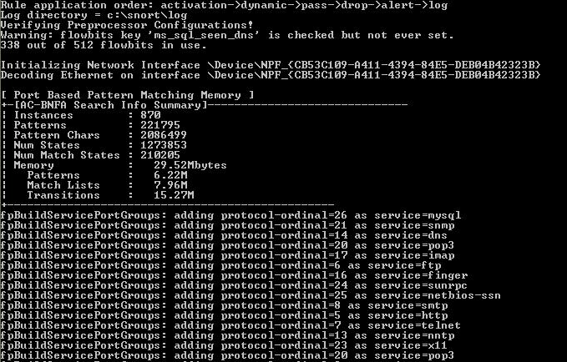

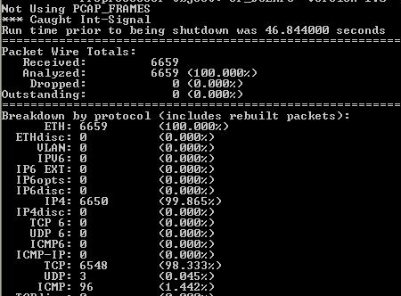

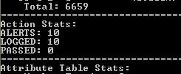

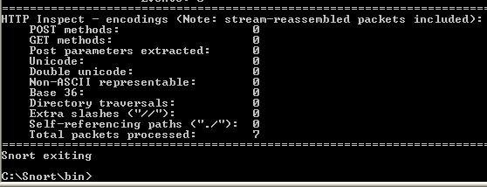

The same process is repeated each time having the rate of the packets from CommView to

200 packets/sec
400 packets /sec
600 packets /sec
800 packets /sec
1000 packets /sec

with the total number of packets remaining constant at 10000 packets. This is shown in the screenshots.

200 packets/sec

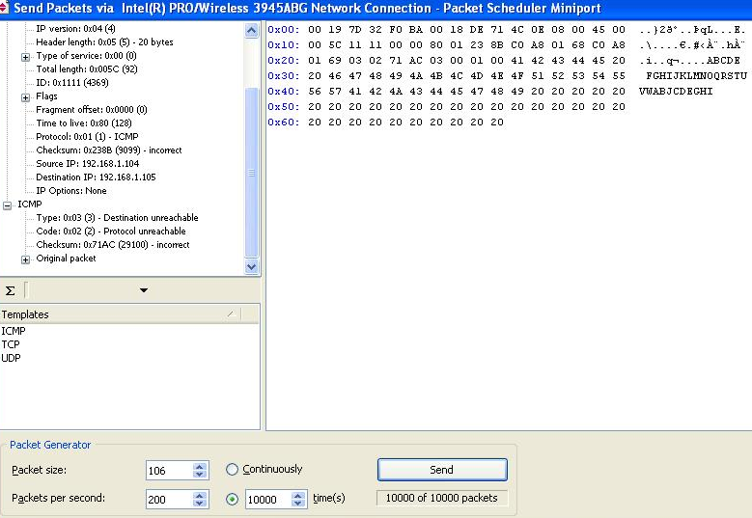

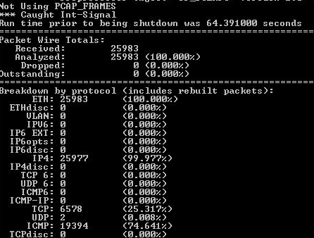

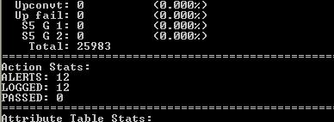

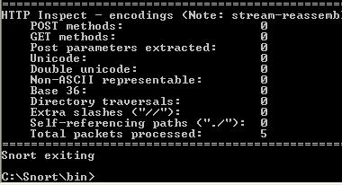

400 packets/sec

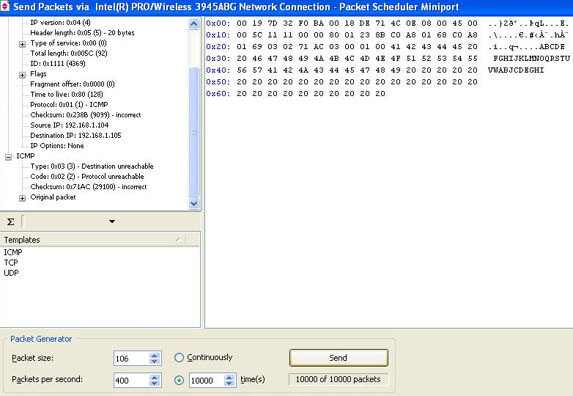

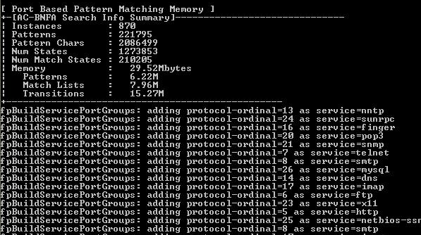

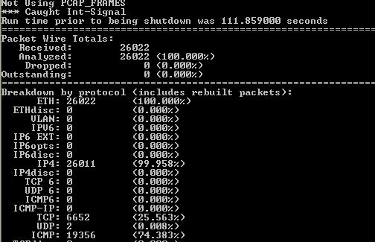

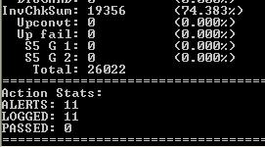

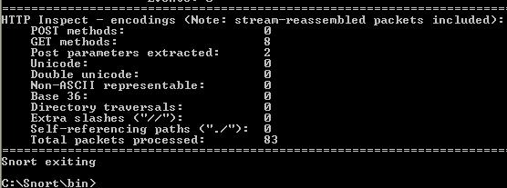

600 packets/sec

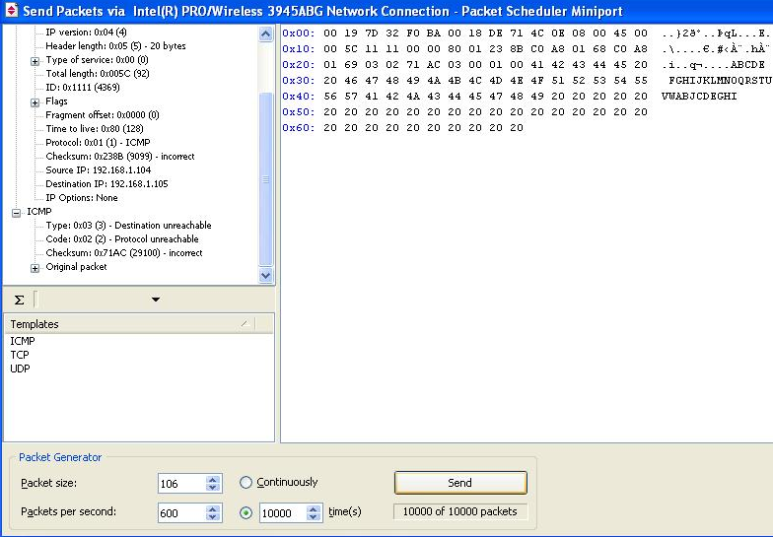

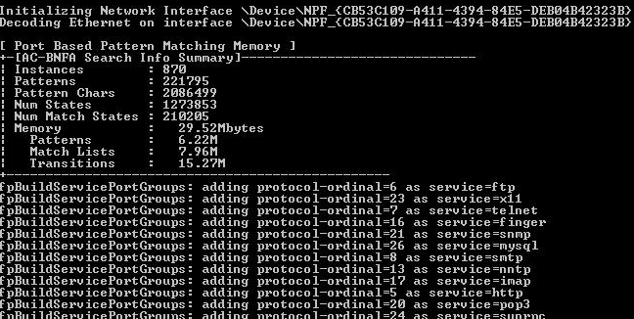

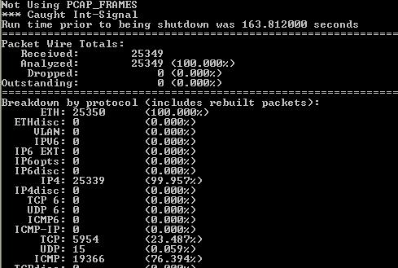

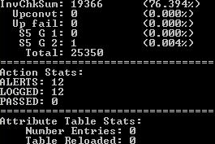

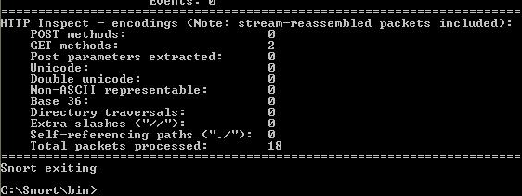

800 packets/sec

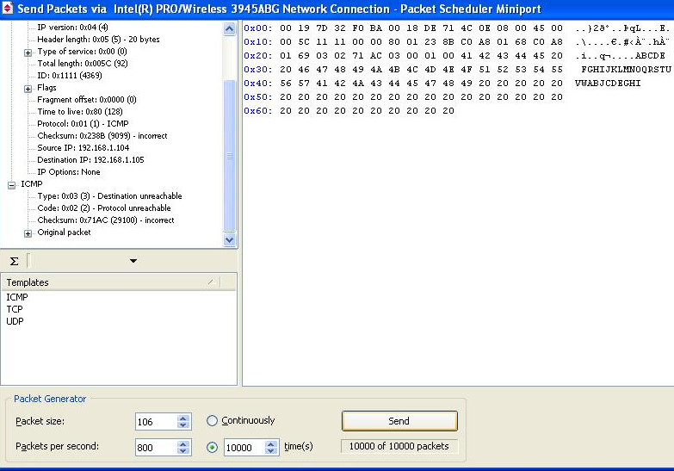

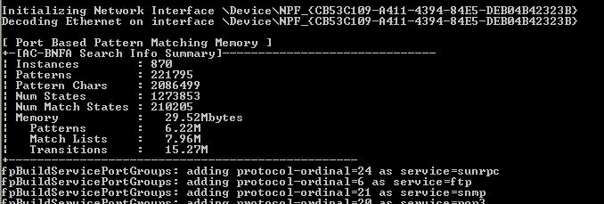

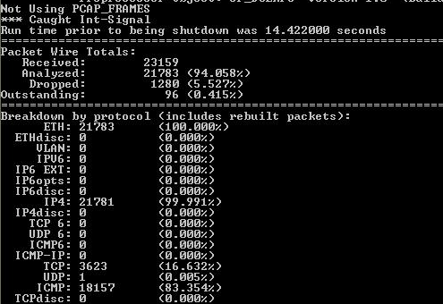

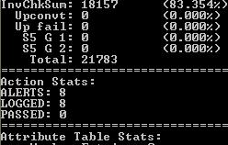

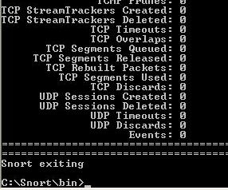

1000 packets/sec

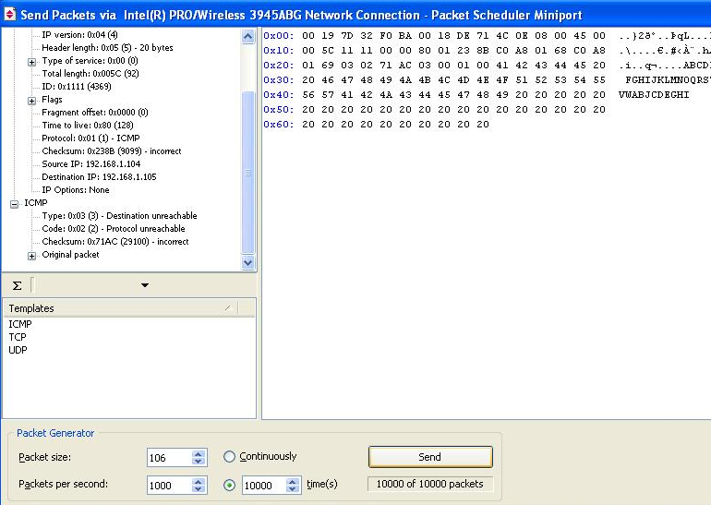

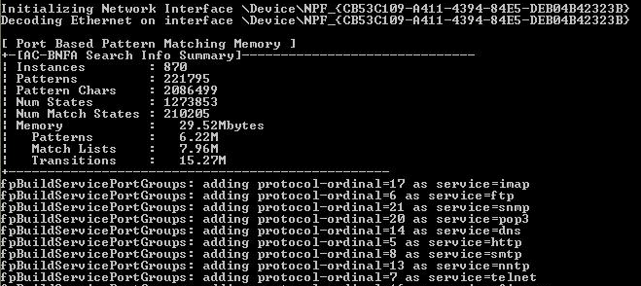

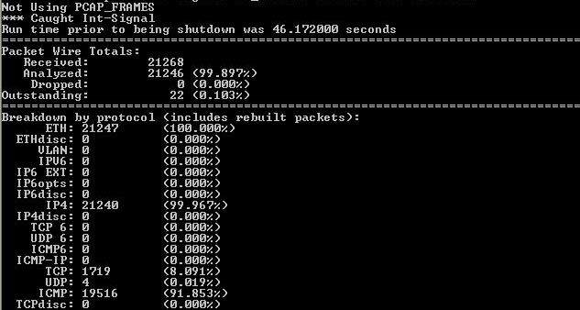

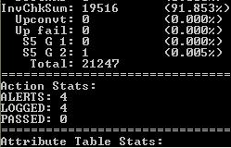

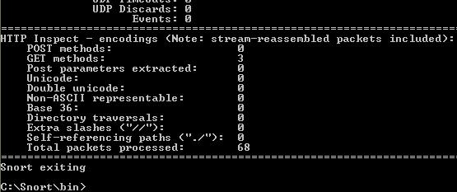

Xmas Tree Scan with Different Levels of Network Traffic.

We conducted 5 separate Xmas tree scans at varying degrees of network traffic. The related information is given in the table below and the corresponding graph.

Total # of Packet Received | Alerts | Rate (Packet/sec) | Total Packets from CommView
25983 | 12 | 200 | 10000
26022 | 11 | 400 | 10000
25349 | 12 | 600 | 10000
23159 | 8 | 800 | 10000
21268 | 6 | 1000 | 10000

Table - This gives the summary of experiment we did

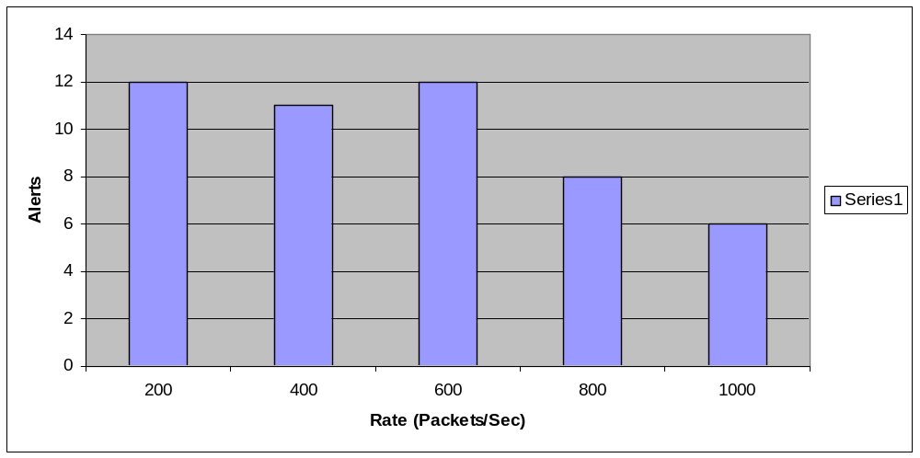

It is obvious from the graph shown below that as the rate is increased, the alert detection rate also decreases except for 600 packets/sec where it rose to 12 alerts. It can fairly be said that as the rate of packet sent to Host A increases, the alert detected decreases.

From this information we can infer that when the level of traffic intensity increases in a network, Snort becomes less accurate. As one can see from the graph, in the first instance of 200 packets per second traffic scenario snort gave 12 alerts. In the second instance with 400 packets per second the number of alerts decreased to 11 but ironically at 600 packets per second the alerts increased to 12. At 800 packets per second, the number of alerts detected by Snort clearly dropped to 8 which is quite significant compared with the first instance. Also, at 1000 packets per second the number of alerts from Snort dropped to 6. So, it’s clearly evident that Snorts effectiveness depends on the traffic in the network. As traffic increases in a network Snort becomes less accurate.

[1] http://www.winpcap.org/

